

**NHS South West London CCG**

**Covid-19 and Care Homes - Frequently Asked Questions**

**Information Sharing Infection Prevention and Control Webinar: Tuesday 10th August 2021**

Dear Social Care Colleagues,

Thank you for joining the Webinar for Care Homes this week; we hope that these continue to support you during the Covid-19 pandemic. It is important to remain diligent in following guidance, using PPE and supporting staff and residents to be vaccinated.

We continue to focus on maintaining the SAGE safety thresholds of 90% vaccination rates among residents and 80% vaccination rates among all staff directly employed, bank and agency. SAGE is the government’s scientific advisory group for emergencies. Thank you to those homes who have achieved this target and we will continue to work alongside homes which have not.   Vaccine information is included in the pack.

To support access to vaccines, **free taxis are now available for Care Home staff to attend a vaccination centre**. Please see the “What’s New” section for more information and let your staff know of this offer.

In the ‘What’s New’ section, please see details of a ‘Mindfulness for Life’, training programme, available to Care Homes in SWL. Our webinar on 17th August will include presentations on the eRedBag pathway and an update on the Remote Monitoring project. Please also see the ‘Summer Readiness’ pack which contains useful information and resources to support Care Homes during warmer weather and heat waves. Please note that next week is the final opportunity to attend DSPT Bitesize webinars (please see the ‘digital’ section).

The COVID-19 pandemic remains an extremely challenging situation globally and we recognise that this is the case for staff working in Care Homes of all types. We are continuing the weekly Infection Prevention and Control and Information Sharing webinar Tuesday mornings at 11:00am. If you have questions in advance or any topics that you would like covered, please email your local CCG Care Home Lead, listed below.

We would like to thank you all for your hard work and commitment during this incredibly challenging time.

**Please share this document weekly with all staff in the Care Home.**

With best regards

Viccie Nelson

**Associate Director of Transformation**

**NHS South West London CCG**

***Your CCG Care Home Leads are:***

Croydon Trisha Wallace [trisha.wallace@swlondon.nhs.uk](mailto:trisha.wallace@swlondon.nhs.uk)

Kingston and Richmond Brian Roberts [brian.roberts@swlondon.nhs.uk](mailto:brian.roberts@swlondon.nhs.uk)

Merton Tayo Fowewe [Kudirat.Fowewe@swlondon.nhs.uk](mailto:Kudirat.Fowewe@swlondon.nhs.uk)

Sutton Lucy Webber [Lucy.Webber@swlondon.nhs.uk](mailto:Lucy.Webber@swlondon.nhs.uk)

Wandsworth Anca Costinas [Anca.Costinas@swlondon.nhs.uk](mailto:Anca.Costinas@swlondon.nhs.uk)

**Please note email address for the Infection Control Team:** [infectioncontrol@swlondon.nhs.uk](mailto:infectioncontrol@swlondon.nhs.uk)

Table of Contents

Coming up . . . 4

Covid-19 vaccination for Care Home staff 4

Opening times and Vaccine Centres for walk in 5

Second COVID-19 Vaccine Doses 5

New Guidance for first dose Astra Zeneca (Oxford) Covid-19 Vaccine 5

Supporting Staff with Vaccine Hesitancy 5

SECTION 1: Updated Guidance 6

Personal Protective Equipment 6

Polyethylene glycol (PEG) 6

111*6 7

What’s New? 8

Vaccination Guides 9

Care Home Champion Meeting 11

IPC guidance direct to your mobile 11

IPC Training offers 11

Uniform Bags 12

Pre-Recorded COVID-19 Vaccine Q&A webinars 12

COVID 19 Vaccine Questions and Answers in English and Polish 12

Ways to Reach out to Friends and Neighbours . . . 12

Good thinking website for Wellbeing 13

Recruitment support through The Prince’s Trust 13

SECTION 2: Frequently Asked Questions 15

1. Is there any recommendation for a ‘Digitalised Social Care Record’ system, which is working well in care homes ? 15

2. Can a relative complete a test at home and bring evidence to the care home? 15

3. I have problems with getting to a vaccination site and so what can I do? 15

4. I only want one type of vaccine; how can I arrange this? 15

5. How do we order more Red Bags? 15

6. Where can we access training for RESTORE2 15

7. How can care homes access the MKad link? 16

8. Regarding the government’s plans to stop wearing masks. Does this apply to care homes? E.G Do staff still have to wear masks around the home at all times. 16

9. What is the next step for Care Homes with visiting following 19/07/2021. Do we need to continue all tests in situ as well as for visitors? 16

10. When will we get more detail about the easing of restrictions/visiting, my phone has not stopped calling from relatives asking if they still have to book and go to a designated room etc? 16

The guidance on Care Home Visiting was updated on 16th July 16

11. I have an NHS email for the care home, is there a way to directly open the care home NHS email? 16

12. I am a manager of a Care Home and I have really tried to encourage my staff to have the vaccine, with several supervision sessions but I don’t know what else I can do for those staff who won’t have it? 16

13. Is it mandatory for non CQC registered care home staff to have the vaccine? 17

14. What is the timeline for someone who has had covid before they can be vaccinated? 17

15. Student staff due to work with us but have another placement due in 5 weeks’ time. Does the guidance still state that those who work in placements cannot work in care homes? 17

16. Is it possible to have a medical exemption for new employees to not wear a face mask in care home? 17

17. Recording overseas vaccinations 17

Section 3: Additional information 19

Infection Control Champions for Care Homes 19

Contact details for advice and support for mental health and wellbeing. 19

Support for Managing Residents with Dementia 19

SECTION 4: ONGOING ADVICE AND SUPPORT 20

Support for EOLC from Hospice UK 20

What to do if a resident has coronavirus symptoms 20

If PPE is running low in your Care Home 20

NICE guidelines on Safeguarding adults in care homes 20

APPENDIX 1: Useful Links and Contacts 21

# 

# *Coming up . . .*

# Covid-19 vaccination for Care Home staff

**Care Home Staff Walk in service**

Currently, Care Home staff can book at the national booking sites or attend as walk-ins. Please see the table below for the venues, addresses, vaccine type and times of the clinics. The national booking link is: <https://www.nhs.uk/conditions/coronavirus-covid-19/coronavirus-vaccination/book-coronavirus-vaccination/>

The national booking link can also be used to book at pharmacies who are providing vaccinations.

Walk in sessions will also be available at the following pharmacies:

* Ace Pharmacy: 1-3 Acre Parade, Hood Road, Chessington KT9 1DR
* Mayday Community Pharmacy: 508 London Road, Croydon CR7 7HQ
* St Boniface Church: 185 Mitcham Road, Wandsworth SW17 9PG
* Valley Pharmacy: St Aiden’s Church Hall, Chipstead Valley Road, Croydon CR5 3BB

For staff who do not have an NHS number or are not registered with a GP please contact [carehome.covidvaccine@swlondon.nhs.uk](mailto:carehome.covidvaccine@swlondon.nhs.uk) who can support access to the clinics above.

# Opening times and Vaccine Centres for walk in

Please note that for all sites you will need to take proof of employment:

* staff id card with photo
* or letter from manager/payslip plus photo id (e.g. Passport, Drivers Licence)

We recognise that information on the COVID-19 virus and vaccine can sometimes be confusing.

In South West London, we are offering staff a chance to ask questions and receive advice about COVID-19 in general and/or the vaccine. The questions are reviewed and answered by qualified clinicians, including GP’s, nurses and other healthcare professionals.

We aim to respond to your questions quickly, but this may take up to 2 working days. Please feel free to submit more than one question: [Carehome.covidvaccine@swlondon.nhs.uk](mailto:Carehome.covidvaccine@swlondon.nhs.uk)

# Second COVID-19 Vaccine Doses

From this week, Health and Social Care Workers and people over the age of 50 will have their second dose vaccines brought forward to 8 weeks.  If you have booked on the national booking system this will be done automatically.  People under the age of 50 who do not work in Health and Social Care will still receive their second dose vaccine between 77 days – 84 days after the first vaccine.  If you do not have a second dose appointment booked within these time frames, then please contact [Carehome.covidvaccine@swlondon.nhs.uk](mailto:Carehome.covidvaccine@swlondon.nhs.uk)  who will support you to book your second dose and can answer any questions.

# New Guidance for first dose Astra Zeneca (Oxford) Covid-19 Vaccine

The JCVI has posted their press release on the [new guidance for under 40s](https://www.gov.uk/government/news/jcvi-advises-on-covid-19-vaccine-for-people-aged-under-40).

Of note, they emphasize this is a precautionary approach and influenced by the lower infection rates in the UK.

The advice provided indicates a ‘*preference for adults aged 30-39 without underlying health conditions to receive an alternative to Oxford/Astra-Zeneca vaccine-where available and only if this does not cause substantial delays in being vaccinated*.’

It remains safe for people under the age of 40 years to have a first dose Pfizer or Moderna Covid-19 vaccination. As a precautionary measure, anyone who has symptoms four days or more after first Astra Zeneca (Oxford) Covid-19 Vaccine’s vaccination is advised to seek prompt medical advice, symptoms include:

* + a new onset of severe or persistent headache, blurred vision, confusion or seizures
  + develop shortness of breath, chest pain, leg swelling or persistent abdominal pain
  + unusual skin bruising or pinpoint round spots beyond the injection site

Then a clinical consultation should be undertaken before the second dose appointment. **If these side-effects were not experienced if is safe to receive the second dose.**

For people over 40 years of age it is safe to use any of the vaccines unless you have a specific clinical allergy or contraindication. To book a Pfizer first dose, for any queries or to enquire about 2nd doses, please email: [CareHome.CovidVaccine@swlondon.nhs.uk](mailto:CareHome.CovidVaccine@swlondon.nhs.uk) for more information

# Supporting Staff with Vaccine Hesitancy

A one-to-one interview vaccine hesitancy pack for managers has been developed to support managers to undertake interviews with staff who are vaccine hesitant. This pack will be regularly updated with support material. Please contact your CCG Care Home lead if you do not have a copy of the pack; contact details available on first page. The following recordings of the live webinars on the COVID-19 Vaccination can be accessed below:

* [COVID-19 Vaccine Q&As with Dr Patrick Gibson and Dr Marek Jarzembowski with Polish translation](https://www.youtube.com/watch?v=EDa4O8mH5mk)
* [COVID-19 Q&A with Dr Agnelo Fernandes and COVID-19 experience shared by Erik Cortez](https://youtu.be/mo5Bng-ClqI)
* [COVID-19 Vaccine Q&A with Dr Agnelo Fernandes, Dr Aditi Shah and COVID-19 experience shared by Vanessa Vyapooree](https://www.youtube.com/watch?v=5IesnLadLU8&feature=youtu.be)
* [COVID-19 Vaccine Q&As with a Focus on Allergies and Health Conditions with Dr Paul Riley and Dr Vasa Gnanapragasam](https://www.youtube.com/watch?v=qNBjiMpKOIM&feature=youtu.be)
* Young Fit and Healthy, why do I need the COVID-19 Vaccine? With Dr Paul Riley, Gassan Yacob and COVID-19 experience shared by Erik Cortez
* [COVID-19 Vaccine Q&A with BSL, focusing on Race Religion Background or Beliefs with Dr Vasa Gnanapragasam and Chief Pharmacist Sedina Agama](https://youtu.be/eEsY63EmhmM)
* [BSL interpreted FAQs on COVID-19 Vaccine with Dr Paul Riley and COVID-19 experience shared by Lisa Royle](https://youtu.be/mbQczkChffg)
* [COVID-19 Vaccine Q&A with a Focus on Women's Health with Dr Aditi Shah and Fiona White](https://youtu.be/_kFI6Cmc86I)

Below is a video of social worker Marcia Wilson explaining her journey and decision to have the COVID-19 Vaccine

* <https://twitter.com/yourcroydon/status/1357041318313263112>

# SECTION 1: Updated Guidance

## Personal Protective Equipment

This guidance has been updated on Wednesday 19th July 2021 and can be accessed at:

[Personal protective equipment (PPE): resource for care workers working in care homes during sustained COVID-19 transmission in England - GOV.UK (www.gov.uk)](https://www.gov.uk/government/publications/covid-19-how-to-work-safely-in-care-homes/personal-protective-equipment-ppe-resource-for-care-workers-working-in-care-homes-during-sustained-covid-19-transmission-in-england)

* to clarify the meaning of sessional use and the difference between source control and PPE
* to clarify the safe use of face masks and when to use them, focusing on the use of:
* the Type I or II face mask which is worn to protect others from you (source control)
* the Type IIR face mask which is used as PPE. Type IIR face masks help to protect you, the wearer, from exposure to COVID-19 but also act as source control, protecting others from you
* to clarify when to change a Type IIR face mask (being worn as PPE) following direct personal care
* to clarify that you should change a Type IIR face mask when providing direct personal care to COVID-19 positive residents or residents that may have symptoms of COVID-19
* to clarify sessional use of a face mask (Type I or II) is acceptable when carrying out domestic duties or other activities more than 2 metres from residents
* new advice on what to do when within 2 metres of a resident or anyone else within your working environment
* an updated section on what to do with waste including disposing of PPE safely

The guidance has been updated to reflect the current COVID-19 situation in England, the latest scientific evidence at this stage of the pandemic and stakeholder and user feedback.

## Polyethylene glycol (PEG)

laxatives and starch-based thickeners: potential interactive effect when mixed, leading to an increased risk of aspiration [.Gov Drug safety update](https://www.gov.uk/drug-safety-update/polyethylene-glycol-peg-laxatives-and-starch-based-thickeners-potential-interactive-effect-when-mixed-leading-to-an-increased-risk-of-aspiration)

## 111*6

If you are concerned about a resident, please contact a member of your Care Home Support Team (CHST)

If out-of-hours, please contact 111*6. This service is available to all Care Homes across South West London.

The 111*6 telephone line will enable staff in care homes to speak to a service advisor who will take the patient’s details and ask a few clinical questions. They will not have to wait in the same call queue as patients who are calling themselves; this will enable them to have a quicker response.

111*6 is for all care homes who need fast access to a clinical team who can give advice and medical input needed for residents. If admission is required, hospitals are finding patients are arriving without key information (the Reg Bag should contain key paperwork, medication, and essential personal items).

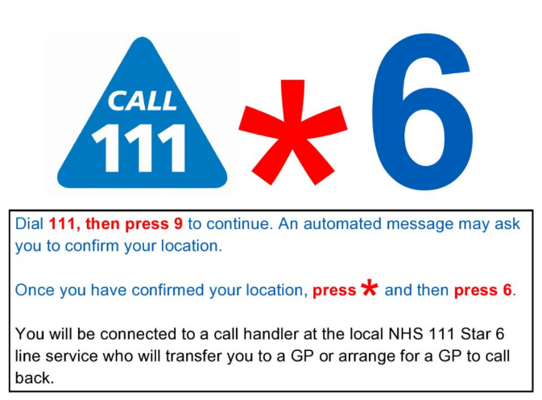

**Covid-19 Restrictions - what you can and cannot do**



Current Coronavirus restrictions: [what-you-can-and-cannot-do](https://www.gov.uk/guidance/covid-19-coronavirus-restrictions-what-you-can-and-cannot-do) (guidance updated 28th July ’21)

Further guidance on care home visiting was updated on 21st June 2021 see what this means for your area and visiting for care homes at: [Care Home Visiting](https://www.gov.uk/government/publications/visiting-care-homes-during-coronavirus/update-on-policies-for-visiting-arrangements-in-care-homes) & [Visits out of care homes](https://www.gov.uk/government/publications/arrangements-for-visiting-out-of-the-care-home/visits-out-of-care-homes) updated 19th July 2021

From 21 June, people admitted to a care home from the community no longer have to self-isolate for 14 days on arrival, so residents will have a less disruptive introduction to their new home. Care home residents will be able to spend more time with family and friends, including overnight stays as part of an easing of visiting restrictions.

Care home residents would still need to isolate for 14 days following a visit out that would be deemed high risk through a risk assessment or after an overnight stay at hospital.

[care home residents can stay overnight](https://www.gov.uk/government/news/care-home-residents-can-stay-overnight-as-visiting-restrictions-ease) (Published 14th June ’21)

**Demonstrating Covid-19 vaccination status when travelling abroad**

People in England who have had a full course of the Covid-19 vaccine will be able to demonstrate their Covid-19 vaccination status for international travel. A full course is currently two doses of any approved vaccine. [Find out more.](https://londoncommunications.cmail20.com/t/d-l-qikhte-ykhtuyiyur-m/) (guidance updated 29th July ’21)

# What’s New?

**eRedBag Pathway**

Further details will be presented at the Care Home Information Sharing webinar on Tuesday 17th August.

**Mindfulness for Life**

**Summer Readiness** 

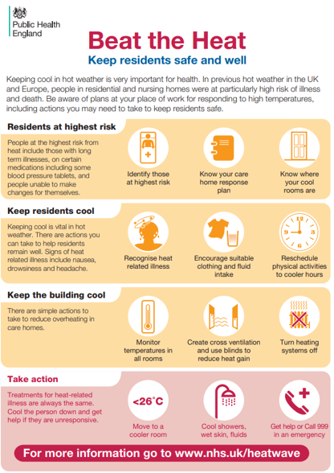

[Summer readiness - Healthy London Partnership](https://www.healthylondon.org/resource/accelerated-improvement-resources/enhanced-health-in-care-homes/seasonal-readiness/summer-readiness/)

The above link page contains useful information and resources to support care homes during warmer periods of the year, especially the summer months.

To help you feel prepared for a heatwave, read through the following ‘[Beat the Heat, keeping residents safe and well](https://www.healthylondon.org/wp-content/uploads/2019/06/Beat_the_heat_care_home_overheating_2017.pdf)’ checklist developed by Public Health England. There is more practical advice for care homes in a guide from NHS England and NHS Improvement, [Heatwave Preparedness – A guide for Care Home Providers](https://www.healthylondon.org/wp-content/uploads/2021/07/Heatwave-care-Home-Information.pdf).

Advice for care home managers and staff:

* [Heatwave plan for England – advice for care home managers and staff](https://www.healthylondon.org/wp-content/uploads/2019/06/Heatwave-Care_Home_Managers.pdf)
* [Heatwave: how to cope in hot weather](https://www.nhs.uk/live-well/healthy-body/heatwave-how-to-cope-in-hot-weather/)
* [Hydration and nutrition information](https://www.healthylondon.org/resource/accelerated-improvement-resources/enhanced-health-in-care-homes/workforce-training-and-development/hydration-and-nutrition/)

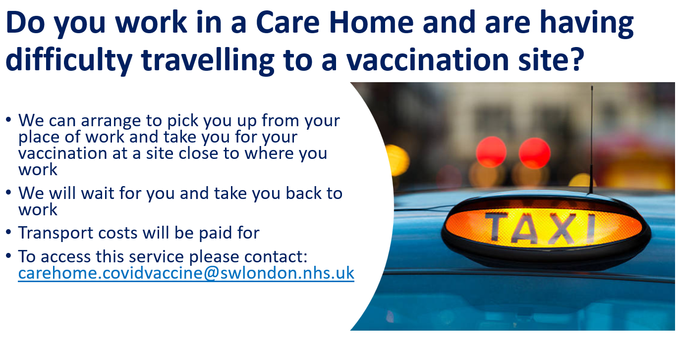

## Vaccination Guides

Version 4 of [COVID-19 vaccination: women of childbearing age, currently pregnant or breastfeeding - GOV.UK (www.gov.uk)](https://www.gov.uk/government/publications/covid-19-vaccination-women-of-childbearing-age-currently-pregnant-planning-a-pregnancy-or-breastfeeding) has been published (updated 29th July ’21)

We have also revised the COVID-19 vaccination guide for adults leaflet– [COVID-19 vaccination: guide for adults - GOV.UK (www.gov.uk)](https://www.gov.uk/government/publications/covid-19-vaccination-guide-for-older-adults) paper copies available to order now (updated 14th June ’21)

What to expect after your COVID-19 vaccination leaflet – [COVID-19 vaccination: what to expect after vaccination - GOV.UK (www.gov.uk)](https://www.gov.uk/government/publications/covid-19-vaccination-what-to-expect-after-vaccination) (updated 2nd July ’21)

COVID-19 vaccination and blood clotting collection has been revised: [COVID-19 vaccination: what to expect after vaccination - GOV.UK (www.gov.uk)](https://www.gov.uk/government/publications/covid-19-vaccination-what-to-expect-after-vaccination) (updated 2nd July ’21)

VITT investigation / management HTML is live: [Clinical investigation and management of COVID-19 vaccine induced thrombosis and thrombocytopenia - GOV.UK (www.gov.uk)](https://www.gov.uk/government/publications/clinical-investigation-and-management-of-covid-19-vaccine-induced-thrombosis-and-thrombocytopenia)

[COVID-19 vaccination and blood clotting – patient guide](https://eur01.safelinks.protection.outlook.com/?url=https%3A%2F%2Fwww.gov.uk%2Fgovernment%2Fpublications%2Fcovid-19-vaccination-and-blood-clotting%2Fcovid-19-vaccination-and-blood-clotting&data=04%7C01%7CC19guidance.SPOC%40phe.gov.uk%7C2789361d9aca4470575a08d908bd94f1%7Cee4e14994a354b2ead475f3cf9de8666%7C0%7C0%7C637550432602356397%7CUnknown%7CTWFpbGZsb3d8eyJWIjoiMC4wLjAwMDAiLCJQIjoiV2luMzIiLCJBTiI6Ik1haWwiLCJXVCI6Mn0%3D%7C1000&sdata=3RLe8GDMPL3Nk2EkuaaNVHBEA%2BW%2BevI7PVJsxdH31R4%3D&reserved=0) (**must** be given to anyone offered the AstraZeneca vaccination)

**Also, a range of COVID-19 vaccination programme publications are available to order now**

All immunisation publications are available for free from the Health Publications order line [here](https://eur01.safelinks.protection.outlook.com/?url=https%3A%2F%2Fwww.healthpublications.gov.uk%2FHome.html&data=04%7C01%7CCherstyn.Hurley%40phe.gov.uk%7C0f44129b8eeb4ba9139908d942d55f27%7Cee4e14994a354b2ead475f3cf9de8666%7C0%7C0%7C637614306446342115%7CUnknown%7CTWFpbGZsb3d8eyJWIjoiMC4wLjAwMDAiLCJQIjoiV2luMzIiLCJBTiI6Ik1haWwiLCJXVCI6Mn0%3D%7C1000&sdata=Q2KoJ%2BVxSqcKvgOAcchk%2BG%2FfBprUAEVBcvNzXwszUdk%3D&reserved=0) ([https://www.healthpublications.gov.uk/Home.html](https://eur01.safelinks.protection.outlook.com/?url=https%3A%2F%2Fwww.healthpublications.gov.uk%2FHome.html&data=04%7C01%7CCherstyn.Hurley%40phe.gov.uk%7C0f44129b8eeb4ba9139908d942d55f27%7Cee4e14994a354b2ead475f3cf9de8666%7C0%7C0%7C637614306446352074%7CUnknown%7CTWFpbGZsb3d8eyJWIjoiMC4wLjAwMDAiLCJQIjoiV2luMzIiLCJBTiI6Ik1haWwiLCJXVCI6Mn0%3D%7C1000&sdata=hS7XR5%2FuP6XmrD3Eu2WwjRNS907vLG8K%2FIiJTKNGN7Q%3D&reserved=0)). Once registered as a provider for this free service, you can also telephone: 0300 123 1002 to place bulk orders.

* People being offered a COVID-19 vaccination should also be offered the PHE/NHS patient leaflet which is the adult Phase 2 leaflet, [COVID-19 vaccination: A guide to phase 2 of the programme](https://eur01.safelinks.protection.outlook.com/?url=https%3A%2F%2Fwww.healthpublications.gov.uk%2FArticleSearch.html%3Fsp%3DSkw-COV2020351V5EN%26sp%3DSreset&data=04%7C01%7CCherstyn.Hurley%40phe.gov.uk%7C0f44129b8eeb4ba9139908d942d55f27%7Cee4e14994a354b2ead475f3cf9de8666%7C0%7C0%7C637614306446352074%7CUnknown%7CTWFpbGZsb3d8eyJWIjoiMC4wLjAwMDAiLCJQIjoiV2luMzIiLCJBTiI6Ik1haWwiLCJXVCI6Mn0%3D%7C1000&sdata=h7nR%2FQFUaQphlIuidkAuD1TNek%2BMxnNdAR7SeiP12wM%3D&reserved=0) (available to order in a choice of languages and formats including Easy Read, British Sign Language (BSL) videos, braille or large print).
* Women should be given the [COVID-19 vaccination guide for women of childbearing age, pregnant or breastfeeding](https://eur01.safelinks.protection.outlook.com/?url=https%3A%2F%2Fwww.healthpublications.gov.uk%2FArticleSearch.html%3Fsp%3DSkw-COV2020374V4%26sp%3DSreset&data=04%7C01%7CCherstyn.Hurley%40phe.gov.uk%7C0f44129b8eeb4ba9139908d942d55f27%7Cee4e14994a354b2ead475f3cf9de8666%7C0%7C0%7C637614306446362033%7CUnknown%7CTWFpbGZsb3d8eyJWIjoiMC4wLjAwMDAiLCJQIjoiV2luMzIiLCJBTiI6Ik1haWwiLCJXVCI6Mn0%3D%7C1000&sdata=eGiFWjWdq1L5Zt6NXdkyJNrgjmN610%2Bzcmm05VMTj14%3D&reserved=0).
* Anyone being offered a first or second dose of AZ vaccine should be given the [COVID-19 guide to blood clotting and vaccination](https://eur01.safelinks.protection.outlook.com/?url=https%3A%2F%2Fwww.healthpublications.gov.uk%2FArticleSearch.html%3Fsp%3DSkw-COV2021700V2%26sp%3DSreset&data=04%7C01%7CCherstyn.Hurley%40phe.gov.uk%7C0f44129b8eeb4ba9139908d942d55f27%7Cee4e14994a354b2ead475f3cf9de8666%7C0%7C0%7C637614306446362033%7CUnknown%7CTWFpbGZsb3d8eyJWIjoiMC4wLjAwMDAiLCJQIjoiV2luMzIiLCJBTiI6Ik1haWwiLCJXVCI6Mn0%3D%7C1000&sdata=hyQ%2B6tU6r8%2FooJPw%2FSu%2BDrYMjAPijylOlQOQQHTy4Us%3D&reserved=0) (currently version 2).
* At vaccination patients should be given the [What to expect after your COVID-19 vaccination leaflet](https://eur01.safelinks.protection.outlook.com/?url=https%3A%2F%2Fwww.healthpublications.gov.uk%2FArticleSearch%2C%24TablePages.linkPage.sdirect%3Fsp%3DAArticleSearch%252CtableView%26sp%3D1&data=04%7C01%7CCherstyn.Hurley%40phe.gov.uk%7C0f44129b8eeb4ba9139908d942d55f27%7Cee4e14994a354b2ead475f3cf9de8666%7C0%7C0%7C637614306446371989%7CUnknown%7CTWFpbGZsb3d8eyJWIjoiMC4wLjAwMDAiLCJQIjoiV2luMzIiLCJBTiI6Ik1haWwiLCJXVCI6Mn0%3D%7C1000&sdata=u67c0RVgYkSY6DE7a2bUDSqK11frQCRS6x8Bs4IyeBM%3D&reserved=0) as well as the PIL and record card and they should be offered a [COVID-19 vaccination sticker](https://eur01.safelinks.protection.outlook.com/?url=https%3A%2F%2Fwww.healthpublications.gov.uk%2FViewArticle.html%3Fsp%3DSihavehadmycovidvaccinationstickers&data=04%7C01%7CCherstyn.Hurley%40phe.gov.uk%7C0f44129b8eeb4ba9139908d942d55f27%7Cee4e14994a354b2ead475f3cf9de8666%7C0%7C0%7C637614306446371989%7CUnknown%7CTWFpbGZsb3d8eyJWIjoiMC4wLjAwMDAiLCJQIjoiV2luMzIiLCJBTiI6Ik1haWwiLCJXVCI6Mn0%3D%7C1000&sdata=eqj8shTZ%2FEET40RbTgLpYllAK0oGhQqGymlto7LsoyQ%3D&reserved=0).

A full list of available publications is available in [Vaccine Update Issue 322](https://eur01.safelinks.protection.outlook.com/?url=https%3A%2F%2Fwww.gov.uk%2Fgovernment%2Fpublications%2Fvaccine-update-issue-322-june-2021-covid-19-phase-2-special-edition&data=04%7C01%7CCherstyn.Hurley%40phe.gov.uk%7C0f44129b8eeb4ba9139908d942d55f27%7Cee4e14994a354b2ead475f3cf9de8666%7C0%7C0%7C637614306446371989%7CUnknown%7CTWFpbGZsb3d8eyJWIjoiMC4wLjAwMDAiLCJQIjoiV2luMzIiLCJBTiI6Ik1haWwiLCJXVCI6Mn0%3D%7C1000&sdata=8OvrbFBVqpZjWZdJmSecKTupIwF0%2FXoqB8SajK%2BzshY%3D&reserved=0) ([https://www.gov.uk/government/collections/vaccine-update](https://eur01.safelinks.protection.outlook.com/?url=https%3A%2F%2Fwww.gov.uk%2Fgovernment%2Fcollections%2Fvaccine-update&data=04%7C01%7CCherstyn.Hurley%40phe.gov.uk%7C0f44129b8eeb4ba9139908d942d55f27%7Cee4e14994a354b2ead475f3cf9de8666%7C0%7C0%7C637614306446381944%7CUnknown%7CTWFpbGZsb3d8eyJWIjoiMC4wLjAwMDAiLCJQIjoiV2luMzIiLCJBTiI6Ik1haWwiLCJXVCI6Mn0%3D%7C1000&sdata=iLqlFXlJItg0OkFuZcr1uMlFmXoeB%2FqaiH5GRfUAMug%3D&reserved=0)) and publications can be ordered for free from [https://www.healthpublications.gov.uk/Home.html](https://eur01.safelinks.protection.outlook.com/?url=https%3A%2F%2Fwww.healthpublications.gov.uk%2FHome.html&data=04%7C01%7CCherstyn.Hurley%40phe.gov.uk%7C0f44129b8eeb4ba9139908d942d55f27%7Cee4e14994a354b2ead475f3cf9de8666%7C0%7C0%7C637614306446381944%7CUnknown%7CTWFpbGZsb3d8eyJWIjoiMC4wLjAwMDAiLCJQIjoiV2luMzIiLCJBTiI6Ik1haWwiLCJXVCI6Mn0%3D%7C1000&sdata=n1SqtV5%2FDOXy8Yeeu27B73SMBUgSJMcH4baBtnkJHC4%3D&reserved=0).

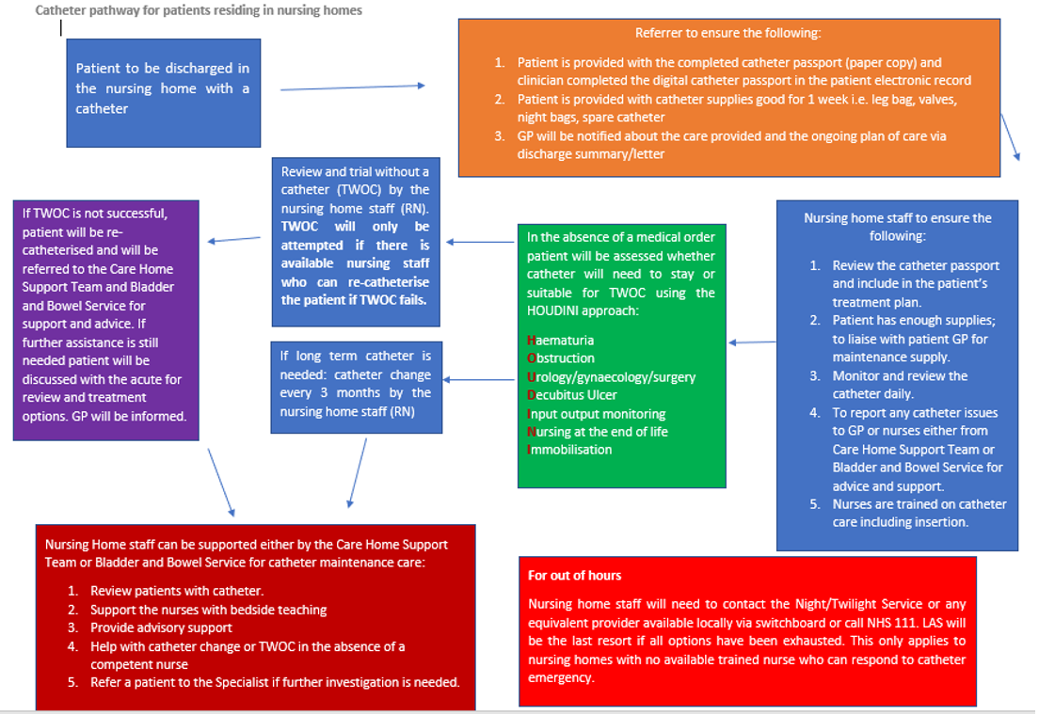**Catheter Pathway for Nursing Home residents**

We were pleased to receive a presentation from Meylene Dela Cruz, Karin Boyton and Dr Vasa Gnanapragasam covering a Catheter Pathway (slides attached), designed for use with Nursing Home residents. The team have subsequently provided an example Catheter Passport (also attached). Further information can be found at the NHS England Website:

[NHS England » Urinary catheter tools](https://www.england.nhs.uk/patient-safety/urinary-catheter-tools/) [Catheter_passport_v7.pdf (england.nhs.uk)](https://www.england.nhs.uk/wp-content/uploads/2020/08/Catheter_passport_v7.pdf)

## Care Home Champion Meeting

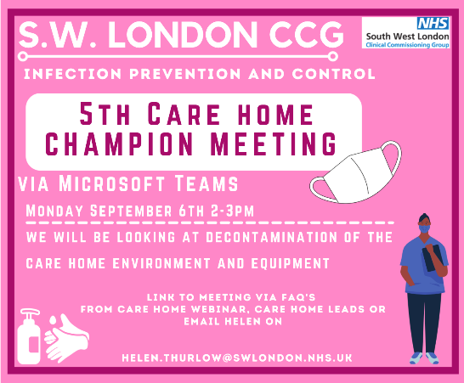

The 5thInfection Prevention and Control Care Home Champion Meeting takes place on 6th September Looking at:  Decontamination of the Care Home Environment and Equipment. This meeting is for IPC champions in each care home, and we would like the care home managers to nominate and send the invite to those people.

The session will be interactive, and we will allow time for questions and the sharing of good practice. Meetings are ongoing and monthly at this time and the aim is to offer support and training for IPC leads and/or Champions in each Care Home. You do not need to have been to first session in April to attend, this meeting is open to all IPC Leads and Champions. Please use the link below to access the meeting or contact [Helen.Thurlow@swlondon.nhs.uk](mailto:Helen.Thurlow@swlondon.nhs.uk) with any questions.

**Microsoft Teams meeting**

Join on your computer or mobile app

[Click here to join the meeting](https://teams.microsoft.com/l/meetup-join/19%3ameeting_YzFmNDVhYmMtNzgzZi00MDg2LTkwNjQtNzMxNWI3ZjRkMWEx%40thread.v2/0?context=%7b%22Tid%22%3a%22c75c680c-ebe2-4232-85b0-a365c8982c49%22%2c%22Oid%22%3a%221632d5fb-5501-4ffa-99bc-8e438cbe2668%22%7d)

Or call in (audio only)

[+44 20 3880 0300,469453404#](tel:+442038800300,,469453404)   United Kingdom, London

[0800 026 6146,469453404#](tel:08000266146,,469453404)   United Kingdom (Toll-free)

Phone Conference ID: 469 453 404#

[Find a local number](https://dialin.teams.microsoft.com/d85a2e8c-c5c9-4c0c-b518-e4b69a36da42?id=469453404) | [Reset PIN](https://mysettings.lync.com/pstnconferencing)

[Learn More](https://aka.ms/JoinTeamsMeeting) | [Meeting options](https://teams.microsoft.com/meetingOptions/?organizerId=1632d5fb-5501-4ffa-99bc-8e438cbe2668&tenantId=c75c680c-ebe2-4232-85b0-a365c8982c49&threadId=19_meeting_YzFmNDVhYmMtNzgzZi00MDg2LTkwNjQtNzMxNWI3ZjRkMWEx@thread.v2&messageId=0&language=en-US)

## 

## IPC guidance direct to your mobile

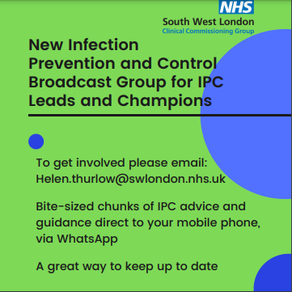

Direct information and Infection Prevention Guidance straight to your mobile.

If you would like to receive this and are an infection prevention and control lead or champion, you can access this service by emailing

[Helen.Thurlow@swlondon.nhs.uk](mailto:Helen.Thurlow@swlondon.nhs.uk)

## IPC Training offers

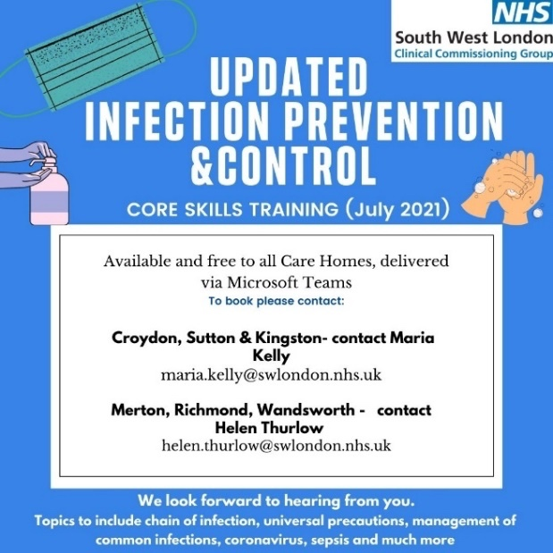

The South West London infection prevention and control team are offering two types of training to all care homes to choose from:

1. Covid-19 specific training
2. Core Skills Training

For bookings, please contact Maria Kelly for Croydon Sutton and Kingston or Helen Thurlow for Merton Richmond and Wandsworth.

## Uniform Bags

A uniform bag is a fabric bag that carries a staff member’s uniform. When staff travel to and from work, they should wear everyday clothes to prevent work clothes coming into contact with coronavirus.

The staff member then changes into the uniform for their shift. At the end of the shift, staff should change into everyday clothes and the used uniform is placed inside the uniform bag securely. When the staff member gets home, the uniform bag and uniform should be put directly into the washing machine and washed on a hot wash. The bag and uniform should then be tumble dried and/or ironed to ensure all virus particles are eliminated.

If a staff member does not have a uniform bag, pillow slips can be used instead.

If you are interested in receiving a uniform bag, please contact Paul Harper [paul.harper@swlondon.nhs.uk](mailto:paul.harper@swlondon.nhs.uk) with Care Home name, location, number of bags required and a contact.

Local charity, Merton A.R.K. (Acts of Random Kindness) have kindly donated Uniform Bags to South West London Care Homes. Pictured here are staff from Care Homes who have gratefully received bags for staff.

## Pre-Recorded COVID-19 Vaccine Q&A webinars

Please see below the link to the staff Q&A session on the Covid-19 vaccine, fertility and pregnancy:

**Recording: Staff Q&A on the Covid-19 vaccine, fertility and pregnancy**

A recording of the health and social care staff Q&A session on the Covid-19 vaccine, fertility and pregnancy is now available to view via this [YouTube link](https://youtu.be/l2kuAs1_UZ8). Questions were answered by three clinical experts:

* Helene Brown, Medical Director (System Improvement and Professional Standards) for NHS London
* Memuna Sowe, Specialist Midwife for vulnerable and marginalised women at NHS Croydon Health Services
* Garima Srivastava, Consultant Gynaecologist and fertility lead at Homerton University Hospital

## COVID 19 Vaccine Questions and Answers in English and Polish

[COVID-19 Q&A What are your Real Questions? Answers with Dr Paul Riley and Chief Pharmacist Sedina Agama](https://youtu.be/KdtRFRoLqQ0)

## Ways to Reach out to Friends and Neighbours . . .

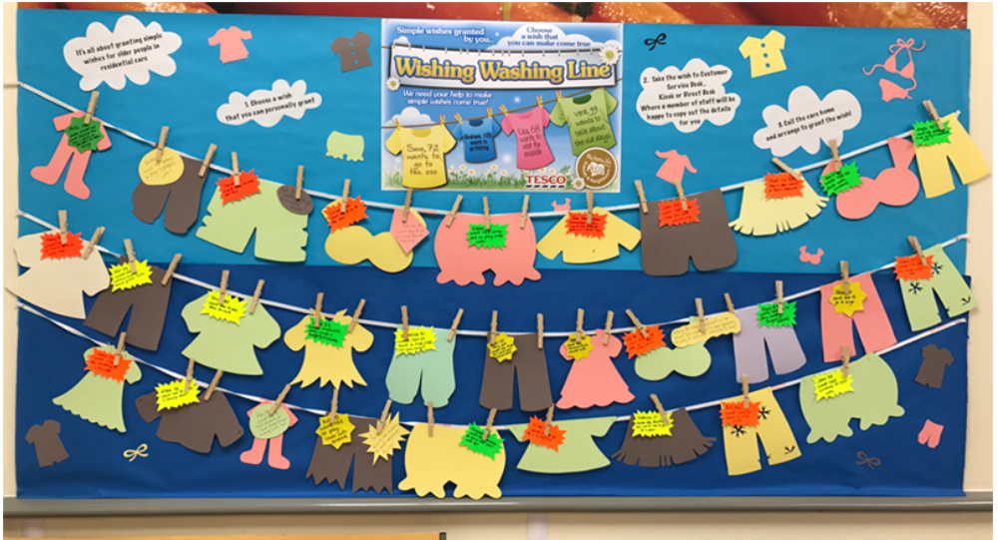

<http://carehomefans.org/fans_in_action/wishing-washing-line/>

Are you a care home wanting to start a Wishing Washing Line? Or are you a community member who could host a Wishing Washing Line in your local area? Either way, please get in touch! [mhl@city.ac.uk](mailto:mhl@city.ac.uk)

## Good thinking website for Wellbeing

## Recruitment support through The Prince’s Trust

## 

The Prince’s Trust has committed to supporting 10,000 young people aged 18-30 into Health & Social Care careers over the next four years. To take part in this programme all The Princes Trust needs is entry level roles for young people to interview for and someone interview them on recruitment day.

**For further information please contact:**

[sunny.chowdhury@princes-trust.org.uk](mailto:sunny.chowdhury@princes-trust.org.uk) or call 07773 002 863

[paul.harper@swlondon.nhs.uk](mailto:paul.harper@swlondon.nhs.uk) or call 07920 815971

**Digital**

Please also see PowerPoint slides accompanying this FAQ.

* **Case Study The impact of a cyber breach on a care service** - please see the following link to ‘Digital Social Care’.

[The impact of a cyber breach on care services - Digital Social Care](https://www.digitalsocialcare.co.uk/the-impact-of-a-cyber-breach-on-care-services/)

* **Digital Social Care Records - accredited supplier list.**

Are you thinking of purchasing a digital system for care planning and monitoring? A Digital Social Care Record (DSCR) allows the digital recording of care information and care received by an individual, within a social care setting, replacing traditional paper records. DSCRs are person-centred and enable information to be shared securely and in real-time with authorised individuals across the health and care sector.

The following suppliers have been accredited on the Dynamic Purchasing System (DPS). New suppliers will continue to join, creating a vibrant marketplace of solutions to fit the diverse needs of social care providers.

[Accredited Supplier List - Digital Social Care](https://www.digitalsocialcare.co.uk/social-care-technology/digital-social-care-records-dynamic-purchasing-system/accredited-supplier-list/)

. . . . and why not sign up to the Digital Social Care Newsletter : [Newsletter Signup - Digital Social Care](https://www.digitalsocialcare.co.uk/newsletter-signup/)

* **Capacity Tracker - weekly webinars for Care Homes**

Webinars for Care Homes with Capacity Tracker, will now take place every second Friday at 2:00pm, commencing 20th August - joining details are:

Microsoft Teams meeting

**Join on your computer or mobile app**

[Click here to join the meeting](https://teams.microsoft.com/l/meetup-join/19%3ameeting_MjVmYTJkNWQtNzYxNy00MjA1LWEwMmMtNzhjMzM0N2M3ZTc1%40thread.v2/0?context=%7b%22Tid%22%3a%227894e05b-53c3-43f7-96e0-ee7edf001f4c%22%2c%22Oid%22%3a%2217f38ef3-5ab3-4adc-a15a-e1acfe14b434%22%7d)

**Or call in (audio only)**

[+44 20 3794 0272,,38306705#](tel:+442037940272,,38306705)   United Kingdom, London

Phone Conference ID: 383 067 05#

[Find a local number](https://dialin.teams.microsoft.com/127a0e7b-f9af-419a-983f-67acd4fe55d5?id=38306705) | [Reset PIN](https://mysettings.lync.com/pstnconferencing)

* **DSPT - Bitesize Sessions**

Please see below the new dates for DSPT Bitesize sessions – anyone wishing to book onto a webinar should email the helpdesk: [nelcsu.information-governance@nhs.net](mailto:nelcsu.information-governance@nhs.net)

* Data Protection Impact Assessment **(DPIA)**
* Information Asset Register **(IAR)**
* Record of Processing Activities **(ROPA)**

|  |  |  |
| --- | --- | --- |
| **Date** | **Time** | **Topic** |
| Tuesday 17 August | 1530-1615 | **IAR** (Information Asset Register) and **ROPA** (Record of Processing Activities) |
| Friday 20 August | 1200-1300 | **DPIA** (Data Protection Impact Assessment) |

# SECTION 2: Frequently Asked Questions

### Are there recommendations for a ‘Digitalised Social Care Record’ system, which is working well in care homes ?

I can partly answer this question. ‘Digital Social Care’ have a shortlist of accredited providers (see the digital section above and the following link : [Accredited Supplier List - Digital Social Care](https://www.digitalsocialcare.co.uk/social-care-technology/digital-social-care-records-dynamic-purchasing-system/accredited-supplier-list/)). The link contains a short video on each system and this list will grow as more providers are accredited.

In terms of what works best, we would like to know from providers who already use Digital Social Care Records (we know about 50 homes across South West London are using a digital care planning system). We are also about to start a piece of work to understanding the appetite of care providers to adopt a digital record system, identify any barriers (and I note the point raised during the webinar, that ‘it is hard to make those staff to agree to a digital care planning system when they have worked with conventional systems. Some staff have low computer literacy’). We want to work with care homes to facilitate access to digital social care records and that may well include support with staff awareness and training.

### Can a relative complete a test at home and bring evidence to the care home?

Yes, a relative can complete an LFT test from home, these can be collected from any local pharmacy or ordered online from [Order coronavirus (COVID-19) rapid lateral flow tests - GOV.UK (www.gov.uk)](https://www.gov.uk/order-coronavirus-rapid-lateral-flow-tests)

The relative will need to report the result here <https://www.gov.uk/report-covid19-result> and show an email response showing the negative result to the care home.

In some instances taking a test at home is preferable as this will avoid delays or overcrowding at the home.

### I have problems with getting to a vaccination site and so what can I do?

***We can help:***

* We can arrange to pick you up from your workplace and take you for your vaccination at a site close to where you work
* We will wait for you and take you back to work
* Transport costs will be paid for

Please get in touch via: [carehome.covidvaccine@swlondon.nhs.uk](mailto:carehome.covidvaccine@swlondon.nhs.uk)

### I only want one type of vaccine; how can I arrange this?

If you contact carehome.covidvaccine@swlondon.nhs.uk you will be offered further information and advice about the vaccines and the vaccination sites

### How do we order more Red Bags?

Please contact your locality lead, who will be able to obtain additional Red Bags. Alternatively contact [paul.harper@swlondon.nhs.uk](mailto:paul.harper@swlondon.nhs.uk)

### Where can we access training for RESTORE2

You can arrange RESTORE2 training through locality training leads:

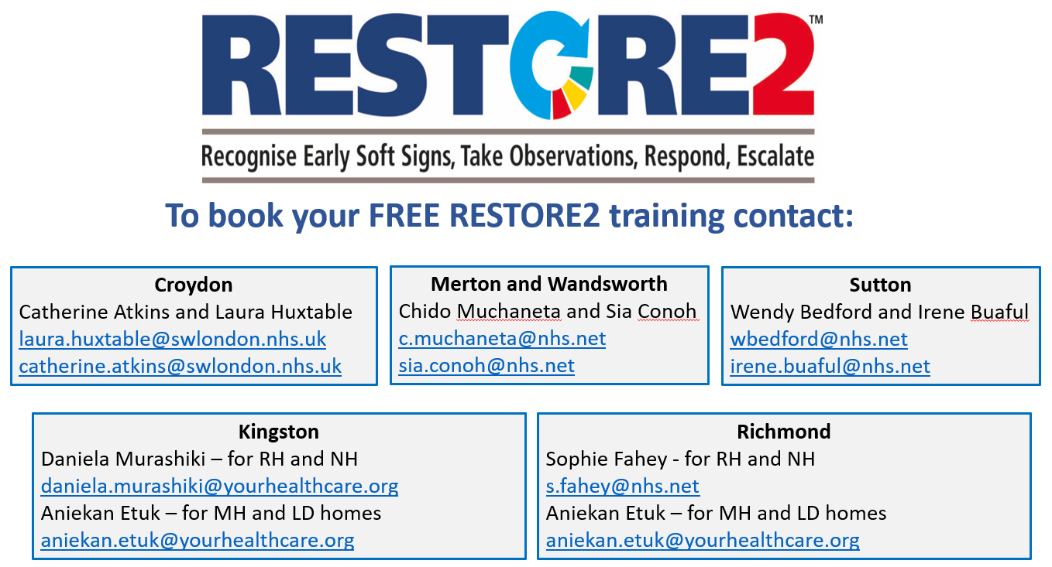

Alternatively, you can contact Jules Sleater (Project Manager) - [jules.sleater@swlondon.nhs.uk](mailto:jules.sleater@swlondon.nhs.uk) or Becky Caicedo (Project Support) - [becky.caicedo@swlondon.nhs.uk](mailto:becky.caicedo@swlondon.nhs.uk)

### How can care homes access the MKad link?

The Mad link can be found at: [Make A Difference (MKAD) - South West London CCG (swlondonccg.nhs.uk)](https://swlondonccg.nhs.uk/contact-us/swl-make-a-difference/)

### Regarding the government’s plans to stop wearing masks. Does this apply to care homes? E.G Do staff still have to wear masks around the home at all times.

We are still working to the guidance Working Safely in Care Homes last updated 9th June 2021 which requires staff to wear PPE including masks. <https://www.gov.uk/government/publications/covid-19-how-to-work-safely-in-care-homes> it is likely that this guidance will be updated to indicate the requirements within the care home setting. It will be updated through the gov.uk website and any updates will be included in the following FAQ’s and sent out on the IPC broadcast group.

### What is the next step for Care Homes with visiting following 19/07/2021. Do we need to continue all tests in situ as well as for visitors?

We are still working to the guidance “How to work safely in care homes” last updated 9th June 2021 which indicates the testing required for care home staff and for residents. <https://www.gov.uk/government/publications/covid-19-how-to-work-safely-in-care-homes> it is likely that this guidance will be updated to indicate the requirements within the care home setting. It will be updated through the gov.uk website and any updates will be included in the following FAQ’s and sent out on the IPC broadcast group.

### When will we get more detail about the easing of restrictions/visiting, my phone has not stopped calling from relatives asking if they still have to book and go to a designated room etc?

### The guidance on Care Home Visiting was updated on 16th July

[Guidance on care home visiting - GOV.UK (www.gov.uk)](https://www.gov.uk/government/publications/visiting-care-homes-during-coronavirus/update-on-policies-for-visiting-arrangements-in-care-homes)

### I have an NHS email for the care home, is there a way to directly open the care home NHS email?

If you would like further support with NHS Mail, please email [SWLcarehomes.admin@swlondon.nhs.uk](mailto:SWLcarehomes.admin@swlondon.nhs.uk) and the team will aid with your queries.

### I am a manager of a Care Home and I have really tried to encourage my staff to have the vaccine, with several supervision sessions but I don’t know what else I can do for those staff who won’t have it?

People have many reasons for declining a vaccine; if you can talk to your member of staff and find out the reasons they are declining. You can ask the member of staff to speak to a clinician they trust to enable them to make an informed decision. We are aware that it has been developed to protect us from the Covid-19 virus and it is important for Care Home staff to have the vaccine.

As a manager, it is good practice to have a 1 to 1 meeting with each staff member who has declined the vaccine to discuss their concerns, ensure they are making the decision based on facts, undertaking a risk assessment and documenting these discussions and actions. To support you as a manager, we have developed a 1 to 1 interview pack for managers to use with staff who are vaccine hesitant. The Pack has been sent out with previous FAQs if you have not yet received it please email [carehome.covidvaccine@swlondon.nhs.uk](mailto:carehome.covidvaccine@swlondon.nhs.uk) and it can be sent to you.

**We strongly encourage you to use this pack with any staff who are refusing the vaccine so that you are protecting the staff and that you are providing evidence as a manager of the support that you have given.**

Staff should be encouraged to speak to someone about the vaccine – they can phone Nurse Fiona White on 07770684842 and she will be happy to answer any of their concerns and questions. There is a consultation about vaccinations and care homes currently in progress. The covid-19 vaccine helps prevent the risk of hospitalisation and decreases the complications to the person, family members and clients, staff you work with. No vaccine is 100% effective so it may not prevent you getting the virus, but evidence is currently showing it can reduce transmission and complications. Fiona has offered to speak to anyone who needs help deciding.

### Is it mandatory for non CQC registered care home staff to have the vaccine?

From 11th November 2021, new regulations will require all care home workers, and anyone working or volunteering inside the indoor premises of a CQC-regulated care home providing nursing or personal care, to be fully vaccinated against COVID-19 (for a two dose vaccine that would mean both doses), unless they have a medical exemption.

The regulation does not currently include non CQC registered homes but a proposal is being put forward to Parliament to make full vaccination a condition of deployment in all patient facing healthcare roles which will likely include non CQC registered homes. It is good practice to ensure and encourage maximum vaccination amongst all health and social care staff in preparation for the Health act to be changed and this regulation to be passed.

### What is the timeline for someone who has had covid before they can be vaccinated?

28 days after the positive test and feeling well. However, if you are still feeling unwell wait until feeling well again. It is explained in this guidance: <https://assets.publishing.service.gov.uk/government/uploads/system/uploads/attachment_data/file/999527/COVID-19_vaccination_programme_guidance_for_healthcare_workers_6July2021_v3.9.pdf>

### Student staff due to work with us but have another placement due in 5 weeks’ time. Does the guidance still state that those who work in placements cannot work in care homes?

Yes, the guidance was last updated in March. It states “to reduce the risk of infections and outbreaks in care homes, providers should not deploy staff to provide nursing care or personal care if those individuals are also providing a regulated activity in another setting. This is for both permanent and temporary staff, including agency and bank staff, staff who work across multiple sites for the same employer and staff who work for more than one health and social care provider”. <https://www.gov.uk/government/publications/restricting-workforce-movement-between-care-homes-and-other-care-settings/restricting-workforce-movement-between-care-homes-and-other-care-settings>

### Is it possible to have a medical exemption for new employees to not wear a face mask in care home?

As it stands, staff should continue to wear PPE including face masks as per the How to Work Safely in care homes guidance.

### Recording overseas vaccinations

This [guidance from Public Health England](https://assets.publishing.service.gov.uk/government/uploads/system/uploads/attachment_data/file/988091/COVID-19_vaccination_programme_guidance_for_healthcare_workers_20_May_2021_v3.7.pdf) (updated 6th July), summarises the status of a variety of vaccines available in the UK and overseas. This includes clinical guidance on whether an individual needs further doses in England and if so, which type of vaccine is recommended to complete the course. It is not recommended that vaccine courses are repeated just so that individuals can be included in the NHS Covid Pass. Extra doses which are not required from a clinical perspective may lead to increased side effects.

Currently there is not a central mechanism for capturing details of overseas Covid vaccines, and only vaccines delivered in the UK can be accepted as evidence for UK Covid certification/ the NHS Covid Pass. A technical solution to support the recording of vaccinations overseas in the NHS immunisation management service (NIMS) is in development, and we will provide an update as soon as possible. In the meantime, if someone has had their first dose outside of the UK, in England they should be directed to a walk-in clinic which administers the same brand of vaccine they have had for their first dose, or a GP practice (especially if they have had a brand of vaccine not available in the UK) to arrange their second dose.

Patients should be told that at this time, only vaccines delivered in the UK will count towards UK Covid certification and that the NHS is working on a solution.

If a patient registered with a GP in England makes you aware they have had a vaccination overseas, it is also good practice for GPs to record the details as free text in the clinical notes section of the patient’s GP record. The vaccination can be coded as a first or second dose, but type of vaccine will not be able to be coded as only vaccines given in the UK have SNOMED codes. Overseas vaccinations should not be added to the Pinnacle (Outcomes4Health) point of care system as this will result in incorrect GP payments.

1. **staff who have had Johnson and Johnson vaccine abroad (not recognized just yet in the UK) are they considered fully vaccinated**

Janssen is a pharmaceutical company of Johnson and Johnson so the vaccine names are often used interchangeably. In the UK four vaccines are recognised for the purposes of obtaining an NHS COVID Pass:

·         those over 18 can obtain an NHS COVID Pass if they are two weeks after completing a full course of vaccination. A full course is accepted as either 2 doses of Moderna, AstraZeneca or Pfizer vaccine or 1 dose of Janssen vaccine (according to the Medicines and Healthcare products Regulatory Agency authorised schedule). <https://www.gov.uk/guidance/nhs-covid-pass>

This would therefore be considered a recognised vaccine in the UK. See response to question 2 on evidence of vaccination abroad or as part of a trial

1. **staff who have had Pfeizer/AZ/Moderna abroad - what proof do they need to show to care home managers as this is not going to appear in the NHS app?**

If a patient has received any Covid vaccination outside of the NHS i.e. at an embassy, abroad or as part of a research study, then the patient should contact that organisation for written confirmation. Alternatively, they can ring 119 for further advice

1. **do you know when Johnson and Johnson vaccine is coming to UK**

The Johnson and Johnson (Janssen) single-shot vaccine has now been authorised in the UK (28th May 2021) but supplies won’t be available for several more months. We don’t as yet have an exact date for expected supply. The government are running a blog which is regularly updated and is worth monitoring for up-to-date information:

<https://healthmedia.blog.gov.uk/2021/06/25/covid-19-vaccines-frequently-asked-questions/>

### Can a resident go to the theatre?

[Visits out of care homes - GOV.UK (www.gov.uk)](https://www.gov.uk/government/publications/arrangements-for-visiting-out-of-the-care-home/visits-out-of-care-homes) The guidance lays out the process for planning and risk assessing visits out of the care home. Any risk out of the home will be a potential risk to exposure to Covid-19. A risk assessment will help mitigate the risks considering issues like wearing a fluid resistant mask, hand hygiene, social distancing where possible, good ventilation and avoiding public transport where possible. Also helpful is to establish the individual’s vulnerability and how likely they will be able to understand and follow good IPC precautions.

If you wish, then contact the IPC team to help review your risk assessment.

### Do you have a helpline for those staff who have fears over allergies due to having had reactions in the past from other vaccines, medication and food?

Not specifically. If staff contact the hub we can arrange for a visit to one of the vaccination sites to have a discussion with a clinician. Alternatively, we have been told that vaccination sites are happy to have a conversation if someone turns up and would like a conversation :

**BEREAVEMENT AND WELLBEING SUPPORT FOR STAFF**

|  |  |  |
| --- | --- | --- |
| **Borough** | **Name of Service** | **Contact Details** |
| All SWL | Marie Curie | Call 020 7091 3656 for emotional and bereavement support.  Monday – Friday, 08:00 – 18:00  Saturday – Sunday, 11:00 – 17:00 |
| Sutton | Sutton Uplift | Telephone hotline (8 am – 5 pm): 020 3513 4044  Self-referral: <https://www.suttonuplift.co.uk/psychological-therapies>  Email: [ssg-tr.suttonuplift@nhs.net](mailto:ssg-tr.suttonuplift@nhs.net) |
| Merton | Merton Uplift | Telephone hotline (9 am – 5 pm): 020 3513 5888  Self-referral: <https://www.mertonuplift.nhs.uk/>  Email: [ssg-tr.mertonuplift@nhs.net](mailto:ssg-tr.mertonuplift@nhs.net) |
| Wandsworth | Talk Wandsworth | Telephone hotline (8 am – 5 pm): 020 3513 6264  Self-referral: <https://www.talkwandsworth.nhs.uk/>  Email: [ssg-tr.WANIAPT@nhs.net](mailto:ssg-tr.WANIAPT@nhs.net) |
| Kingston and Richmond | Bereavement Support  iCope (Kingston only)  Richmond Wellbeing Service | <https://www.kingstonbereavementservice.org.uk/contact-us/>  <https://www.icope.nhs.uk/kingston/>  <https://www.richmondwellbeingservice.nhs.uk/> |
| Richmond | Cruse | Tel: 0749 5776 401 |

**EOLC CLINICAL SUPPORT FOR STAFF**

|  |  |  |  |  |
| --- | --- | --- | --- | --- |
| **Provider Service** | **Borough** | **What is on Offer** | **Operating Hours** | **Contact Details** |
| St Raphael’s Hospice | Sutton and Merton | Clinical Advice from Clinical Nurse Specialist on triage team.  Access to Medical team advice.  Clinical Advice from Palliative Care Nurses covering inpatient wards. | Monday - Sunday  09:00-17:00  Monday-Sunday  17:00-09:00 | Central Hospice Switch:  020 8099 7777    Ask for CNS triage team.    Ask for inpatient unit. |
| Royal Trinity Hospice | Wandsworth | A Clinical Nurse Specialist to provide expert advice and support for GPs, HCPs, patients and carers.  Medical on call cover (Registrar and Consultant) | 24 hours a day, 7 days a week | Central Hospice Switch:  020 8099 7777    Ask for CNS triage team.  Ask for inpatient unit. |

|  |  |  |  |  |
| --- | --- | --- | --- | --- |
| Marie Curie | All SWL Boroughs | Professional Information and Support | Monday – Friday  08:00 – 18:00  Saturday – Sunday  11:00–17:00 | Tel: 020 7091 3656  [www.mariecurie.org.uk/southwestlondon](http://www.mariecurie.org.uk/southwestlondon) |
| Princess Alice Hospice | Richmond and Kingston | Careline which has a triage process with access to senior staff and Community Nurse’s | 24 hours a day, 7 days a week | Tel: 020 8744 9414 |
| St Christopher’s Hospice | Croydon | Professionals’ helpline for clinical support  Patient support line | 24 hours a day, 7 days a week | Professionals: 020 8767 4582  Patients: 020 8767 4500 |

# 

# Section 3: Additional information

## Infection Control Champions for Care Homes

Please contact Helen Thurlow ([infectioncontrol@swlondon.nhs.uk](mailto:infectioncontrol@swlondon.nhs.uk)) with the details of any individual who would like to become an IPC Champion.

## Contact details for advice and support for mental health and wellbeing.

The Health and Wellbeing of staff in the care sector is available online at: <https://www.good-thinking.uk/>

This website has links to useful apps quizzes workbooks and advice. There are 4 free apps at present. If you register on the app now you can have lifetime access to meditation sessions, mindfulness, cognition exercises and other podcasts that help with improving wellbeing.

## Support for Managing Residents with Dementia

NHS England have just published a guide for Dementia wellbeing in the COVID-19 pandemic.  This provides single page support pages for supporting people with Dementia. The document is attached and is available via the following links: <https://www.england.nhs.uk/mental-health/resources/dementia/>  
<https://www.england.nhs.uk/coronavirus/community-social-care-ambulance/mental-health/>

# SECTION 4: ONGOING ADVICE AND SUPPORT

### Support for EOLC from Hospice UK

Hospice UK have released a support pack. You can access the guidance at: <https://www.hospiceuk.org/what-we-offer/clinical-and-care-support/clinical-resources>

### What to do if a resident has coronavirus symptoms

Isolate the resident in their own room and away from other residents for 14 days. Close the door if possible or consider moving the resident's bed 2m away from the door. The resident should preferably have a room with an en-suite. If this is not possible then the resident will need to use a commode. Contact the resident’s GP, or access 111 services online. **For a medical emergency dial 999.** If ONE resident displays COVID symptoms you need to contact the South London Health Protection Team/London COVID Response Cell (LCRC) to advise them of a suspected outbreak.

|  |  |
| --- | --- |
| SWL Health Protection Team | 0344 326 2052 |
| London COVID-19 Response Cell | 0300 303 0450 / [phe.lcrc@nhs.net](mailto:phe.lcrc@nhs.net) |

### If PPE is running low in your Care Home

From the 6th November 2020 it had been agreed that CQC registered organisations in primary and social care should access the national PPE portal for their stock requirements.

The PPE portal can be found at <https://www.gov.uk/guidance/ppe-portal-how-to-order-emergency-personal-protective-equipment> (updated 18th May ’21) and we have attached an FAQs document which has been shared with us for your information. You will need to register on this portal first.

From this week social care organisations, including Care Homes, should utilise the national PPE portal as its primary supply of PPE. If organisations have difficulty in securing PPE stocks the steps they should take are:

(1) PPE Portal

(2) Local Resilience Forum

(3) BAU Suppliers

(4) South West London Mutual Aid via <http://swlpp.uk> online access.

South West London Mutual Aid will be updating their agreement with you and will contact you directly.

### NICE guidelines on Safeguarding adults in care homes



This final guideline has now been published on the [NICE website](https://www.nice.org.uk/guidance/NG189).

The guideline is for care home providers, commissioners of care homes, safeguarding practitioners, local authorities and safeguarding boards. It may also be useful to anyone who lives, works or visits care homes.

* [induction and training](https://www.nice.org.uk/guidance/ng189/chapter/Recommendations#induction-and-training-in-care-homes)
* [care home culture and management](https://www.nice.org.uk/guidance/ng189/chapter/Recommendations#care-home-culture-learning-and-management)
* [indicators of individual abuse and neglect](https://www.nice.org.uk/guidance/ng189/chapter/Recommendations#indicators-of-individual-abuse-and-neglect)
* immediate actions to take if you [consider](https://www.nice.org.uk/guidance/ng189/chapter/Recommendations#immediate-actions-to-take-if-you-consider-abuse-or-neglect) or [suspect](https://www.nice.org.uk/guidance/ng189/chapter/Recommendations#immediate-actions-to-take-if-you-suspect-abuse-or-neglect) abuse or neglect
* [how care home safeguarding leads and local authorities should respond to reports of abuse or neglect](https://www.nice.org.uk/guidance/ng189/chapter/Recommendations#responding-to-reports-of-abuse-or-neglect)
* [indicators of organisational abuse and neglect](https://www.nice.org.uk/guidance/ng189/chapter/Recommendations#indicators-of-organisational-abuse-and-neglect)

It includes summary versions of indicators to help practitioners identify abuse and neglect relating to [individuals](https://www.nice.org.uk/guidance/ng189/resources/indicators-of-individual-abuse-and-neglect-pdf-9013017709) and indicators of [organisational](https://www.nice.org.uk/guidance/ng189/resources/indicators-of-organisational-abuse-and-neglect-pdf-9013017710) abuse and neglect.

## APPENDIX 1: Useful Links and Contacts

#### NHS MAIL

NHS Mail is available free to all Care Homes allowing personal identifiable information to be sent securely to NHS services.  NHS Mail also allows access to Microsoft Teams which has video conferencing facilities, to connect with GPs, Health Care staff and the resident’s family.

If you need help to access, please contact: [SWLcarehomes.admin@swlondon.nhs.uk](mailto:SWLcarehomes.admin@swlondon.nhs.uk)

Most of you will have your NHS mail account now and we really want you to use your NHS shared mailbox now as this is the way the NHS will now contact you using the shared mailbox. We will be setting some deadlines for that with your local leads. The shared mailbox does keep your data secure and accessible, and everything is in one place. We are sending out certificates so you can email your care home email lead or [SWLcarehomes.admin@swlondon.nhs.uk](mailto:SWLcarehomes.admin@swlondon.nhs.uk) from your shared mailbox, we will send you a certificate.

#### CAPACITY TRACKER

All Care Homes are being asked to submit **daily** information on staffing, bed vacancies, number of COVID cases and PPE or when the situation changes so that the NHS can support your homes more effectively.

If you are not yet set up, or have more questions, please contact your local lead listed on the front of the FAQ. Please complete the ASC fund questions **weekly**. Contact 03005550340 or 01916913729 8am to 8pm if you have any questions or need support with this.

#### WORKFORCE AND STAFFING

COVID is a challenging time for maintaining staffing levels in Care Homes. We have a project running with Princes Trust to provide Care Support Workers, Domestic and administrative staff into Care Homes.  If you would like some support, please contact Paul Harper at: [paul.harper@swlondon.nhs.uk](mailto:paul.harper@swlondon.nhs.uk)

OTHER USEFUL LINKS

|  |  |
| --- | --- |
| **Topic** | **Click Links below** |
| The phone number for the IT Helpdesk is **020 3880 0268**. Open during 09:00 – 17:00. | [Information for free digital tools from Digital Social Care](https://www.digitalsocialcare.co.uk/covid-19-guidance/free-digital-tools-resources-for-covid-19/) |
| **PPE Portal help line number**: 0800 876 6802 | [How to order COVID-19 PPE](https://www.gov.uk/guidance/ppe-portal-how-to-order-covid-19-personal-protective-equipment)  [PPE resource for care workers](https://www.gov.uk/government/publications/covid-19-how-to-work-safely-in-care-homes/personal-protective-equipment-ppe-resource-for-care-workers-working-in-care-homes-during-sustained-covid-19-transmission-in-england)  [How to correctly don and doff of PPE in Care Homes](https://www.gov.uk/government/publications/covid-19-how-to-work-safely-in-care-homes/covid-19-putting-on-and-removing-ppe-a-guide-for-care-homes-video) |
| **Swabbing Residents Staff and Visitors** | [Coronavirus Testing process and how to register LFD Test](https://www.gov.uk/guidance/coronavirus-covid-19-getting-tested#care-home)  [Online Swabbing competency assessment](https://genqa.org/carehomes) |
| **Admissions and Care** | [COVID-19 Admission and Care of Residents in Care Homes](https://www.gov.uk/government/publications/coronavirus-covid-19-admission-and-care-of-people-in-care-homes/coronavirus-covid-19-admission-and-care-of-people-in-care-homes#section-1-admission) |
| **Infection Prevention and Control Guidance** | [Infection Prevention and Control Recommendations](https://assets.publishing.service.gov.uk/government/uploads/system/uploads/attachment_data/file/954690/Infection_Prevention_and_Control_Guidance_January_2021.pdf) |
| **Advice for pregnant health care workers** | [Pregnant employees COVID-19 advice](https://www.gov.uk/government/publications/coronavirus-covid-19-advice-for-pregnant-employees/coronavirus-covid-19-advice-for-pregnant-employees) |
| **Travel and self-isolation** | [Travel Corridors](https://www.gov.uk/guidance/coronavirus-covid-19-travel-corridors) |