

**NHS South West London CCG**

**Covid-19 and Care Homes - Frequently Asked Questions**

**Information Sharing Infection Prevention and Control Webinar: Tuesday 13th July 2021**

Dear Social Care Colleagues,

Thank you for attending the Webinar for Care Homes this week; we hope that these continue to support you during the Covid-19 pandemic.

Thank you, too, for all your hard work to support your staff to take up the Covid-19 vaccine.

You may be aware the Delta variant is the most predominant COVID-19 strain circulating in the UK at present. Cases of infection have been increasing in South West London. Vaccinations are now available to all adults over 18.

We continue to focus on maintaining the SAGE safety thresholds of 90% vaccination rates among residents and 80% vaccination rates among all staff directly employed, bank and agency. SAGE is the government’s scientific advisory group for emergencies. We will continue to work alongside homes which have not yet achieved these targets.

As we move to the 19th July, the NHS and councils in London are working to ensure maximum vaccination uptake across London, so that all people can be protected from Covid 19 when restrictions are lifted. As part of this, we are reaching out to you to offer further support to reach the SAGE safety thresholds. With that in mind, you may already have been or will shortly be contacted.

The COVID-19 pandemic is an extremely challenging situation globally and we recognise that this is the case for staff working in Care Homes of all types. We are offering our support in many different ways, and one of these is through running a weekly Infection Prevention and Control and Information Sharing webinar Tuesday mornings at 11am. It is possible to ask questions during the webinar. If you have questions in advance, please email your local CCG Care Home Lead, listed below.

We would like to thank you all for your hard work and commitment during this incredibly challenging time.

**Please share this document weekly with all staff in the Care Home.**

With best regards

Viccie Nelson

**Associate Director of Transformation**

**NHS South West London CCG**

Your CCG Care Home Leads are:

Croydon Trisha Wallace [trisha.wallace@swlondon.nhs.uk](mailto:trisha.wallace@swlondon.nhs.uk)

Kingston and Richmond Brian Roberts [brian.roberts@swlondon.nhs.uk](mailto:brian.roberts@swlondon.nhs.uk)

Merton Tayo Fowewe [Kudirat.Fowewe@swlondon.nhs.uk](mailto:Kudirat.Fowewe@swlondon.nhs.uk)

Sutton Lucy Webber [Lucy.Webber@swlondon.nhs.uk](mailto:Lucy.Webber@swlondon.nhs.uk)

Wandsworth Anca Costinas [Anca.Costinas@swlondon.nhs.uk](mailto:Anca.Costinas@swlondon.nhs.uk)

**Please note email address for the Infection Control Team:** [infectioncontrol@swlondon.nhs.uk](mailto:infectioncontrol@swlondon.nhs.uk)

Table of Contents

Covid-19 vaccination for Care Home staff 4

Opening times and Vaccine Centers for walk in 5

Second COVID-19 Vaccine Doses 5

New Guidance for first dose Astra Zeneca (Oxford) Covid-19 Vaccine 6

Supporting Staff with Vaccine Hesitancy 6

SECTION 1: Updated Guidance 24/06/21 6

Personal Protective Equipment 6

Polyethylene glycol (PEG) 7

111*6 7

What’s New? 9

Vaccination Guides 9

Care Home Champion Meeting 10

IPC guidance direct to your mobile 10

IPC Training offers 11

Uniform Bags 11

Pre-Recorded COVID-19 Vaccine Q&A webinars 12

COVID 19 Vaccine Questions and Answers in English and Polish 12

Ways to Reach out to Friends and Neighbours 12

Good thinking website for Wellbeing 12

Recruitment support through The Prince’s Trust 12

Upcoming Webinars 13

SECTION 2: Frequently Asked Questions 14

1. The Prime Minister said that the government expects and recommends face masks in public settings after the 19th. Could this be considered for care homes? 14

2. What happens if care homes are unable to meet the SAGE guidelines for levels of vaccine uptake? 14

3. Can we make allowance for staff with natural antibodies? 14

4. So we continue LFD with visitors and temperature checks? 14

5. Is there anything else that can be done to help overcome potential barriers to achieving the SAGE safety targets? 14

6. Regarding the government’s plans to stop wearing masks. Does this apply to care homes? E.G Do staff still have to wear masks around the home at all times. 15

7. How long do you anticipate we continue with the twice daily temp, SATs and pulse checks on our residents? 15

Section 5.1 outlines the current guidance 15

8. What is the next step for Care Homes with visiting following 19/07/2021. Do we need to continue all tests in situ as well as for visitors? 15

9. Has there been any news on booster jabs for staff and residents who got their jabs last year? 16

10. We have a new resident discharged to community from hospital then comes to care home within 14 days of discharge but hospital ward confirmed there was no covid on ward and they have negative PCR do they still have to self-isolate? 16

11. If staff have to go to the hospital overnight due to illness do they need to isolate at home? 16

12. We have a service user who is in hospital since last week. The hospital will conduct a covid test on the day of discharge. On their return, if the result is negative, do they still need to isolate? All residents are being tested weekly in addition. 16

13. When will we get more detail about the easing of restrictions/visiting, my phone has not stopped calling from relatives asking if they still have to book and go to a designated room etc? 17

14. We really want to start small outings again (picnic in the park via minibus etc.) How do you feel about that? 17

15. Is there any data on how many of those in hospital are double vaccinated/single vaccinated/not vaccinated? 17

16. Can you send the link to the new guidance on reducing staff movement in care homes please? 17

17. Do we know whether residents will be able to go out unescorted after the 19th? – In relation to residential younger adults home please? 17

18. I have one resident who will hit out at the nurses if they try to give her the vaccine but her daughter wants the resident to have it, the GP is aware and said they cannot intervene with this. I have one other resident whose daughter doesn’t want her to have the vaccine but the resident will let the nurses give her the vaccine. This resident’s daughter doesn’t have LPOA so she can still make that decision, again the GP is aware but said he cannot intervene. These are the only 2 residents in the home that are not vaccinated. 17

19. I have a resident who has had one vaccine and now needs their second but our GPs are no longer vaccinating in homes. Do I book a place at the local hub and take the resident there? 17

20. As society opens up is there support on communicating ‘collective responsibility for keeping people safe’ as people so often focus only on their visit to their loved one rather than risk to a community of people. How can we make the message more positive? 18

21. My staff member had their 1st covid jab last Wed at the Fairfield Halls drop in and was advised to book 2nd jab in 3-12 week’s, but he doesn't know how to or who to contact. Will they contact him? 18

22. How reliable and effective is the PCR test that we are doing for the NHS as we cannot use the negative result in travelling? 18

23. Our IPC lead has left, she has trained us, but will there be more training? 18

24. Four of our staff decided to resign once Covid19 vaccination become mandatory. I am struggling to recruit new staff; one new staff alone didn't come back to work post 1 day shift. Most people I interview wants flexible shift after 9am to 2pm.  Could you help us with recruitment support (the local authority has supported in the past). 18

25. The costs associated with DSPT (NHS Data Security and Protection Toolkit) are significant . . . 18

26. If a resident would like to stay at a relative’s home overnight and the care home deems it is safe, will the resident need to self-isolate on return? 19

27. If Vaccinations become mandatory, are we allowed to accept aromatherapist in our home once they have 1st and 2nd dose? 19

28. We have a family member who wants to obviously ensure that all staff are vaccinated working with their elderly family member. We have agency staff who are not vaccinated. On these grounds can we refuse shifts to these workers? 19

29. Advice on new symptoms? 19

30. Do I need to complete Data Security and Protection Toolkit (DSPT)? 19

31. I have an NHS email for the care home, is there a way to directly open the care home NHS email? 19

32. I am a manager of a Care Home and I have really tried to encourage my staff to have the vaccine, with several supervision sessions but I don’t know what else I can do for those staff who won’t have it? 20

33. What is the updated care home visiting guidance? 20

Section 3: Additional information 21

Infection Control Champions for Care Homes 22

Contact details for advice and support for mental health and wellbeing. 22

Support for Managing Residents with Dementia 22

SECTION 4: ONGOING ADVICE AND SUPPORT 22

Support for EOLC from Hospice UK 22

What to do if a resident has coronavirus symptoms 22

If PPE is running low in your Care Home 22

NICE guidelines on Safeguarding adults in care homes 23

APPENDIX 1: Useful Links and Contacts 23

## Covid-19 vaccination for Care Home staff

**The way you book an appointment is changing**

**Care Home Staff Walk in service**

Currently, Care Home staff can book at the national booking sites or attend as walk-ins. Please see the table below for the venues, addresses, vaccine type and times of the clinics. The national booking link is: <https://www.nhs.uk/conditions/coronavirus-covid-19/coronavirus-vaccination/book-coronavirus-vaccination/>

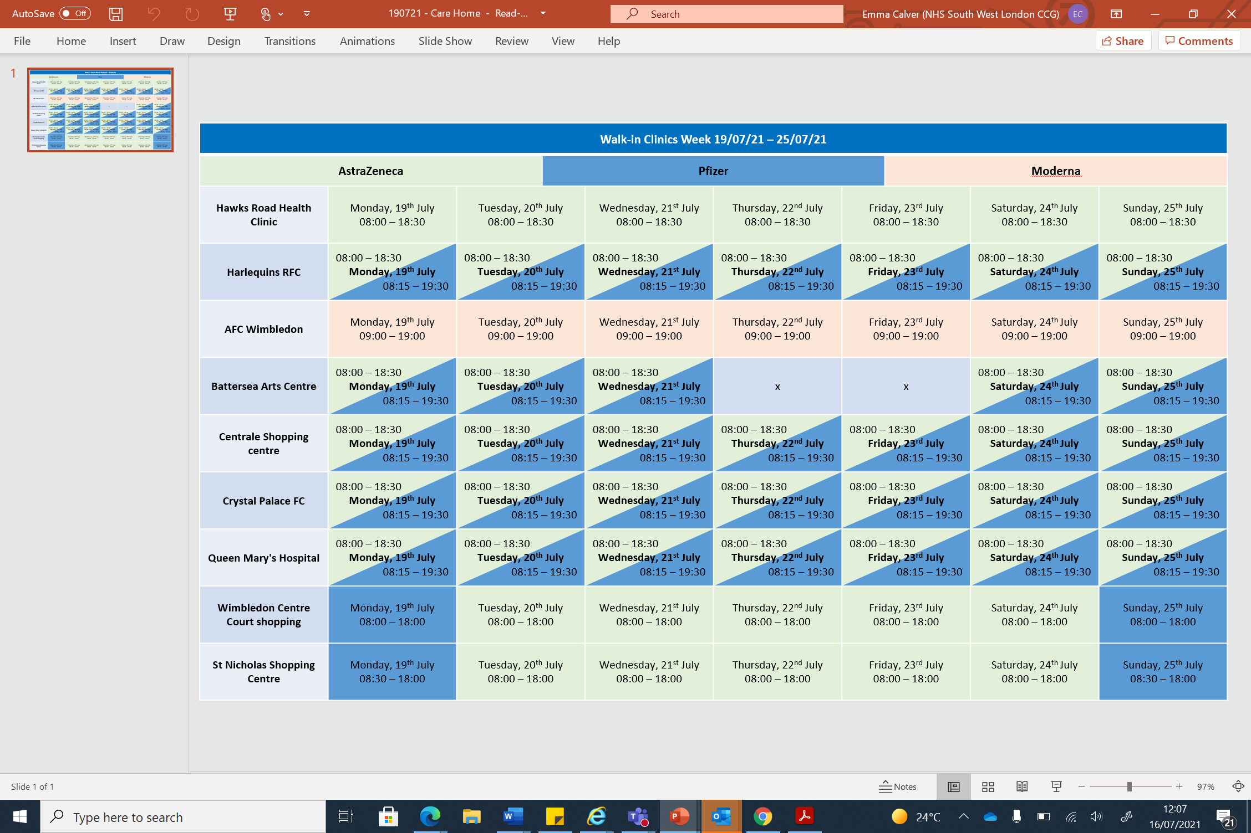

The national booking link can also be used to book at pharmacies who are providing vaccinations.

Walk in sessions will also be available at the following pharmacies:

* Ace Pharmacy: 1-3 Acre Parade, Hood Road, Chessington KT9 1DR
* Mayday Community Pharmacy: 508 London Road, Croydon CR7 7HQ
* St Boniface Church: 185 Mitcham Road, Wandsworth SW17 9PG
* Valley Pharmacy: St Aiden’s Church Hall, Chipstead Valley Road, Croydon CR5 3BB

## Opening times and Vaccine Centers for walk in

Please note that for all sites you will need to take proof of employment:

* staff id card with photo
* or letter from manager/payslip plus photo id (e.g. Passport, Drivers Licence)

We recognise that information on the COVID-19 virus and vaccine can sometimes be confusing.

In South West London, we are offering staff a chance to ask questions and receive advice about COVID-19 in general and/or the vaccine. The questions are reviewed and answered by qualified clinicians, including GP’s, nurses and other healthcare professionals.

We aim to respond to your questions quickly, but this may take up to 2 working days. Please feel free to submit more than one question.

[Carehome.covidvaccine@swlondon.nhs.uk](mailto:Carehome.covidvaccine@swlondon.nhs.uk)

## Second COVID-19 Vaccine Doses

From this week, Health and Social Care Workers and people over the age of 50 will have their second dose vaccines brought forward to 8 weeks.  If you have booked on the national booking system this will be done automatically.  People under the age of 50 who do not work in Health and Social Care will still receive their second dose vaccine between 77 days – 84 days after the first vaccine.  If you do not have a second dose appointment booked within these time frames, then please contact [Carehome.covidvaccine@swlondon.nhs.uk](mailto:Carehome.covidvaccine@swlondon.nhs.uk)  who will support you to book your second dose and can answer any questions.

# New Guidance for first dose Astra Zeneca (Oxford) Covid-19 Vaccine

The JCVI has posted their press release on the [new guidance for under 40s](https://www.gov.uk/government/news/jcvi-advises-on-covid-19-vaccine-for-people-aged-under-40).

Of note, they emphasize this is a precautionary approach and influenced by the lower infection rates in the UK.

The advice provided indicates a ‘*preference for adults aged 30-39 without underlying health conditions to receive an alternative to Oxford/Astra-Zeneca vaccine-where available and only if this does not cause substantial delays in being vaccinated*.’

It remains safe for people under the age of 40 years to have a first dose Pfizer or Moderna Covid-19 vaccination. As a precautionary measure, anyone who has symptoms four days or more after first Astra Zeneca (Oxford) Covid-19 Vaccines vaccination is advised to seek prompt medical advice, symptoms include :

* + a new onset of severe or persistent headache, blurred vision, confusion or seizures
  + develop shortness of breath, chest pain, leg swelling or persistent abdominal pain
  + unusual skin bruising or pinpoint round spots beyond the injection site

Then a clinical consultation should be undertaken before the second dose appointment. **If these side-effects were not experienced if is safe to receive the second dose.**

For people over 40 years of age it is safe to use any of the vaccines unless you have a specific clinical allergy or contraindication. To book a Pfizer first dose, for any queries or to enquire about 2nd doses, please email: [CareHome.CovidVaccine@swlondon.nhs.uk](mailto:CareHome.CovidVaccine@swlondon.nhs.uk) for more information

# Supporting Staff with Vaccine Hesitancy

A one-to-one interview vaccine hesitancy pack for managers has been developed to support managers to undertake interviews with staff who are vaccine hesitant. This pack will be regularly updated with support material. Please contact your CCG Care Home lead if you do not have a copy of the pack; contact details available on first page. The following recordings of the live webinars on the COVID-19 Vaccination can be accessed below :

* [COVID-19 Vaccine Q&As with Dr Patrick Gibson and Dr Marek Jarzembowski with Polish translation](https://www.youtube.com/watch?v=EDa4O8mH5mk)
* [COVID-19 Q&A with Dr Agnelo Fernandes and COVID-19 experience shared by Erik Cortez](https://youtu.be/mo5Bng-ClqI)
* [COVID-19 Vaccine Q&A with Dr Agnelo Fernandes, Dr Aditi Shah and COVID-19 experience shared by Vanessa Vyapooree](https://www.youtube.com/watch?v=5IesnLadLU8&feature=youtu.be)
* [COVID-19 Vaccine Q&As with a Focus on Allergies and Health Conditions with Dr Paul Riley and Dr Vasa Gnanapragasam](https://www.youtube.com/watch?v=qNBjiMpKOIM&feature=youtu.be)
* Young Fit and Healthy, why do I need the COVID-19 Vaccine? With Dr Paul Riley, Gassan Yacob and COVID-19 experience shared by Erik Cortez
* [COVID-19 Vaccine Q&A with BSL, focusing on Race Religion Background or Beliefs with Dr Vasa Gnanapragasam and Chief Pharmacist Sedina Agama](https://youtu.be/eEsY63EmhmM)
* [BSL interpreted FAQs on COVID-19 Vaccine with Dr Paul Riley and COVID-19 experience shared by Lisa Royle](https://youtu.be/mbQczkChffg)
* [COVID-19 Vaccine Q&A with a Focus on Women's Health with Dr Aditi Shah and Fiona White](https://youtu.be/_kFI6Cmc86I)

Below is a video of social worker Marcia Wilson explaining her journey and decision to have the COVID-19 Vaccine

* <https://twitter.com/yourcroydon/status/1357041318313263112>

# SECTION 1: Updated Guidance 24/06/21

## Personal Protective Equipment

This guidance has been updated on Wednesday 9th June 2021 and can be accessed at:

[Personal protective equipment (PPE): resource for care workers working in care homes during sustained COVID-19 transmission in England - GOV.UK (www.gov.uk)](https://www.gov.uk/government/publications/covid-19-how-to-work-safely-in-care-homes/personal-protective-equipment-ppe-resource-for-care-workers-working-in-care-homes-during-sustained-covid-19-transmission-in-england)

* to clarify the meaning of sessional use and the difference between source control and PPE
* to clarify the safe use of face masks and when to use them, focusing on the use of:
* the Type I or II face mask which is worn to protect others from you (source control)
* the Type IIR face mask which is used as PPE. Type IIR face masks help to protect you, the wearer, from exposure to COVID-19 but also act as source control, protecting others from you
* to clarify when to change a Type IIR face mask (being worn as PPE) following direct personal care
* to clarify that you should change a Type IIR face mask when providing direct personal care to COVID-19 positive residents or residents that may have symptoms of COVID-19
* to clarify sessional use of a face mask (Type I or II) is acceptable when carrying out domestic duties or other activities more than 2 metres from residents
* new advice on what to do when within 2 metres of a resident or anyone else within your working environment
* an updated section on what to do with waste including disposing of PPE safely

The guidance has been updated to reflect the current COVID-19 situation in England, the latest scientific evidence at this stage of the pandemic and stakeholder and user feedback.

## Polyethylene glycol (PEG)

laxatives and starch-based thickeners: potential interactive effect when mixed, leading to an increased risk of aspiration [.Gov Drug safety update](https://www.gov.uk/drug-safety-update/polyethylene-glycol-peg-laxatives-and-starch-based-thickeners-potential-interactive-effect-when-mixed-leading-to-an-increased-risk-of-aspiration)

## 111*6

### 

If you are concerned about a resident, please contact a member of your Care Home Support Team (CHST)

If out-of-hours, please contact 111*6. This service is available to all Care Homes across South West London.

The 111*6 telephone line will enable staff in care homes to speak to a service advisor who will take the patient’s details and ask a few clinical questions. They will not have to wait in the same call queue as patients who are calling themselves; this will enable them to have a quicker response.

111*6 is for all care homes who need fast access to a clinical team who can give advice and medical input needed for residents. If admission is required, hospitals are finding patients are arriving without key information (the Reg Bag should contain key paperwork, medication, and essential personal items).

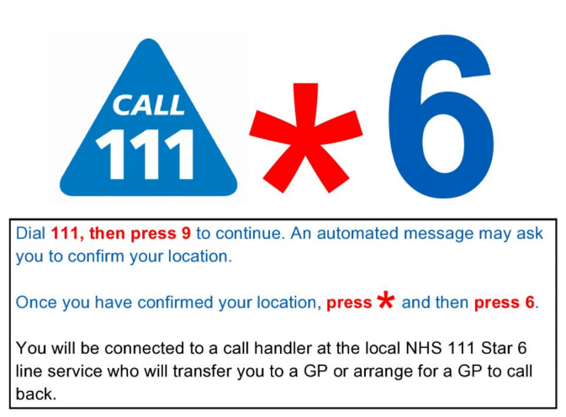

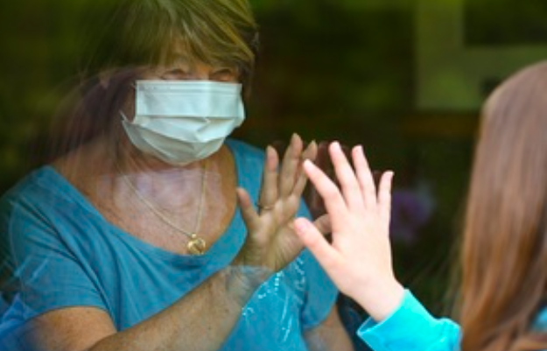

Current Coronavirus restrictions: [what-you-can-and-cannot-do](https://www.gov.uk/guidance/covid-19-coronavirus-restrictions-what-you-can-and-cannot-do)

There has been a joint statement from UK Chief medical officers recommending that the UK COVID-19 Alert will move from level 4 to **level 3** [Covid -19 alert level](https://www.gov.uk/government/news/covid-19-alert-level-update-from-the-uk-chief-medical-officers-10-may-2021) on the 10th May 2021

Further guidance on care home visiting was updated on 21st June 2021 see what this means for your area and visiting for care homes at: [Care Home Visiting](https://www.gov.uk/government/publications/visiting-care-homes-during-coronavirus/update-on-policies-for-visiting-arrangements-in-care-homes) & [Visits out of care homes](https://www.gov.uk/government/publications/arrangements-for-visiting-out-of-the-care-home/visits-out-of-care-homes) updated 17th June 2021

From 21 June, people admitted to a care home from the community will no longer have to self-isolate for 14 days on arrival, so residents will have a less disruptive introduction to their new home.

Care home residents will be able to spend more time with family and friends, including overnight stays as part of an easing of visiting restrictions

Care home residents would still need to isolate for 14 days following a visit out that would be deemed high risk through a risk assessment or after an overnight stay at hospital.

[care home residents can stay overnight](https://www.gov.uk/government/news/care-home-residents-can-stay-overnight-as-visiting-restrictions-ease)

**Demonstrating Covid-19 vaccination status when travelling abroad**

From 17 May, people in England who have had a full course of the Covid-19 vaccine will be able to demonstrate their Covid-19 vaccination status for international travel. A full course is currently two doses of any approved vaccine. [Find out more.](https://londoncommunications.cmail20.com/t/d-l-qikhte-ykhtuyiyur-m/)

# What’s New?

**Help make the vaccination experience better in care homes**

The NHS Coronavirus Vaccines Programme needs your help to improve the vaccination experience at care homes. We’d like to talk with clinicians working in care home settings and are involved in the vaccination programme. Your help will allow us to learn about the needs of people using the service and how it can be improved.

**Interested in taking part?**

To take part please complete this short [survey](https://feedback.digital.nhs.uk/jfe/form/SV_0dIHGtwthFg3ut0). We will contact you to arrange a date and time for you to take part in our research.

## Vaccination Guides

Version 4 of [COVID-19 vaccination guide for childbearing, pregnant or breastfeeding women](https://eur01.safelinks.protection.outlook.com/?url=https%3A%2F%2Fwww.gov.uk%2Fgovernment%2Fpublications%2Fcovid-19-vaccination-women-of-childbearing-age-currently-pregnant-planning-a-pregnancy-or-breastfeeding&data=04%7C01%7CC19guidance.SPOC%40phe.gov.uk%7C2789361d9aca4470575a08d908bd94f1%7Cee4e14994a354b2ead475f3cf9de8666%7C0%7C0%7C637550432602326531%7CUnknown%7CTWFpbGZsb3d8eyJWIjoiMC4wLjAwMDAiLCJQIjoiV2luMzIiLCJBTiI6Ik1haWwiLCJXVCI6Mn0%3D%7C1000&sdata=BERUAkHN%2BSURMIREOxyVRnmKAucwSdj0vzQcAzRd4o0%3D&reserved=0) has been published.

We have also revised the COVID-19 vaccination guide for adults leaflet– [new version 4 for Phase 2](https://eur01.safelinks.protection.outlook.com/?url=https%3A%2F%2Fwww.gov.uk%2Fgovernment%2Fpublications%2Fcovid-19-vaccination-guide-for-older-adults&data=04%7C01%7CC19guidance.SPOC%40phe.gov.uk%7C2789361d9aca4470575a08d908bd94f1%7Cee4e14994a354b2ead475f3cf9de8666%7C0%7C0%7C637550432602336488%7CUnknown%7CTWFpbGZsb3d8eyJWIjoiMC4wLjAwMDAiLCJQIjoiV2luMzIiLCJBTiI6Ik1haWwiLCJXVCI6Mn0%3D%7C1000&sdata=Bz9JvBXSdv3ivuxVrfuXgBy7J8ws70nHfO92WJJxV7k%3D&reserved=0) paper copies available to order now

What to expect after your COVID-19 vaccination leaflet – [new version for Phase 2](https://eur01.safelinks.protection.outlook.com/?url=https%3A%2F%2Fwww.gov.uk%2Fgovernment%2Fpublications%2Fcovid-19-vaccination-what-to-expect-after-vaccination%2F&data=04%7C01%7CC19guidance.SPOC%40phe.gov.uk%7C2789361d9aca4470575a08d908bd94f1%7Cee4e14994a354b2ead475f3cf9de8666%7C0%7C0%7C637550432602336488%7CUnknown%7CTWFpbGZsb3d8eyJWIjoiMC4wLjAwMDAiLCJQIjoiV2luMzIiLCJBTiI6Ik1haWwiLCJXVCI6Mn0%3D%7C1000&sdata=5nuuhOlc7wC%2BRHIJbSlDKlmQgl1PAGK4%2BgJ0J4E8DME%3D&reserved=0) as above

COVID-19 vaccination and blood clotting collection has been revised:

[https://www.gov.uk/government/collections/covid-19-vaccination-and-blood-clotting](https://eur01.safelinks.protection.outlook.com/?url=https%3A%2F%2Fwww.gov.uk%2Fgovernment%2Fcollections%2Fcovid-19-vaccination-and-blood-clotting&data=04%7C01%7CC19guidance.SPOC%40phe.gov.uk%7C2789361d9aca4470575a08d908bd94f1%7Cee4e14994a354b2ead475f3cf9de8666%7C0%7C0%7C637550432602346432%7CUnknown%7CTWFpbGZsb3d8eyJWIjoiMC4wLjAwMDAiLCJQIjoiV2luMzIiLCJBTiI6Ik1haWwiLCJXVCI6Mn0%3D%7C1000&sdata=5rARbuM7FayGf8Cn%2Fu%2Fd36qTBMa5ZcZ5C9QcAq5as2o%3D&reserved=0)

VITT investigation / management HTML is live:

[https://www.gov.uk/government/publications/clinical-investigation-and-management-of-covid-19-vaccine-induced-thrombosis-and-thrombocytopenia](https://eur01.safelinks.protection.outlook.com/?url=https%3A%2F%2Fwww.gov.uk%2Fgovernment%2Fpublications%2Fclinical-investigation-and-management-of-covid-19-vaccine-induced-thrombosis-and-thrombocytopenia&data=04%7C01%7CC19guidance.SPOC%40phe.gov.uk%7C2789361d9aca4470575a08d908bd94f1%7Cee4e14994a354b2ead475f3cf9de8666%7C0%7C0%7C637550432602346432%7CUnknown%7CTWFpbGZsb3d8eyJWIjoiMC4wLjAwMDAiLCJQIjoiV2luMzIiLCJBTiI6Ik1haWwiLCJXVCI6Mn0%3D%7C1000&sdata=VitVEruyye4LYMO5IaW%2BCvB4qIa%2BoJzo9Z5ka%2BxLwUk%3D&reserved=0)

[COVID-19 vaccination and blood clotting – patient guide](https://eur01.safelinks.protection.outlook.com/?url=https%3A%2F%2Fwww.gov.uk%2Fgovernment%2Fpublications%2Fcovid-19-vaccination-and-blood-clotting%2Fcovid-19-vaccination-and-blood-clotting&data=04%7C01%7CC19guidance.SPOC%40phe.gov.uk%7C2789361d9aca4470575a08d908bd94f1%7Cee4e14994a354b2ead475f3cf9de8666%7C0%7C0%7C637550432602356397%7CUnknown%7CTWFpbGZsb3d8eyJWIjoiMC4wLjAwMDAiLCJQIjoiV2luMzIiLCJBTiI6Ik1haWwiLCJXVCI6Mn0%3D%7C1000&sdata=3RLe8GDMPL3Nk2EkuaaNVHBEA%2BW%2BevI7PVJsxdH31R4%3D&reserved=0) (**must** be given to anyone offered the AstraZeneca vaccination)

**Catheter Pathway for Nursing Home residents**

We were pleased to receive a presentation from Meylene Dela Cruz, Karin Boyton and Dr Vasa Gnanapragasam covering a Catheter Pathway (slides attached), designed for use with Nursing Home residents. The team have subsequently provided an example Catheter Passport (also attached). Further information can be found at the NHS England Website:

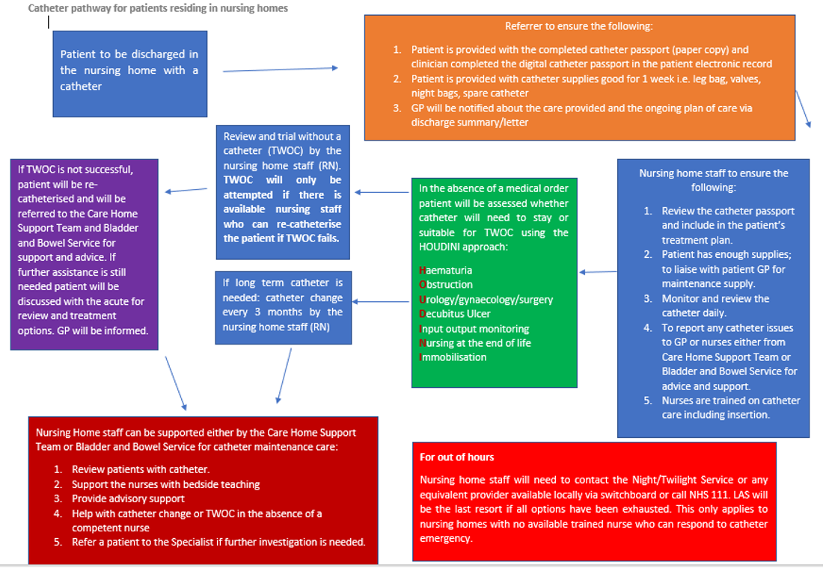[NHS England » Urinary catheter tools](https://www.england.nhs.uk/patient-safety/urinary-catheter-tools/) [Catheter_passport_v7.pdf (england.nhs.uk)](https://www.england.nhs.uk/wp-content/uploads/2020/08/Catheter_passport_v7.pdf)

## Care Home Champion Meeting

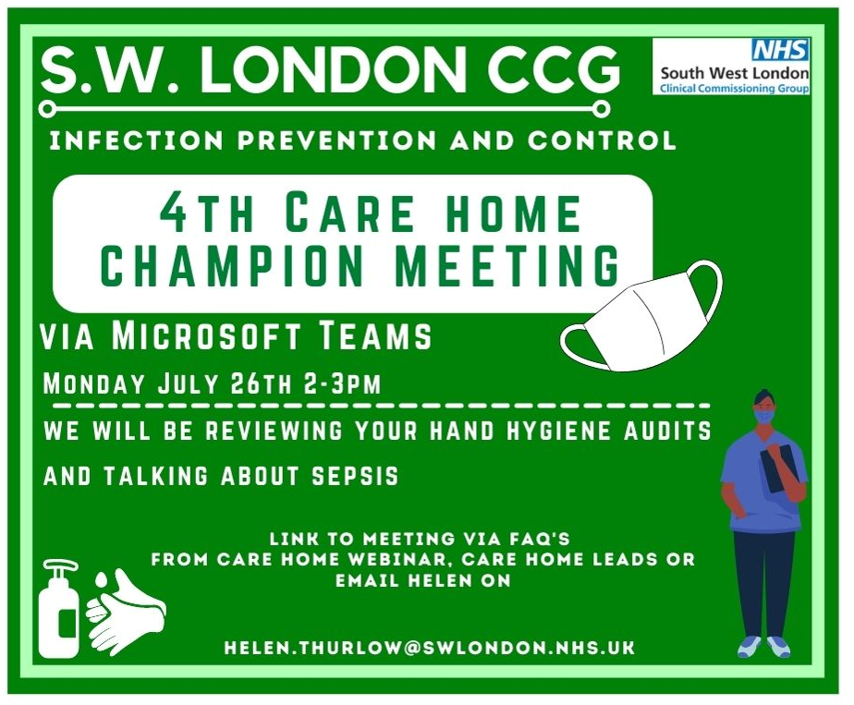

The 3rd Infection Prevention and Control Care Home Champion Meeting takes place on 26th July (the last Monday of every month).

Looking at:  Hand Hygiene Audit plus dehydration and its devastating effects.

This meeting is for IPC champions in each care home, and we would like the care home managers to nominate and send the invite to those people. The aim of this meeting is to look at a small part of the IPC audit tool and the Chain of Infection.

The session will be interactive, and we will allow time for questions and the sharing of good practice. Meetings are ongoing and monthly at this time and the aim is to offer support and training for IPC leads and/or Champions in each Care Home. You do not need to have been to first session in April to attend, this meeting is open to all IPC Leads and Champions.

Please use the link below to access the meeting or contact [Helen.Thurlow@swlondon.nhs.uk](mailto:Helen.Thurlow@swlondon.nhs.uk) with any questions

Microsoft Teams meeting

**Join on your computer or mobile app**

[Click here to join the meeting](https://teams.microsoft.com/l/meetup-join/19%3ameeting_OWI5ZmQ4ODktOWE2YS00YmM2LWE4MGYtMDIxODI0MzE2YTFh%40thread.v2/0?context=%7b%22Tid%22%3a%22c75c680c-ebe2-4232-85b0-a365c8982c49%22%2c%22Oid%22%3a%22a41755ae-e58d-4a93-a63f-2e5b0e907142%22%7d)

[Learn More](https://aka.ms/JoinTeamsMeeting) | [Meeting options](https://teams.microsoft.com/meetingOptions/?organizerId=a41755ae-e58d-4a93-a63f-2e5b0e907142&tenantId=c75c680c-ebe2-4232-85b0-a365c8982c49&threadId=19_meeting_OWI5ZmQ4ODktOWE2YS00YmM2LWE4MGYtMDIxODI0MzE2YTFh@thread.v2&messageId=0&language=en-US)

## IPC guidance direct to your mobile

Direct information and Infection Prevention Guidance straight to your mobile.

If you would like to receive this and are an infection prevention and control lead or champion, you can access this service by emailing

[Helen.Thurlow@swlondon.nhs.uk](mailto:Helen.Thurlow@swlondon.nhs.uk)

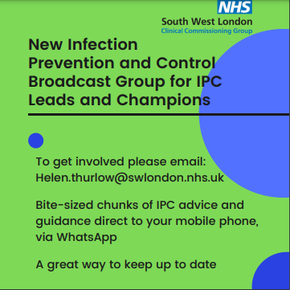

## IPC Training offers

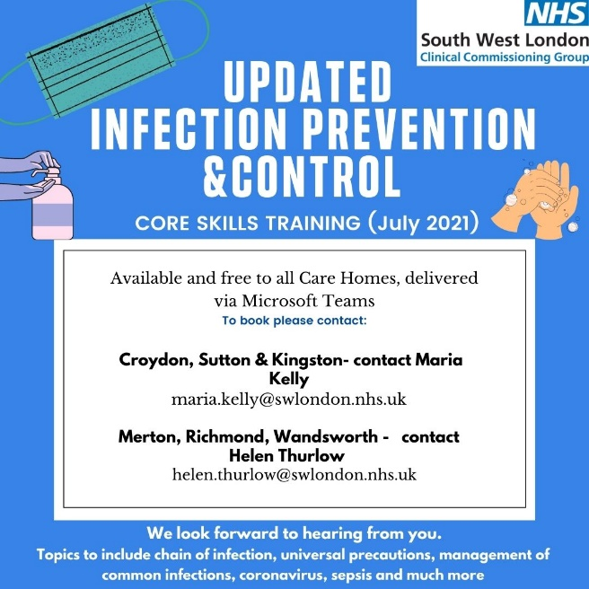

The South West London infection prevention and control team are offering two types of training to all care homes to choose from:

1. Covid-19 specific training
2. Core Skills Training

For bookings, please contact Maria Kelly for Croydon Sutton and Kingston or Helen Thurlow for Merton Richmond and Wandsworth.

## Uniform Bags

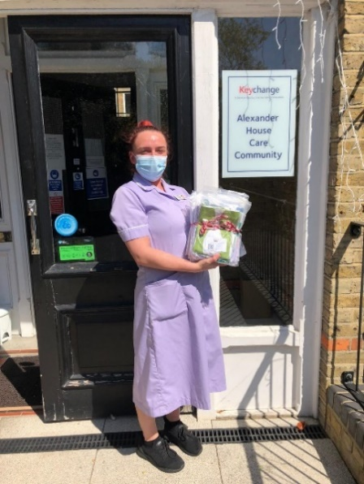

Local charity, Merton A.R.K. (Acts of Random Kindness) have kindly donated Uniform Bags to South West London Care Homes. Pictured here are staff from Care Homes who have gratefully received bags for staff.

A uniform bag is a fabric bag that carries a staff member’s uniform. When staff travel to and from work, they should wear everyday clothes to prevent work clothes coming into contact with coronavirus.

The staff member then changes into the uniform for their shift. At the end of the shift, staff should change into everyday clothes and the used uniform is placed inside the uniform bag securely. When the staff member gets home, the uniform bag and uniform should be put directly into the washing machine and washed on a hot wash. The bag and uniform should then be tumble dried and/or ironed to ensure all virus particles are eliminated.

If a staff member does not have a uniform bag, pillow slips can be used instead.

If you are interested in receiving a uniform bag please contact Paul Harper [paul.harper@swlondon.nhs.uk](mailto:paul.harper@swlondon.nhs.uk) with Care Home name, location, number of bags required and a contact.

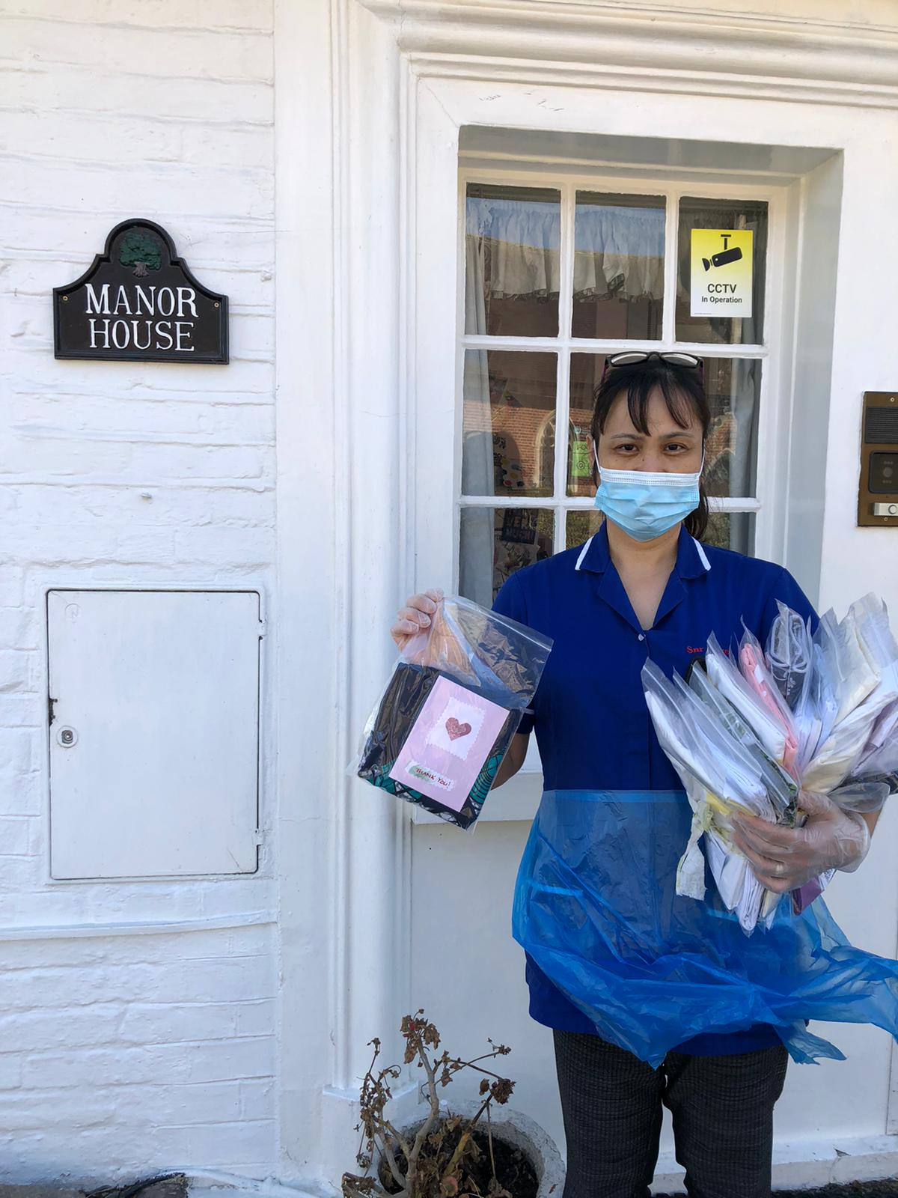

## Pre-Recorded COVID-19 Vaccine Q&A webinars

Please see below the link to the staff Q&A session on the Covid-19 vaccine, fertility and pregnancy:

**Recording: Staff Q&A on the Covid-19 vaccine, fertility and pregnancy**

A recording of the health and social care staff Q&A session on the Covid-19 vaccine, fertility and pregnancy is now available to view via this [YouTube link](https://youtu.be/l2kuAs1_UZ8). Questions were answered by three clinical experts:

* Helene Brown, Medical Director (System Improvement and Professional Standards) for NHS London
* Memuna Sowe, Specialist Midwife for vulnerable and marginalised women at NHS Croydon Health Services
* Garima Srivastava, Consultant Gynaecologist and fertility lead at Homerton University Hospital

## COVID 19 Vaccine Questions and Answers in English and Polish

[COVID-19 Q&A What are your Real Questions? Answers with Dr Paul Riley and Chief Pharmacist Sedina Agama](https://youtu.be/KdtRFRoLqQ0)

## Ways to Reach out to Friends and Neighbours

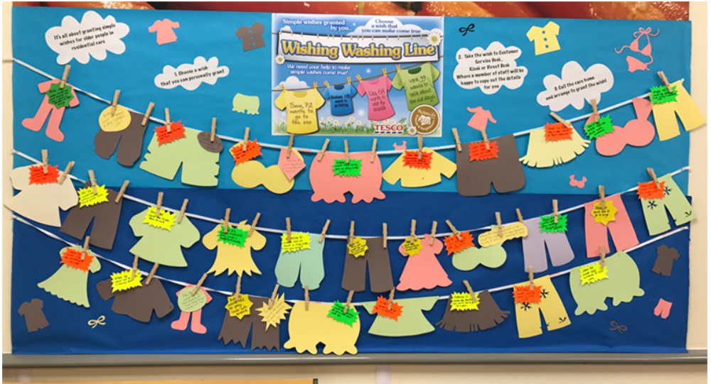

<http://carehomefans.org/fans_in_action/wishing-washing-line/>

Are you a care home wanting to start a Wishing Washing Line? Or are you a community member who could host a Wishing Washing Line in your local area? Either way, please get in touch! [mhl@city.ac.uk](mailto:mhl@city.ac.uk)

## Good thinking website for Wellbeing

There are lots of NHS-approved wellbeing apps available on Good Thinking (many of which are free if you live or work in London) and workbooks written by the Centre for Clinical Interventions. The Good Thinking team has also produced specific advice for health and care professionals related to mental health and COVID-19, including a free [**employers toolkit**](https://www.good-thinking.uk/employers/) to help support employees' mental health. You can access the site or click on this link: <https://www.good-thinking.uk/health-and-care-professionals/>

## Recruitment support through The Prince’s Trust

The Prince’s Trust has committed to supporting 10,000 young people aged 18-30 into Health & Social Care careers over the next four years. To take part in this programme all The Princes Trust needs is entry level roles for young people to interview for and someone interview them on recruitment day.

**For further information please contact :**

[sunny.chowdhury@princes-trust.org.uk](mailto:sunny.chowdhury@princes-trust.org.uk) or call 07773 002 863

[paul.harper@swlondon.nhs.uk](mailto:paul.harper@swlondon.nhs.uk) or call 07920 815971

## 

## Upcoming Webinars

Becoming an Advocate for Allyship and Inclusive Leadership

Multiple dates available

<https://www.eventbrite.co.uk/e/becoming-an-advocate-for-allyship-and-inclusive-leadership-tickets-156978662405>

**Digital**

This week’s ‘digital’, update included the following (please also see PowerPoint slides accompanying this FAQ.

* **Case Study The impact of a cyber breach on a care service** - please see the following link to ‘Digital Social Care’.

[The impact of a cyber breach on care services - Digital Social Care](https://www.digitalsocialcare.co.uk/the-impact-of-a-cyber-breach-on-care-services/)

* **Digital Social Care Records** - accredited supplier list.

Are you thinking of purchasing a digital system for care planning and monitoring? A Digital Social Care Record (DSCR) allows the digital recording of care information and care received by an individual, within a social care setting, replacing traditional paper records. DSCRs are person-centred and enable information to be shared securely and in real-time with authorised individuals across the health and care sector.

The following suppliers have been accredited on the Dynamic Purchasing System (DPS). New suppliers will continue to join, creating a vibrant marketplace of solutions to fit the diverse needs of social care providers.

[Accredited Supplier List - Digital Social Care](https://www.digitalsocialcare.co.uk/social-care-technology/digital-social-care-records-dynamic-purchasing-system/accredited-supplier-list/)

. . . . and why not sign up to the Digital Social Care Newsletter : [Newsletter Signup - Digital Social Care](https://www.digitalsocialcare.co.uk/newsletter-signup/)

* **Capacity Tracker - weekly webinars for Care Homes**

Weekly Webinars for Care Homes with Capacity Tracker, continue to take place every Friday at 2:00pm - joining details are :

Microsoft Teams meeting

**Join on your computer or mobile app**

[Click here to join the meeting](https://teams.microsoft.com/l/meetup-join/19%3ameeting_MjVmYTJkNWQtNzYxNy00MjA1LWEwMmMtNzhjMzM0N2M3ZTc1%40thread.v2/0?context=%7b%22Tid%22%3a%227894e05b-53c3-43f7-96e0-ee7edf001f4c%22%2c%22Oid%22%3a%2217f38ef3-5ab3-4adc-a15a-e1acfe14b434%22%7d)

**Or call in (audio only)**

[+44 20 3794 0272,,38306705#](tel:+442037940272,,38306705)   United Kingdom, London

Phone Conference ID: 383 067 05#

# SECTION 2: Frequently Asked Questions

### The Prime Minister said that the government expects and recommends face masks in public settings after the 19th. Could this be considered for care homes?

We are currently following the national guidance for care homes “How to work safely in care homes” An update is expected from NHSE this week to advise if there are any changes in requirement for face masks to be work in healthcare settings. Until that time we should continue to follow the how to work safely in care homes guidelines and wear personal protective clothing including face masks. <https://www.gov.uk/government/publications/covid-19-how-to-work-safely-in-care-homes>

### What happens if care homes are unable to meet the SAGE guidelines for levels of vaccine uptake?

Discussions are ongoing to identify contingency plans if the SAGE guidelines are not met including a follow on from the CQC requirements. At this point we don’t know what will happen. Our priority is to deliver safe care to residents. This issue is evolving and we encourage you to work with colleagues to uptake the vaccine.

### Can we make allowance for staff with natural antibodies?

No, just because you have natural antibodies does not give you the same level of protection as the vaccine. There is evidence to show that antibodies from natural infection diminish over time and so vaccination gives optimum protection.

### So we continue LFD with visitors and temperature checks?

For the time being all indoor visitors should have a negative test taken the day that they are visiting. Visitors should also be screened for signs and symptoms of covid infection and a temperature check before visiting. A surgical face mask and good hand hygiene continue to be required for indoor visiting.

### Is there anything else that can be done to help overcome potential barriers to achieving the SAGE safety targets?

### 

### Capacity Tracker

### Staff who are on maternity leave or other long-term absence (including long term sick), should not be included in the staff numbers. If/when they do return to work, that is when they are included in the numbers. In the staff total figure, homes should not include staff who are not currently working in the home for any reasons. When reporting residents, providers should not include vacant beds as unvaccinated residents. Your baseline denominators should just include all residents in the care home and not empty beds.

### 

### Those without a GP/NHS number

### If you know of someone who is not registered with a GP this will not exclude them from having the vaccine. Please contact [carehome.covidvaccine@swlondon.nhs.uk](mailto:carehome.covidvaccine@swlondon.nhs.uk) for further advice and support.

### Regarding the government’s plans to stop wearing masks. Does this apply to care homes? E.G Do staff still have to wear masks around the home at all times.

We are still working to the guidance Working Safely in Care Homes last updated 9th June 2021 which requires staff to wear PPE including masks. <https://www.gov.uk/government/publications/covid-19-how-to-work-safely-in-care-homes> it is likely that this guidance will be updated to indicate the requirements within the care home setting. It will be updated through the gov.uk website and any updates will be included in the following FAQ’s and sent out on the IPC broadcast group.

### How long do you anticipate we continue with the twice daily temp, SATs and pulse checks on our residents?

The guidance below remains current at 6.7.21.

<https://www.gov.uk/government/publications/coronavirus-covid-19-admission-and-care-of-people-in-care-homes/coronavirus-covid-19-admission-and-care-of-people-in-care-homes>

### Section 5.1 outlines the current guidance

“Care home providers should follow relevant government guidance for everyone in their care home. For example, wherever possible, care homes should implement [social distancing measures](https://www.gov.uk/government/publications/staying-alert-and-safe-social-distancing), and support individuals to follow [guidance for people who are clinically extremely vulnerable](https://www.gov.uk/government/publications/guidance-on-shielding-and-protecting-extremely-vulnerable-persons-from-covid-19).

Care home residents (including older and younger residents with a learning disability, and autistic people) may not present with the typical COVID-19 symptoms of a cough or fever. They may also not be able to report a loss of taste or smell.

It is important to assess residents twice daily for:

* the development of a high temperature (37.8°C or above)
* a cough

It is also important to look for softer signs, including:

* shortness of breath
* if residents are less alert
* if residents have a new onset of confusion
* if residents are off food
* if residents have reduced fluid intake, diarrhoea or vomiting.

Care home providers and staff should consider COVID-19 as the possible cause of any worsening in physical or mental ability when there is no other known cause. See Annex B.

Through NHS ‘mutual aid’, the NHS will be supporting care home professionals to use well evaluated tools such as [RESTORE2](https://www.hampshiresouthamptonandisleofwightccg.nhs.uk/your-health/restore-official) and [NEWS2](https://www.england.nhs.uk/ourwork/clinical-policy/sepsis/nationalearlywarningscore/) (supported in current [British Geriatric Society (BGS) guidance](https://www.bgs.org.uk/resources/covid-19-managing-the-covid-19-pandemic-in-care-homes)).

Any such changes in a resident’s condition could indicate to staff that the resident has COVID-19. Staff should immediately report residents with these symptoms or signs to the HPT, as outlined in sections 5.3 and 5.4”

### What is the next step for Care Homes with visiting following 19/07/2021. Do we need to continue all tests in situ as well as for visitors?

We are still working to the guidance “How to work safely in care homes” last updated 9th June 2021 which indicates the testing required for care home staff and for residents. <https://www.gov.uk/government/publications/covid-19-how-to-work-safely-in-care-homes> it is likely that this guidance will be updated to indicate the requirements within the care home setting. It will be updated through the gov.uk website and any updates will be included in the following FAQ’s and sent out on the IPC broadcast group.

### Has there been any news on booster jabs for staff and residents who got their jabs last year?

Yes there is consultation regarding the advice from the JCVI on boosters vaccination programme published 30th June 2021 . [JCVI interim advice on a potential coronavirus (COVID-19) booster vaccine programme for winter 2021 to 2022 - GOV.UK (www.gov.uk)](https://www.gov.uk/government/publications/jcvi-interim-advice-on-a-potential-coronavirus-covid-19-booster-vaccine-programme-for-winter-2021-to-2022?utm_medium=email&utm_campaign=govuk-notifications&utm_source=451661a2-9eb7-4479-9ff8-d51ffebfbf95&utm_content=daily) The proposal is that most vulnerable could be offered booster COVID19 vaccines from September Boosters aim to ensure protection from COVID-19 is maintained ahead of winter and against new variants. Pending further data and final advice, millions may be offered booster vaccine from September. The proposal is that it will be rolled out in 2 stages :

**Stage 1.** The following people should be offered a third dose COVID-19 booster vaccine and the annual influenza vaccine as soon as possible from September 2021:

* Adults aged 16 years and over who are immunosuppressed
* Those living in residential care homes for older adults · all adults aged 70 years or over
* Adults aged 16 years and over who are considered clinically extremely vulnerable
* Frontline health and social care workers

**Stage 2.** The following people should be offered a third COVID-19 booster vaccine as soon as practicable after stage 1 with equal emphasis on deployment of the influenza vaccine where eligible:

* All adults aged 50 years and over
* All adults aged 16 to 49 years who are in an influenza or COVID-19 at-risk group as outlined in the Green Book
* Adult household contacts of immunosuppressed individual

### We have a new resident discharged to community from hospital then comes to care home within 14 days of discharge but hospital ward confirmed there was no covid on ward and they have negative PCR do they still have to self-isolate?

The guidance states that admissions to care homes from hospitals if there has been an overnight stay should be isolated for 14 days. This is slightly different as the resident went back to the community before admission to the care home. Given the knowledge that the resident has had a recent hospital admission it would be reasonable to isolate the resident up to the 14th day from when they were discharged from the hospital. This should be supported where possible by PCR testing.

### If staff have to go to the hospital overnight due to illness do they need to isolate at home?

There is no specific national guidance on this and so you would need to undertake a risk assessment to establish the risk. . Currently only residents need to isolate for 14 days post discharge from a hospital stay and this is due to their weakened immune system and the risk that they could incubate the risk for longer. If the staff member is fully vaccinated and did not come into contact with a positive case then they could return to work when well supported by regular LFD and PCR tests and ensuring compliance with wearing correct PPE and hand hygiene etc.

### We have a service user who is in hospital since last week. The hospital will conduct a covid test on the day of discharge. On their return, if the result is negative, do they still need to isolate? All residents are being tested weekly in addition.

As per national guidance discharges from overnight stays in hospitals and transfers from other care homes will be required to isolate for 14 days.

### When will we get more detail about the easing of restrictions/visiting, my phone has not stopped calling from relatives asking if they still have to book and go to a designated room etc?

### Yesterday’s press statement and at the Prime ministers briefing suggested that restrictions on the number of visitors to care homes would be lifted. This has not yet been updated in the national guidance which was last updated on 21st June 2021. <https://www.gov.uk/government/publications/visiting-care-homes-during-coronavirus/update-on-policies-for-visiting-arrangements-in-care-homes> Until the guidance is updated or instructed otherwise we should continue to follow the current guidance above.

### We really want to start small outings again (picnic in the park via minibus etc.) How do you feel about that?

The guidance for visits outside of the care home was updated on 17th June and applies from 21st June 2021[*https://www.gov.uk/government/publications/arrangements-for-visiting-out-of-the-care-home/visits-out-of-care-homes*](https://www.gov.uk/government/publications/arrangements-for-visiting-out-of-the-care-home/visits-out-of-care-homes)It makes sense to work towards enabling safe outdoor visits and outings. In line with the guidance such visits are made safer by undertaking risk assessments and making plans to reduce the risk. Such as outdoor outings with plenty of fresh air, using own transport with the windows open, avoiding crowds, and assisting residents with regular hand hygiene.

### Is there any data on how many of those in hospital are double vaccinated/single vaccinated/not vaccinated?

This data is still being collected but local indications are that the majority of hospitalised covid patients have either had no vaccine, are partially vaccinated or within 10 days of the second vaccine.

### Can you send the link to the new guidance on reducing staff movement in care homes please?

Here is a link to the guidance and consultation [Stopping movement of staff between care settings: response to consultation - GOV.UK (www.gov.uk)](https://www.gov.uk/government/consultations/stopping-movement-of-staff-between-care-settings/outcome/stopping-movement-of-staff-between-care-settings-response-to-consultation)

### Do we know whether residents will be able to go out unescorted after the 19th? – In relation to residential younger adults home please?

We continue to work with the current guidance for visits outside of the care home [*https://www.gov.uk/government/publications/arrangements-for-visiting-out-of-the-care-home/visits-out-of-care-homes*](https://www.gov.uk/government/publications/arrangements-for-visiting-out-of-the-care-home/visits-out-of-care-homes) ***.*** It is likely that this will be updated before 19th July. As soon as we are made aware of any updates we will send with the next FAQ’s and to the IPC broadcast to those who have signed up. Alternatively keep checking the Gov.uk website.

### I have one resident who will hit out at the nurses if they try to give her the vaccine but her daughter wants the resident to have it, the GP is aware and said they cannot intervene with this. I have one other resident whose daughter doesn’t want her to have the vaccine but the resident will let the nurses give her the vaccine. This resident’s daughter doesn’t have LPOA so she can still make that decision, again the GP is aware but said he cannot intervene. These are the only 2 residents in the home that are not vaccinated.

There are a couple of very important issues here. It is important that there is a formal assessment by the GP to establish capacity. If it is deemed that the resident does not have capacity then a best interests meeting should be called. In any case the most suitable person to advise on individual cases is initially the GP and the safeguarding lead for your borough. If you are unsure who your safeguarding lead is you should either contact your care home lead or contact me at [Debbie.calver@swlondon.nhs.uk](mailto:Debbie.calver@swlondon.nhs.uk) and we can put you in touch.

### I have a resident who has had one vaccine and now needs their second but our GPs are no longer vaccinating in homes. Do I book a place at the local hub and take the resident there?

Please follow the national booking link here <https://www.nhs.uk/conditions/coronavirus-covid-19/coronavirus-vaccination/book-coronavirus-vaccination/>

### As society opens up is there support on communicating ‘collective responsibility for keeping people safe’ as people so often focus only on their visit to their loved one rather than risk to a community of people. How can we make the message more positive?

It is important that as we learn to live with the virus and start to relax restrictions that we continue to protect our most vulnerable. Everyone has a part to play in keeping residents safe including visitors, friends and families. There is a section on the visitors responsibilities and the importance of good communication in the latest visiting guidance <https://www.gov.uk/government/publications/visiting-care-homes-during-coronavirus/update-on-policies-for-visiting-arrangements-in-care-homes>

### My staff member had their 1st covid jab last Wed at the Fairfield Halls drop in and was advised to book 2nd jab in 3-12 week’s, but he doesn't know how to or who to contact. Will they contact him?

A couple of recent queries regarding Fairfield Halls have been addressed, however people are advised to book through the national booking service : <https://www.nhs.uk/conditions/coronavirus-covid-19/coronavirus-vaccination/book-coronavirus-vaccination/> If you are experiencing any difficulty, please contact the South West London team at : [CareHome.CovidVaccine@swlondon.nhs.uk](mailto:CareHome.CovidVaccine@swlondon.nhs.uk)

### How reliable and effective is the PCR test that we are doing for the NHS as we cannot use the negative result in travelling?

The PCR testing is the same as that used for testing before and after travel which gives good reliability. The NHS testing kits and services cannot currently be used for testing post foreign travel. Testing for foreign travel is processed by a government nominated non-NHS private company and must be paid for separately.

### Our IPC lead has left, she has trained us, but will there be more training?

Currently there are two types of Infection Prevention and control training available. Covid-specific training including donning and doffing PPE and secondly a more generic IPC training including core skills and other health care associated infections such as Noro virus and clostridium difficile. These can be arranged by emailing [infectioncontrol@swlondon.nhs.uk](mailto:infectioncontrol@swlondon.nhs.uk)

### Four of our staff decided to resign once Covid19 vaccination become mandatory. I am struggling to recruit new staff; one new staff alone didn't come back to work post 1 day shift. Most people I interview wants flexible shift after 9am to 2pm.  Could you help us with recruitment support (the local authority has supported in the past).

Making vaccination a condition of deployment is a proposal that has yet to be voted for in parliament, however Public consultation has now been undertaken and the results indicate support for the proposal. If you are struggling with staff recruitment, please contact Paul Harper in the first instance: [paul.harper@swlondon.nhs.uk](mailto:paul.harper@swlondon.nhs.uk)

### The costs associated with DSPT (NHS Data Security and Protection Toolkit) are significant . . .

Whilst DSPT does require time to complete (and time is cost) and involves contributions from a number of staff, we would argue that the benefits of having DSPT in place outweigh these costs and include:

* Access to digital solutions:

- nationally, such as, proxy access to GP records and ongoing access to NHSmail

- regionally in London, such as, Coordinate My Care

- locally in South West London (SWL), such as, eRedBag, remote monitoring pilot and coming soon is access to the summary care record app on the NHSX iPads

* Satisfies CQC’s C3.3 and W.2.8 Key Line of Enquiry (KLOE) questions about how to manage data securely
* Increasingly becoming a contractual requirement of providing services to CCGs and Local Authorities, particularly continuing healthcare services
* Compliance with various legal requirements and legislation
* Ensures your organisation is safe with its data and cyber security
* Opportunity to audit staff processes, digital systems, and organisational policies
* Reassurance to you, staff, clients, and families that their and your data protection is taken seriously
* Accredited and understood by the wider system

Support is available through local and regional teams, helping homes to complete their DSPT, please contact Paul Harper in the first instance: [paul.harper@swlondon.nhs.uk](mailto:paul.harper@swlondon.nhs.uk)

### If a resident would like to stay at a relative’s home overnight and the care home deems it is safe, will the resident need to self-isolate on return?

If the care home managers deem that the overnight visit is safe, there will not be a need to isolate. This decision will need to be based on a risk assessment by the care home manager. <https://www.gov.uk/government/publications/visiting-care-homes-during-coronavirus/update-on-policies-for-visiting-arrangements-in-care-homes>

### If Vaccinations become mandatory, are we allowed to accept aromatherapist in our home once they have 1st and 2nd dose?

An aromatherapist would need to provide evidence that they have received both doses of the vaccine and would need to follow all IPC guidelines. Certified Aromatherapists have been able to attend Care Homes since 12th April 2021 following a negative LFD test.

### We have a family member who wants to obviously ensure that all staff are vaccinated working with their elderly family member. We have agency staff who are not vaccinated. On these grounds can we refuse shifts to these workers?

As a care home manager, you can request agency staff who have been vaccinated. Agencies are providing vaccinated staff. It has been recognised that agencies are held to the same request of vaccine uptake, we are in contact with local authorities to address this with agencies.

### Advice on new symptoms?

Reports are suggesting that common symptoms of the Delta variant may be different to those of other variants. Some surveillance suggests that headache, sore throat, runny nose and diarrhoea are common symptoms of the Delta variant, but the UK guidance has not been updated yet to reflect these new symptoms. It is important where there is any suspicion that you may have symptoms including that of the new symptoms reported of COVID-19 infection that you isolate and test with PCR.

### Do I need to complete Data Security and Protection Toolkit (DSPT)?

CQC inspectors encourage care providers to use the officially recognised Data Security and Protection Toolkit (DSPT) to assess their own data and cyber security arrangements – and provide evidence that they are complying with legal and regulatory requirements. At present, it is not mandatory for care providers to complete the toolkit in order to demonstrate compliance with CQC standards. However, it is certainly one of the most effective and efficient ways of demonstrating compliance to our inspectors and we do expect providers to consider how information is accessed, shared by others and kept safe.

Given the particularly challenging year that care providers have faced during the COVID-19 pandemic, our inspectors have, understandably, been focused on other areas – especially infection control. So, although inspectors many do not ask for evidence that a care provider has completed the Data Security and Protection Toolkit, we would definitely encourage providers to use it.

### I have an NHS email for the care home, is there a way to directly open the care home NHS email?

If you would like further support with NHS Mail, please email [SWLcarehomes.admin@swlondon.nhs.uk](mailto:SWLcarehomes.admin@swlondon.nhs.uk) and the team will provide assistance with your queries.

### I am a manager of a Care Home and I have really tried to encourage my staff to have the vaccine, with several supervision sessions but I don’t know what else I can do for those staff who won’t have it?

People have many reasons for declining a vaccine; if you can talk to your member of staff and find out the reasons they are declining. You can ask the member of staff to speak to a clinician they trust to enable them to make an informed decision. We are aware that it has been developed to protect us from the Covid-19 virus and it is important for Care Home staff to have the vaccine.

As a manager, it is good practice to have a 1 to 1 meeting with each staff member who has declined the vaccine to discuss their concerns, ensure they are making the decision based on facts, undertaking a risk assessment and documenting these discussions and actions.

To support you as a manager, we have developed a 1 to 1 interview pack for managers to use with staff who are vaccine hesitant. The Pack has been sent out with previous FAQs if you have not yet received it please email [carehome.covidvaccine@swlondon.nhs.uk](mailto:carehome.covidvaccine@swlondon.nhs.uk) and it can be sent to you.

**We strongly encourage you to use this pack with any staff who are refusing the vaccine so that you are protecting the staff and that you are providing evidence as a manager of the support that you have given.**

Staff should be encouraged to speak to someone about the vaccine – they can phone Nurse Fiona White on 07770684842 and she will be happy to answer any of their concerns and questions. There is a consultation about vaccinations and care homes currently in progress. The covid-19 vaccine helps prevent the risk of hospitalisation and decreases the complications to the person, family members and clients, staff you work with. No vaccine is 100% effective so it may not prevent you getting the virus, but evidence is currently showing it can reduce transmission and complications. Fiona has offered to speak to anyone who needs help making a decision.

### What is the updated care home visiting guidance?

Care homes can allow every resident to name up to 5 people who can come for regular indoor visits. But importantly this will **only** include a maximum of 2 per resident at any given time and in one day As far as possible these should remain the same 5 people. Care homes can only welcome a certain number of visitors a day to ensure social distancing can be adhered to. The visits will need to be arranged by appointment in advance and ad hoc visits cannot be enabled. Care Home mangers are best placed to decide how this will be managed.

These 5 visitors must include the essential giver if one has been identified.

Please find more information at [Summary of Care Home visiting guidance](https://www.gov.uk/government/publications/visiting-care-homes-during-coronavirus/summary-of-guidance-for-visitors--2) updated on 21st June 2021

The named visitors will need to follow some important steps to reduce the risk of infection to the person they are visiting and to others in the care home.

**Take a rapid lateral flow test**

The named visitors will need to take a rapid (lateral flow) test every time they visit. If the result is negative, the visit can go ahead.

**Wear PPE**

Visitors will need to wear personal protective equipment (PPE) for the duration of the visit.

Visits should take place in a well-ventilated room, for example with windows and doors open where it is safe to do so. Providers should consider the use of designated visiting rooms, which are only used by one resident and their visitors at a time and are subject to regular enhanced cleaning and ventilation between visits. Any areas used by visitors should be decontaminated several times throughout the day and providers should avoid clutter to aid cleaning.

BEREAVEMENT AND WELLBEING SUPPORT FOR STAFF

|  |  |  |
| --- | --- | --- |
| **Borough** | **Name of Service** | **Contact Details** |
| All SWL | Marie Curie | Call 020 7091 3656 for emotional and bereavement support.  Monday – Friday, 08:00 – 18:00  Saturday – Sunday, 11:00 – 17:00 |
| Sutton | Sutton Uplift | Telephone hotline (8 am – 5 pm): 020 3513 4044  Self-referral: <https://www.suttonuplift.co.uk/psychological-therapies>  Email: [ssg-tr.suttonuplift@nhs.net](mailto:ssg-tr.suttonuplift@nhs.net) |
| Merton | Merton Uplift | Telephone hotline (9 am – 5 pm): 020 3513 5888  Self-referral: <https://www.mertonuplift.nhs.uk/>  Email: [ssg-tr.mertonuplift@nhs.net](mailto:ssg-tr.mertonuplift@nhs.net) |
| Wandsworth | Talk Wandsworth | Telephone hotline (8 am – 5 pm): 020 3513 6264  Self-referral: <https://www.talkwandsworth.nhs.uk/>  Email: [ssg-tr.WANIAPT@nhs.net](mailto:ssg-tr.WANIAPT@nhs.net) |
| Kingston and Richmond | Bereavement Support  iCope (Kingston only)  Richmond Wellbeing Service | <https://www.kingstonbereavementservice.org.uk/contact-us/>  <https://www.icope.nhs.uk/kingston/>  <https://www.richmondwellbeingservice.nhs.uk/> |
| Richmond | Cruse | Tel: 0749 5776 401 |

EOLC CLINICAL SUPPORT FOR STAFF

|  |  |  |  |  |
| --- | --- | --- | --- | --- |
| **Provider Service** | **Borough** | **What is on Offer** | **Operating Hours** | **Contact Details** |
| St Raphael’s Hospice | Sutton and Merton | Clinical Advice from Clinical Nurse Specialist on triage team.  Access to Medical team advice.  Clinical Advice from Palliative Care Nurses covering inpatient wards. | Monday - Sunday  09:00-17:00  Monday-Sunday  17:00-09:00 | Central Hospice Switch:  020 8099 7777    Ask for CNS triage team.    Ask for inpatient unit. |
| Royal Trinity Hospice | Wandsworth | A Clinical Nurse Specialist to provide expert advice and support for GPs, HCPs, patients and carers.  Medical on call cover (Registrar and Consultant) | 24 hours a day, 7 days a week | Central Hospice Switch:  020 8099 7777    Ask for CNS triage team.  Ask for inpatient unit. |
| Marie Curie | All SWL Boroughs | Professional Information and Support | Monday – Friday  08:00 – 18:00  Saturday – Sunday  11:00–17:00 | Tel: 020 7091 3656  [www.mariecurie.org.uk/southwestlondon](http://www.mariecurie.org.uk/southwestlondon) |
| Princess Alice Hospice | Richmond and Kingston | Careline which has a triage process with access to senior staff and Community Nurse’s | 24 hours a day, 7 days a week | Tel: 020 8744 9414 |
| St Christopher’s Hospice | Croydon | Professionals’ helpline for clinical support  Patient support line | 24 hours a day, 7 days a week | Professionals: 020 8767 4582  Patients: 020 8767 4500 |

# Section 3: Additional information

## Infection Control Champions for Care Homes

Please contact Helen Thurlow ([infectioncontrol@swlondon.nhs.uk](mailto:infectioncontrol@swlondon.nhs.uk)) with the details of any individual who would like to become an IPC Champion.

## Contact details for advice and support for mental health and wellbeing.

The Health and Wellbeing of staff in the care sector is available online at: <https://www.good-thinking.uk/>

This website has links to useful apps quizzes workbooks and advice. There are 4 free apps at present. If you register on the app now you can have lifetime access to meditation sessions, mindfulness, cognition exercises and other podcasts that help with improving wellbeing.

## Support for Managing Residents with Dementia

NHS England have just published a guide for Dementia wellbeing in the COVID-19 pandemic.  This provides single page support pages for supporting people with Dementia. The document is attached and is available via the following links: <https://www.england.nhs.uk/mental-health/resources/dementia/>  
<https://www.england.nhs.uk/coronavirus/community-social-care-ambulance/mental-health/>

# SECTION 4: ONGOING ADVICE AND SUPPORT

### Support for EOLC from Hospice UK

Hospice UK have released a support pack. You can access the guidance at: <https://www.hospiceuk.org/what-we-offer/clinical-and-care-support/clinical-resources>

### What to do if a resident has coronavirus symptoms

Isolate the resident in their own room and away from other residents for 14 days. Close the door if possible or consider moving the resident's bed 2m away from the door. The resident should preferably have a room with an en-suite. If this is not possible then the resident will need to use a commode. Contact the resident’s GP, or access 111 services online. **For a medical emergency dial 999.** If ONE resident displays COVID symptoms you need to contact the South London Health Protection Team/London COVID Response Cell (LCRC) to advise them of a suspected outbreak.

|  |  |
| --- | --- |
| SWL Health Protection Team | 0344 326 2052 |
| London COVID-19 Response Cell | 0300 303 0450 / [phe.lcrc@nhs.net](mailto:phe.lcrc@nhs.net) |

### If PPE is running low in your Care Home

From the 6th November 2020 it had been agreed that CQC registered organisations in primary and social care should access the national PPE portal for their stock requirements.

The PPE portal can be found at <https://www.gov.uk/guidance/ppe-portal-how-to-order-emergency-personal-protective-equipment> and we have attached an FAQs document which has been shared with us for your information. You will need to register on this portal first.

From this week social care organisations, including Care Homes, should utilise the national PPE portal as its primary supply of PPE. If organisations have difficulty in securing PPE stocks the steps they should take are:

(1) PPE Portal

(2) Local Resilience Forum

(3) BAU Suppliers

(4) South West London Mutual Aid via <http://swlpp.uk> online access.

South West London Mutual Aid will be updating their agreement with you and will contact you directly.

### NICE guidelines on Safeguarding adults in care homes



This final guideline has now been published on the [NICE website](https://www.nice.org.uk/guidance/NG189).

The guideline is for care home providers, commissioners of care homes, safeguarding practitioners, local authorities and safeguarding boards. It may also be useful to anyone who lives, works or visits care homes.

* [induction and training](https://www.nice.org.uk/guidance/ng189/chapter/Recommendations#induction-and-training-in-care-homes)
* [care home culture and management](https://www.nice.org.uk/guidance/ng189/chapter/Recommendations#care-home-culture-learning-and-management)
* [indicators of individual abuse and neglect](https://www.nice.org.uk/guidance/ng189/chapter/Recommendations#indicators-of-individual-abuse-and-neglect)
* immediate actions to take if you [consider](https://www.nice.org.uk/guidance/ng189/chapter/Recommendations#immediate-actions-to-take-if-you-consider-abuse-or-neglect) or [suspect](https://www.nice.org.uk/guidance/ng189/chapter/Recommendations#immediate-actions-to-take-if-you-suspect-abuse-or-neglect) abuse or neglect
* [how care home safeguarding leads and local authorities should respond to reports of abuse or neglect](https://www.nice.org.uk/guidance/ng189/chapter/Recommendations#responding-to-reports-of-abuse-or-neglect)
* [indicators of organisational abuse and neglect](https://www.nice.org.uk/guidance/ng189/chapter/Recommendations#indicators-of-organisational-abuse-and-neglect)

It includes summary versions of indicators to help practitioners identify abuse and neglect relating to [individuals](https://www.nice.org.uk/guidance/ng189/resources/indicators-of-individual-abuse-and-neglect-pdf-9013017709) and indicators of [organisational](https://www.nice.org.uk/guidance/ng189/resources/indicators-of-organisational-abuse-and-neglect-pdf-9013017710) abuse and neglect.

## APPENDIX 1: Useful Links and Contacts

#### NHS MAIL

NHS Mail is available free to all Care Homes allowing personal identifiable information to be sent securely to NHS services.  NHS Mail also allows access to Microsoft Teams which has video conferencing facilities, to connect with GPs, Health Care staff and the resident’s family.

If you need help to access, please contact: [SWLcarehomes.admin@swlondon.nhs.uk](mailto:SWLcarehomes.admin@swlondon.nhs.uk)

Most of you will have your NHS mail account now and we really want you to use your NHS shared mailbox now as this is the way the NHS will now contact you using the shared mailbox. We will be setting some deadlines for that with your local leads. The shared mailbox does keep your data secure and accessible, and everything is in one place. We are sending out certificates so you can email your care home email lead or [SWLcarehomes.admin@swlondon.nhs.uk](mailto:SWLcarehomes.admin@swlondon.nhs.uk) from your shared mailbox, we will send you a certificate.

#### CAPACITY TRACKER

All Care Homes are being asked to submit **daily** information on staffing, bed vacancies, number of COVID cases and PPE or when the situation changes so that the NHS can support your homes more effectively. If you are not yet set up, or have more questions, please contact your local lead listed on the front of the FAQ. Please complete the ASC fund questions **weekly**. Contact 03005550340 or 01916913729 8am to 8pm if you have any questions or need support with this.

#### WORKFORCE AND STAFFING

COVID is a challenging time for maintaining staffing levels in Care Homes. We have a project running with Princes Trust to provide Care Support Workers, Domestic and administrative staff into Care Homes.  If you would like some support, please contact Paul Harper at: [paul.harper@swlondon.nhs.uk](mailto:paul.harper@swlondon.nhs.uk)

|  |  |
| --- | --- |
| **Topic** | **Click Links below** |
| The phone number for the IT Helpdesk is **020 3880 0268**. Open during 09:00 – 17:00. | [Information for free digital tools from Digital Social Care](https://www.digitalsocialcare.co.uk/covid-19-guidance/free-digital-tools-resources-for-covid-19/) |
| **PPE Portal help line number**: 0800 876 6802 | [How to order COVID-19 PPE](https://www.gov.uk/guidance/ppe-portal-how-to-order-covid-19-personal-protective-equipment)  [PPE resource for care workers](https://assets.publishing.service.gov.uk/government/uploads/system/uploads/attachment_data/file/931616/How_to_work_safely_in_care_homes_v8_2_11_2020.pdf)  [How to correctly don and doff of PPE in Care Homes](https://www.gov.uk/government/publications/covid-19-how-to-work-safely-in-care-homes/covid-19-putting-on-and-removing-ppe-a-guide-for-care-homes-video) |
| **Swabbing Residents Staff and Visitors** | [Coronavirus Testing process and how to register LFD Test](https://www.gov.uk/guidance/coronavirus-covid-19-getting-tested#care-home)  [Online Swabbing competency assessment](https://genqa.org/carehomes) |
| **Admissions and Care** | [COVID-19 Admission and Care of Residents in Care Homes](https://www.gov.uk/government/publications/coronavirus-covid-19-admission-and-care-of-people-in-care-homes/coronavirus-covid-19-admission-and-care-of-people-in-care-homes#section-1-admission) |
| **Infection Prevention and Control Guidance** | [Infection Prevention and Control Recommendations](https://assets.publishing.service.gov.uk/government/uploads/system/uploads/attachment_data/file/954690/Infection_Prevention_and_Control_Guidance_January_2021.pdf) |
| **Advice for pregnant health care workers** | [Pregnant employees COVID-19 advice](https://www.gov.uk/government/publications/coronavirus-covid-19-advice-for-pregnant-employees/coronavirus-covid-19-advice-for-pregnant-employees) |
| **Travel and self-isolation** | [Travel Corridors](https://www.gov.uk/guidance/coronavirus-covid-19-travel-corridors) |