

**NHS South West London CCG**

**Covid-19 and Care Homes - Frequently Asked Questions**

**Information Sharing Infection Prevention and Control Webinar: Tuesday 15th June 2021**

Dear Social Care Colleagues,

Thank you for attending the Webinar for Care Homes this week; we hope that these continue to support you during the Covid-19 pandemic.

Thank you, too, for all your hard work to support your staff to take up the Covid-19 vaccine.

You may be aware the Delta variant is the most predominant COVID-19 strain circulating in the UK at present. Cases of infection have been increasing in South West London. Vaccinations have now opened up to all adults over 18.

The recommendation from SAGE (the government’s scientific advisory group for emergencies) is that care homes should have 90% vaccination rates among residents and 80% vaccination rates among staff, for safety. However, not all homes in London have reached these levels. We recognise the challenges that providers are facing in this, despite your significant work to date.

As we move to the 19th July, the NHS and councils in London are working to ensure maximum vaccination uptake across London, so that all people can be protected from Covid 19 when restrictions are lifted. As part of this, we are reaching out to you to offer further support to reach the SAGE safety thresholds. With that in mind, you will shortly be contacted.

In the weekly digital update, Paul Harper, summarised the benefits to Care Homes of the DSPT standard (Data Security and Protection Toolkit) and of NHS Mail.

Sources of help and support available were highlighted covering 'digital' initiatives for Care Homes (DSPT and Information Governance and for support with NHSx iPADs and Capacity Tracker).

A link to guidance for DSPT across multi-site organisations:

<https://www.digitalsocialcare.co.uk/data-security-protecting-my-information/data-security-and-protection-toolkit/multisite-organisations/>

Update shared on Capacity Tracker with links to an error reporting form and a new form enabling care homes to raise questions,  for a response at 'Masterclass' 2:00pm each Friday - please contact [paul.harper@swlondon.nhs.uk](mailto:paul.harper@swlondon.nhs.uk) if you require the diary link

A procurement for an ‘Urgent Care Planning’ tool will commence shortly in SWL and your participation is this process will be highly appreciated.  Currently, Coordinate My Care (CMC) is being used, however, the contract for CMC is coming to an end and the procurement process is to ensure that the most appropriate tool will be identified for all service users, including care home residents.

“It will be appreciated if you are able join the procurement process and work with other people on the panel in choosing the most suitable care plan tool that suits the needs of all service users.    Your commitment for this exercise will be 4 – 5 days over a period of a month and evaluation of written submissions over a week – 10 day period, 2 half days of moderation and half a day of demonstrations.”

If you are interested, or you require further information, please do get in touch with Lucy Colleer [lucy.Colleer@swlondon.nhs.uk](mailto:lucy.Colleer@swlondon.nhs.uk)

The COVID-19 pandemic is an extremely challenging situation globally and we recognise that this is the case for staff working in Care Homes of all types. We are offering our support in many different ways, and one of these is through running a weekly Infection Prevention and Control and Information Sharing webinar Tuesday mornings at 11am. It is possible to ask questions during the webinar. If you have questions in advance, please email your local CCG Care Home Lead, listed below.

We would like to thank you all for your hard work and commitment during this incredibly challenging time.

**Please share this document weekly with all staff in the Care Home.**

With best regards

Viccie Nelson

**Associate Director of Transformation**

**NHS South West London CCG**

Your CCG Care Home Leads are:

Croydon Daniele Serdoz [trisha.wallace@swlondon.nhs.uk](mailto:trisha.wallace@swlondon.nhs.uk)

Kingston and Richmond Brian Roberts [brian.roberts@swlondon.nhs.uk](mailto:brian.roberts@swlondon.nhs.uk)

Merton Tayo Fowewe [Kudirat.Fowewe@swlondon.nhs.uk](mailto:Kudirat.Fowewe@swlondon.nhs.uk)

Sutton Lucy Webber [Lucy.Webber@swlondon.nhs.uk](mailto:Lucy.Webber@swlondon.nhs.uk)

Wandsworth Anca Costinas [Anca.Costinas@swlondon.nhs.uk](mailto:Anca.Costinas@swlondon.nhs.uk)

**Please note email address for the Infection Control Team:** [infectioncontrol@swlondon.nhs.uk](mailto:infectioncontrol@swlondon.nhs.uk)

Table of Contents

Covid-19 vaccination for Care Home staff 4

Opening times and Vaccine Centers for walk in 5

Second COVID-19 Vaccine Doses 5

New Guidance for first dose Astra Zeneca (Oxford) Covid-19 Vaccine 6

Supporting Staff with Vaccine Hesitancy 6

SECTION 1: Updated Guidance 17/06/21 8

Personal Protective Equipment 8

Polyethylene glycol (PEG) 9

111*6 9

What’s New? 10

Vaccination Guides 10

Care Home Champion Meeting 10

IPC guidance direct to your mobile 11

IPC Training offers 11

Uniform Bags 12

Pre-Recorded COVID-19 Vaccine Q&A webinars 13

COVID 19 Vaccine Questions and Answers in English and Polish 13

Ways to Reach out to Friends and Neighbours 13

Good thinking website for Wellbeing 13

Support available from The Prince’s Trust 14

Upcoming Webinars 14

SECTION 2: Frequently Asked Questions 15

1. Are visitors to care homes still required to take a Lateral Flow Device test before visiting? 15

2. Are professionals still required to provide proof of negative testing before visiting care homes? 15

3. Advice on new symptoms? 15

4. Do I need to complete Data Security and Protection Toolkit (DSPT)? 15

5. I have not been receiving the weekly information sharing FAQs? 15

6. I have an NHS email for the care home, is there a way to directly open the care home NHS email? 15

7. How can I support my staff with the EU Settlement Scheme? 15

8. I am a manager of a Care Home and I have really tried to encourage my staff to have the vaccine, with several supervision sessions but I don’t know what else I can do for those staff who won’t have it? 16

9. What is the updated care home visiting guidance? 16

Section 3: Additional information 18

Infection Control Champions for Care Homes 18

Contact details for advice and support for mental health and wellbeing. 18

Support for Managing Residents with Dementia 18

SECTION 4: ONGOING ADVICE AND SUPPORT 18

Support for EOLC from Hospice UK 18

What to do if a resident has coronavirus symptoms 18

If PPE is running low in your Care Home 19

NICE guidelines on Safeguarding adults in care homes 19

APPENDIX 1: Useful Links and Contacts 20

## Covid-19 vaccination for Care Home staff

**The way you book an appointment is changing**

**Care Home Staff Walk in service**

Currently, Care Home staff can book at the national booking sites or attend as walk-ins. Please see the table below for the venues, addresses, vaccine type and times of the clinics. The national booking link is: <https://www.nhs.uk/conditions/coronavirus-covid-19/coronavirus-vaccination/book-coronavirus-vaccination/>

The national booking link can also be used to book at pharmacies who are providing vaccinations.

Walk in sessions will also be available at the following pharmacies:

* Ace Pharmacy: 1-3 Acre Parade, Hood Road, Chessington KT9 1DR
* Mayday Community Pharmacy: 508 London Road, Croydon CR7 7HQ
* St Boniface Church: 185 Mitcham Road, Wandsworth SW17 9PG
* Valley Pharmacy: St Aiden’s Church Hall, Chipstead Valley Road, Croydon CR5 3BB

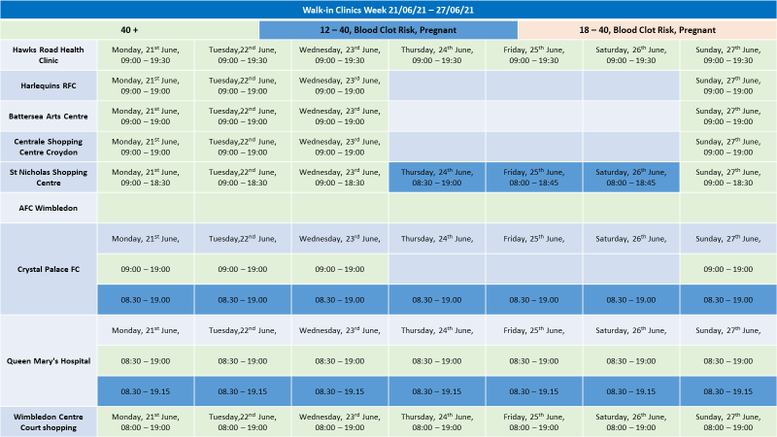Please note this information is applicable to Care Home staff only and should not be shared more widely.

## Opening times and Vaccine Centers for walk in

Please note that for all sites you will need to take proof of employment:

* staff id card with photo
* or letter from manager/payslip plus photo id (e.g. Passport, Drivers Licence)

We recognise that information on the COVID-19 virus and vaccine can sometimes be confusing.

In South West London, we are offering staff a chance to ask questions and receive advice about COVID-19 in general and/or the vaccine. The questions are reviewed and answered by qualified clinicians, including GP’s, nurses and other healthcare professionals.

We aim to respond to your questions quickly, but this may take up to 2 working days. Please feel free to submit more than one question.

[Carehome.covidvaccine@swlondon.nhs.uk](mailto:Carehome.covidvaccine@swlondon.nhs.uk)

## Second COVID-19 Vaccine Doses

From this week, Health and Social Care Workers and people over the age of 50 will have their second dose vaccines brought forward to 8 weeks.  If you have booked on the national booking system this will be done automatically.  People under the age of 50 who do not work in Health and Social Care will still receive their second dose vaccine between 77 days – 84 days after the first vaccine.  If you do not have a second dose appointment booked within these time frames, then please contact [Carehome.covidvaccine@swlondon.nhs.uk](mailto:Carehome.covidvaccine@swlondon.nhs.uk)  who will support you to book your second dose and can answer any questions.

# New Guidance for first dose Astra Zeneca (Oxford) Covid-19 Vaccine

The JCVI has posted their press release on the [new guidance for under 40s](https://www.gov.uk/government/news/jcvi-advises-on-covid-19-vaccine-for-people-aged-under-40).

Of note, they emphasize this is a precautionary approach and influenced by the lower infection rates in the UK.

The advice provided indicates a ‘*preference for adults aged 30-39 without underlying health conditions to receive an alternative to Oxford/Astra-Zeneca vaccine-where available and only if this does not cause substantial delays in being vaccinated*.’

It remains safe for people under the age of 40 years to have a first dose Pfizer or Moderna Covid-19 vaccination.

If you experienced any of the following symptoms after your first Astra Zeneca (Oxford) Covid-19 Vaccines:

* As a precautionary measure, anyone who has symptoms four days or more after vaccination is advised to seek prompt medical advice, such as:
  + a new onset of severe or persistent headache, blurred vision, confusion or seizures
  + develop shortness of breath, chest pain, leg swelling or persistent abdominal pain
  + unusual skin bruising or pinpoint round spots beyond the injection site

Then a clinical consultation should be undertaken before the second dose appointment. **If these side-effects were not experienced if is safe to receive the second dose.**

For people over 40 years of age it is safe to use any of the vaccines unless you have a specific clinical allergy or contraindication.

To book a Pfizer first dose, for any queries or to enquire about 2nd doses, please email: [CareHome.CovidVaccine@swlondon.nhs.uk](mailto:CareHome.CovidVaccine@swlondon.nhs.uk) for more information

# Supporting Staff with Vaccine Hesitancy

A one to one interview vaccine hesitancy pack for managers has been developed to support managers to undertake interviews with staff who are vaccine hesitant. This pack will be regularly updated with support material. Please contact your CCG Care Home lead if you do not have a copy of the pack; contact details available on first page.

The following recordings of the live webinars on the COVID-19 Vaccination can be accessed below.

* [COVID-19 Vaccine Q&As with Dr Patrick Gibson and Dr Marek Jarzembowski with Polish translation](https://www.youtube.com/watch?v=EDa4O8mH5mk)
* [COVID-19 Q&A with Dr Agnelo Fernandes and COVID-19 experience shared by Erik Cortez](https://youtu.be/mo5Bng-ClqI)
* [COVID-19 Vaccine Q&A with Dr Agnelo Fernandes, Dr Aditi Shah and COVID-19 experience shared by Vanessa Vyapooree](https://www.youtube.com/watch?v=5IesnLadLU8&feature=youtu.be)
* [COVID-19 Vaccine Q&As with a Focus on Allergies and Health Conditions with Dr Paul Riley and Dr Vasa Gnanapragasam](https://www.youtube.com/watch?v=qNBjiMpKOIM&feature=youtu.be)
* Young Fit and Healthy, why do I need the COVID-19 Vaccine? With Dr Paul Riley, Gassan Yacob and COVID-19 experience shared by Erik Cortez
* [COVID-19 Vaccine Q&A with BSL, focusing on Race Religion Background or Beliefs with Dr Vasa Gnanapragasam and Chief Pharmacist Sedina Agama](https://youtu.be/eEsY63EmhmM)
* [BSL interpreted FAQs on COVID-19 Vaccine with Dr Paul Riley and COVID-19 experience shared by Lisa Royle](https://youtu.be/mbQczkChffg)
* [COVID-19 Vaccine Q&A with a Focus on Women's Health with Dr Aditi Shah and Fiona White](https://youtu.be/_kFI6Cmc86I)

Below is a video of social worker Marcia Wilson explaining her journey and decision to have the COVID-19 Vaccine

* <https://twitter.com/yourcroydon/status/1357041318313263112>

# SECTION 1: Updated Guidance 17/06/21



Current Coronavirus restrictions: [what-you-can-and-cannot-do](https://www.gov.uk/guidance/covid-19-coronavirus-restrictions-what-you-can-and-cannot-do)

There has been a joint statement from UK Chief medical officers recommending that the UK COVID-19 Alert will move from level 4 to **level 3** [Covid -19 alert level](https://www.gov.uk/government/news/covid-19-alert-level-update-from-the-uk-chief-medical-officers-10-may-2021) on the 10th May 2021

Further guidance on care home visiting was update on 17th June 2021 see what this means for your area and visiting for care homes at: [Care Home Visiting](https://www.gov.uk/government/publications/visiting-care-homes-during-coronavirus/update-on-policies-for-visiting-arrangements-in-care-homes) &

[Visits out of care homes](https://www.gov.uk/government/publications/arrangements-for-visiting-out-of-the-care-home/visits-out-of-care-homes)

From 21 June, people admitted to a care home from the community will no longer have to self-isolate for 14 days on arrival, so residents will have a less disruptive introduction to their new home.

Care home residents will be able to spend more time with family and friends, including overnight stays as part of an easing of visiting restrictions

Care home residents would still need to isolate for 14 days following a visit out that would be deemed high risk through a risk assessment or after an overnight stay at hospital.

[care home residents can stay overnight](https://www.gov.uk/government/news/care-home-residents-can-stay-overnight-as-visiting-restrictions-ease)

**Demonstrating Covid-19 vaccination status when travelling abroad**

From 17 May, people in England who have had a full course of the Covid-19 vaccine will be able to demonstrate their Covid-19 vaccination status for international travel. A full course is currently two doses of any approved vaccine. [Find out more.](https://londoncommunications.cmail20.com/t/d-l-qikhte-ykhtuyiyur-m/)

## Personal Protective Equipment

This guidance has been updated on Wednesday 9th June 2021 and can be accessed at:

[.gov how-to-work-safely-in-care-homes PPE](https://www.gov.uk/government/publications/covid-19-how-to-work-safely-in-care-homes/personal-protective-equipment-ppe-resource-for-care-workers-working-in-care-homes-during-sustained-covid-19-transmission-in-england)

* to clarify the meaning of sessional use and the difference between source control and PPE
* to clarify the safe use of face masks and when to use them, focusing on the use of:
  + the Type I or II face mask which is worn to protect others from you (source control)
  + the Type IIR face mask which is used as PPE. Type IIR face masks help to protect you, the wearer, from exposure to COVID-19 but also act as source control, protecting others from you
* to clarify when to change a Type IIR face mask (being worn as PPE) following direct personal care
* to clarify that you should change a Type IIR face mask when providing direct personal care to COVID-19 positive residents or residents that may have symptoms of COVID-19
* to clarify sessional use of a face mask (Type I or II) is acceptable when carrying out domestic duties or other activities more than 2 metres from residents
* new advice on what to do when within 2 metres of a resident or anyone else within your working environment
* an updated section on what to do with waste including disposing of PPE safely

The guidance has been updated to reflect the current COVID-19 situation in England, the latest scientific evidence at this stage of the pandemic and stakeholder and user feedback.

## Polyethylene glycol (PEG)

laxatives and starch-based thickeners: potential interactive effect when mixed, leading to an increased risk of aspiration [.Gov Drug safety update](https://www.gov.uk/drug-safety-update/polyethylene-glycol-peg-laxatives-and-starch-based-thickeners-potential-interactive-effect-when-mixed-leading-to-an-increased-risk-of-aspiration)

## 111*6

### 

If you are concerned about a resident, please contact a member of your Care Home Support Team (CHST)

If out-of-hours, please contact 111*6. This service is available to all Care Homes across South West London.

The 111*6 telephone line will enable staff in care homes to speak to a service advisor who will take the patient’s details and ask a few clinical questions. They will not have to wait in the same call queue as patients who are calling themselves; this will enable them to have a quicker response.

111*6 is for all care homes who need fast access to a clinical team who can give advice and medical input needed for residents. If admission is required, hospitals are finding patients are arriving without key information (the Reg Bag should contain key paperwork, medication, and essential personal items).

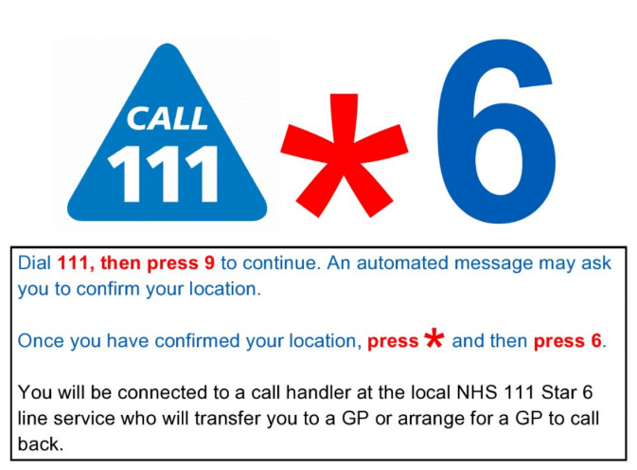

# What’s New?

## Vaccination Guides

Version 4 of [COVID-19 vaccination guide for childbearing, pregnant or breastfeeding women](https://eur01.safelinks.protection.outlook.com/?url=https%3A%2F%2Fwww.gov.uk%2Fgovernment%2Fpublications%2Fcovid-19-vaccination-women-of-childbearing-age-currently-pregnant-planning-a-pregnancy-or-breastfeeding&data=04%7C01%7CC19guidance.SPOC%40phe.gov.uk%7C2789361d9aca4470575a08d908bd94f1%7Cee4e14994a354b2ead475f3cf9de8666%7C0%7C0%7C637550432602326531%7CUnknown%7CTWFpbGZsb3d8eyJWIjoiMC4wLjAwMDAiLCJQIjoiV2luMzIiLCJBTiI6Ik1haWwiLCJXVCI6Mn0%3D%7C1000&sdata=BERUAkHN%2BSURMIREOxyVRnmKAucwSdj0vzQcAzRd4o0%3D&reserved=0) has been published.

We have also revised the

COVID-19 vaccination guide for adults leaflet– [new version 4 for Phase 2](https://eur01.safelinks.protection.outlook.com/?url=https%3A%2F%2Fwww.gov.uk%2Fgovernment%2Fpublications%2Fcovid-19-vaccination-guide-for-older-adults&data=04%7C01%7CC19guidance.SPOC%40phe.gov.uk%7C2789361d9aca4470575a08d908bd94f1%7Cee4e14994a354b2ead475f3cf9de8666%7C0%7C0%7C637550432602336488%7CUnknown%7CTWFpbGZsb3d8eyJWIjoiMC4wLjAwMDAiLCJQIjoiV2luMzIiLCJBTiI6Ik1haWwiLCJXVCI6Mn0%3D%7C1000&sdata=Bz9JvBXSdv3ivuxVrfuXgBy7J8ws70nHfO92WJJxV7k%3D&reserved=0) paper copies available to order now

What to expect after your COVID-19 vaccination leaflet – [new version for Phase 2](https://eur01.safelinks.protection.outlook.com/?url=https%3A%2F%2Fwww.gov.uk%2Fgovernment%2Fpublications%2Fcovid-19-vaccination-what-to-expect-after-vaccination%2F&data=04%7C01%7CC19guidance.SPOC%40phe.gov.uk%7C2789361d9aca4470575a08d908bd94f1%7Cee4e14994a354b2ead475f3cf9de8666%7C0%7C0%7C637550432602336488%7CUnknown%7CTWFpbGZsb3d8eyJWIjoiMC4wLjAwMDAiLCJQIjoiV2luMzIiLCJBTiI6Ik1haWwiLCJXVCI6Mn0%3D%7C1000&sdata=5nuuhOlc7wC%2BRHIJbSlDKlmQgl1PAGK4%2BgJ0J4E8DME%3D&reserved=0) as above

COVID-19 vaccination and blood clotting collection has been revised

[https://www.gov.uk/government/collections/covid-19-vaccination-and-blood-clotting](https://eur01.safelinks.protection.outlook.com/?url=https%3A%2F%2Fwww.gov.uk%2Fgovernment%2Fcollections%2Fcovid-19-vaccination-and-blood-clotting&data=04%7C01%7CC19guidance.SPOC%40phe.gov.uk%7C2789361d9aca4470575a08d908bd94f1%7Cee4e14994a354b2ead475f3cf9de8666%7C0%7C0%7C637550432602346432%7CUnknown%7CTWFpbGZsb3d8eyJWIjoiMC4wLjAwMDAiLCJQIjoiV2luMzIiLCJBTiI6Ik1haWwiLCJXVCI6Mn0%3D%7C1000&sdata=5rARbuM7FayGf8Cn%2Fu%2Fd36qTBMa5ZcZ5C9QcAq5as2o%3D&reserved=0)

VITT investigation / management HTML is live

[https://www.gov.uk/government/publications/clinical-investigation-and-management-of-covid-19-vaccine-induced-thrombosis-and-thrombocytopenia](https://eur01.safelinks.protection.outlook.com/?url=https%3A%2F%2Fwww.gov.uk%2Fgovernment%2Fpublications%2Fclinical-investigation-and-management-of-covid-19-vaccine-induced-thrombosis-and-thrombocytopenia&data=04%7C01%7CC19guidance.SPOC%40phe.gov.uk%7C2789361d9aca4470575a08d908bd94f1%7Cee4e14994a354b2ead475f3cf9de8666%7C0%7C0%7C637550432602346432%7CUnknown%7CTWFpbGZsb3d8eyJWIjoiMC4wLjAwMDAiLCJQIjoiV2luMzIiLCJBTiI6Ik1haWwiLCJXVCI6Mn0%3D%7C1000&sdata=VitVEruyye4LYMO5IaW%2BCvB4qIa%2BoJzo9Z5ka%2BxLwUk%3D&reserved=0)

[COVID-19 vaccination and blood clotting – patient guide](https://eur01.safelinks.protection.outlook.com/?url=https%3A%2F%2Fwww.gov.uk%2Fgovernment%2Fpublications%2Fcovid-19-vaccination-and-blood-clotting%2Fcovid-19-vaccination-and-blood-clotting&data=04%7C01%7CC19guidance.SPOC%40phe.gov.uk%7C2789361d9aca4470575a08d908bd94f1%7Cee4e14994a354b2ead475f3cf9de8666%7C0%7C0%7C637550432602356397%7CUnknown%7CTWFpbGZsb3d8eyJWIjoiMC4wLjAwMDAiLCJQIjoiV2luMzIiLCJBTiI6Ik1haWwiLCJXVCI6Mn0%3D%7C1000&sdata=3RLe8GDMPL3Nk2EkuaaNVHBEA%2BW%2BevI7PVJsxdH31R4%3D&reserved=0) (**must** be given to anyone offered the AstraZeneca vaccination)

## Care Home Champion Meeting

The 3rd Infection Prevention and Control Care Home Champion Meeting takes place on:

28th June 2021 2-3pm (last Monday of every month)

Looking at:  Hand Hygiene Audit plus dehydration and its devastating effects.

This meeting is for IPC champions in each care home and we would like the care home managers to nominate and send the invite to those people. The aim of this meeting is to look at a small part of the IPC audit tool and the Chain of Infection.

The session will be interactive, and we will allow time for questions and the sharing of good practice. Meetings are ongoing and monthly at this time and the aim is to offer support and training for IPC leads and/or Champions in each Care Home. You do not need to have been to first session in April to attend, this meeting is open to all IPC Leads and Champions.

Please use the link below to access the meeting or contact [Helen.Thurlow@swlondon.nhs.uk](mailto:Helen.Thurlow@swlondon.nhs.uk) with any questions

Microsoft Teams meeting

**Join on your computer or mobile app**

[Click here to join the meeting](https://teams.microsoft.com/l/meetup-join/19%3ameeting_OWI5ZmQ4ODktOWE2YS00YmM2LWE4MGYtMDIxODI0MzE2YTFh%40thread.v2/0?context=%7b%22Tid%22%3a%22c75c680c-ebe2-4232-85b0-a365c8982c49%22%2c%22Oid%22%3a%22a41755ae-e58d-4a93-a63f-2e5b0e907142%22%7d)

[Learn More](https://aka.ms/JoinTeamsMeeting) | [Meeting options](https://teams.microsoft.com/meetingOptions/?organizerId=a41755ae-e58d-4a93-a63f-2e5b0e907142&tenantId=c75c680c-ebe2-4232-85b0-a365c8982c49&threadId=19_meeting_OWI5ZmQ4ODktOWE2YS00YmM2LWE4MGYtMDIxODI0MzE2YTFh@thread.v2&messageId=0&language=en-US)

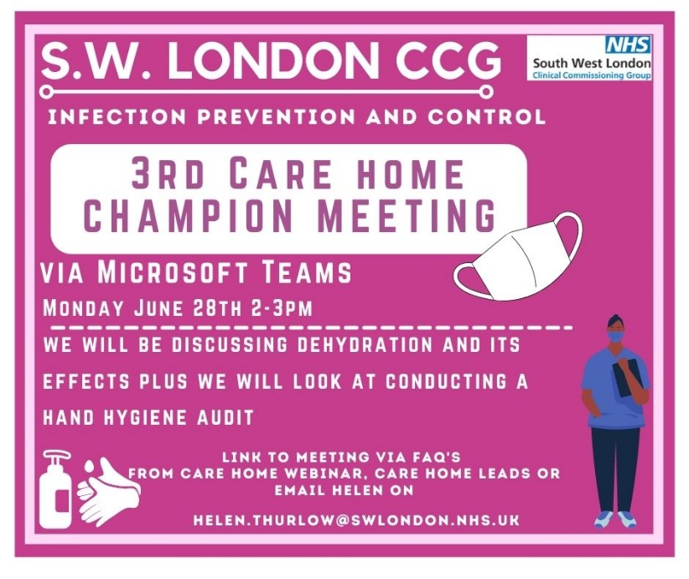

## IPC guidance direct to your mobile

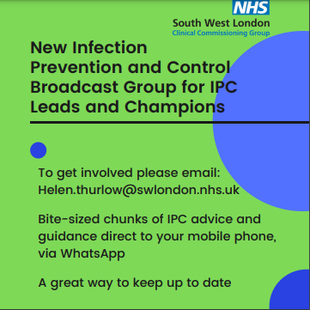

Direct information and Infection Prevention Guidance straight to your mobile.

If you would like to receive this and are an infection prevention and control lead or champion, you can access this service by emailing

[Helen.Thurlow@swlondon.nhs.uk](mailto:Helen.Thurlow@swlondon.nhs.uk)

## IPC Training offers

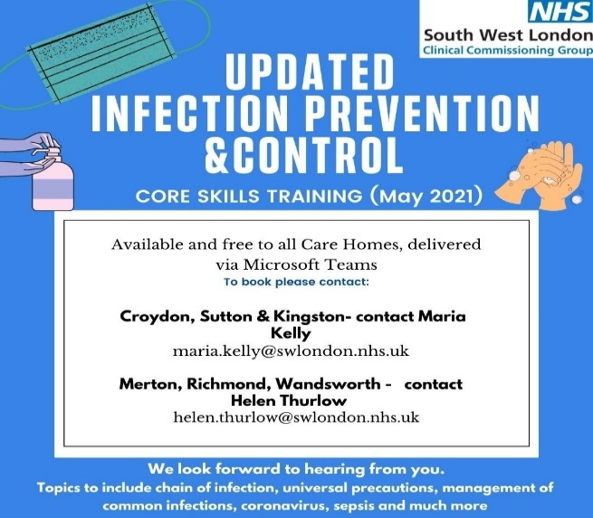

The South West London infection prevention and control team are offering two types of training to all care homes to choose from:

1. Covid-19 specific training
2. Core Skills Training

They are now booking sessions for the week commencing 7th June please contact Maria Kelly for Croydon Sutton and Kingston or Helen Thurlow for Merton Richmond and Wandsworth.

## Uniform Bags

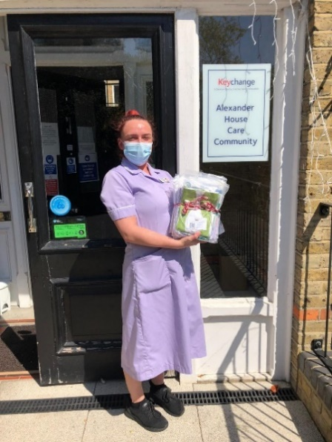

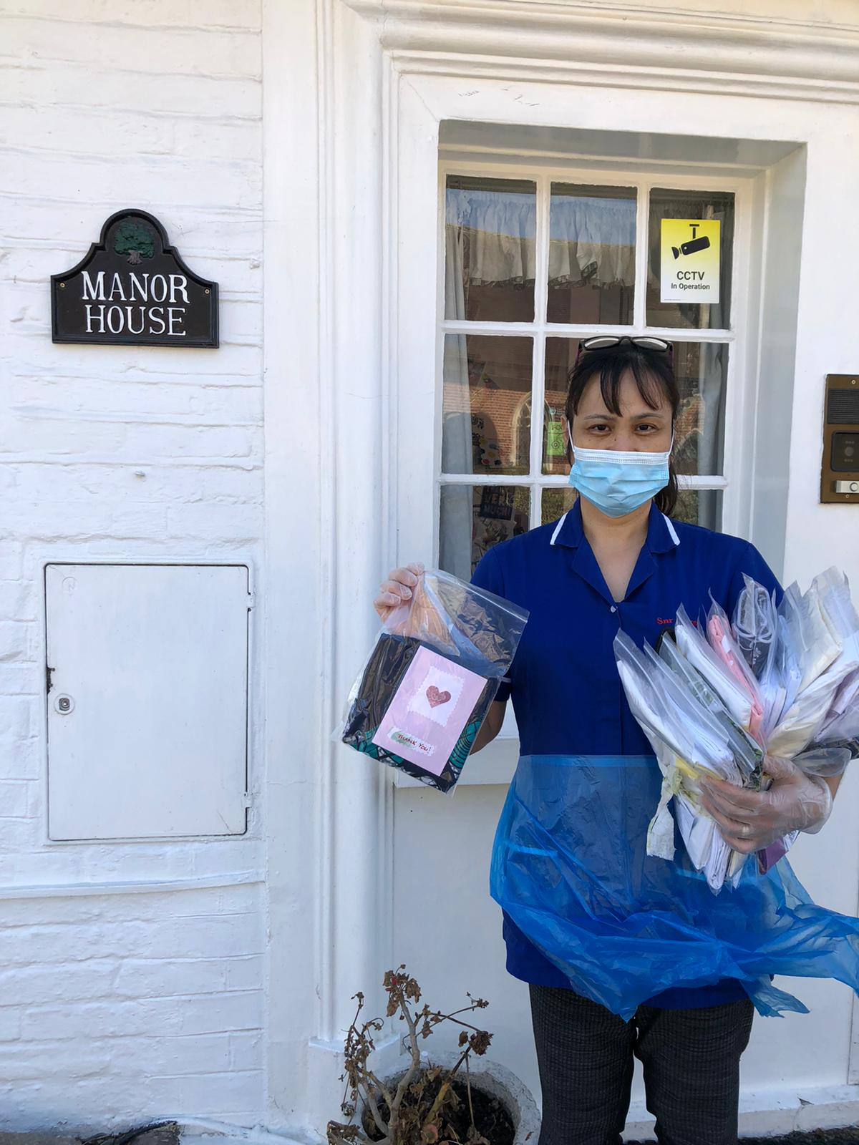

Local charity, Merton A.R.K. (Acts of Random Kindness) have kindly donated Uniform Bags to South West London Care Homes. Pictured here are staff from Care Homes who have gratefully received bags for staff.

A uniform bag is a fabric bag that carries a staff member’s uniform. When staff travel to and from work, they should wear everyday clothes to prevent work clothes coming into contact with coronavirus.

The staff member then changes into the uniform for their shift. At the end of the shift, staff should change into everyday clothes and the used uniform is placed inside the uniform bag securely. When the staff member gets home, the uniform bag and uniform should be put directly into the washing machine and washed on a hot wash. The bag and uniform should then be tumble dried and/or ironed to ensure all virus particles are eliminated.

If a staff member does not have a uniform bag, pillow slips can be used instead.

If you are interested in receiving a uniform bag please contact Jiggy Trivedi-Gardner on [jiggy.trivedi-gardner@swlondon.nhs.uk](mailto:jiggy.trivedi-gardner@swlondon.nhs.uk) with Care Home name, location, number of bags required and a contact.

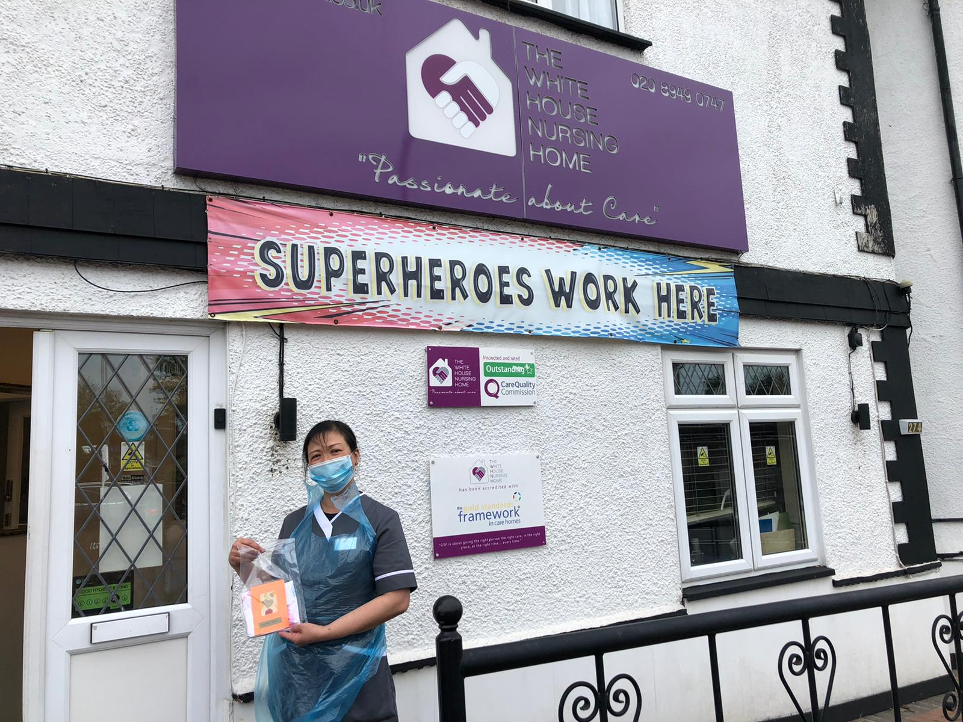

## Pre-Recorded COVID-19 Vaccine Q&A webinars

Please see below the link to the staff Q&A session on the Covid-19 vaccine, fertility and pregnancy:

**Recording: Staff Q&A on the Covid-19 vaccine, fertility and pregnancy**

A recording of the health and social care staff Q&A session on the Covid-19 vaccine, fertility and pregnancy is now available to view via this [YouTube link](https://youtu.be/l2kuAs1_UZ8). Questions were answered by three clinical experts:

* Helene Brown, Medical Director (System Improvement and Professional Standards) for NHS London
* Memuna Sowe, Specialist Midwife for vulnerable and marginalised women at NHS Croydon Health Services
* Garima Srivastava, Consultant Gynaecologist and fertility lead at Homerton University Hospital

## COVID 19 Vaccine Questions and Answers in English and Polish



[COVID-19 Vaccine Q&As with Dr Patrick Gibson and Dr Marek Jarzembowski with Polish translation](https://www.youtube.com/watch?v=EDa4O8mH5mk)

## Ways to Reach out to Friends and Neighbours

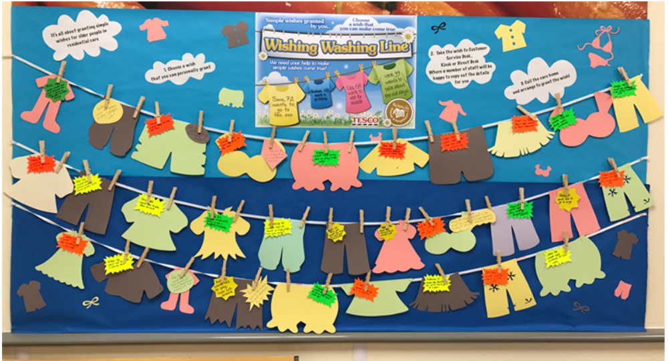

<http://carehomefans.org/fans_in_action/wishing-washing-line/>

Are you a care home wanting to start a Wishing Washing Line? Or are you a community member who could host a Wishing Washing Line in your local area? Either way, please get in touch! [mhl@city.ac.uk](mailto:mhl@city.ac.uk)

## Good thinking website for Wellbeing





There are lots of NHS-approved wellbeing apps available on Good Thinking (many of which are free if you live or work in London) and workbooks written by the Centre for Clinical Interventions. The Good Thinking team has also produced specific advice for health and care professionals related to mental health and COVID-19, including a free [**employers toolkit**](https://www.good-thinking.uk/employers/) to help support employees' mental health.

You can scan the QR code to access the site or click on this link: <https://www.good-thinking.uk/health-and-care-professionals/>

## Support available from The Prince’s Trust

The Prince’s Trust has committed to supporting 10,000 young people aged 18-30 into Health & Social Care careers over the next four years. To take part in this programme all The Princes Trust needs is entry level roles for young people to interview for and someone interview them on recruitment day.

Student Placements

Are you interested in hosting a placement student (Nurses and AHPs in training)? Individual placements run for a minimum of 3 weeks, we can establish a regular rotation, supervision is required (training and is provided).

Recruiting staff

The Work and Health Programme is an employment support programme, seeking to find long term sustainable employment opportunities for people in South London.

Please let us know about your recruitment needs, we may be able to help - please complete our survey:





## Upcoming Webinars



Becoming an Advocate for Allyship and Inclusive Leadership

Multiple dates available

<https://www.eventbrite.co.uk/e/becoming-an-advocate-for-allyship-and-inclusive-leadership-tickets-156978662405>

Digital

The following sessions have been scheduled with the 'Better Security Better Care' team (DSPT) to deliver bitesize sessions to care homes covering Data Protection Impact Assessment (DPIA)

Information Asset Register (IAR). Record of Processing Activities (ROPA). over the next month:

|  |  |  |
| --- | --- | --- |
| Tuesday, June 22, 2021 | 15:30-16:15 | Care Homes: IAR and ROPA |
| Tuesday, June 29, 2021 | 15:30-16:15 | Care Homes: IAR and ROPA |
| Friday, July 2, 2021 | 15:30-16:15 | Care Homes: DPIA |
| Tuesday, July 6, 2021 | 15:30-16:15 | Care Homes: IAR and ROPA |
| Friday, July 9, 2021 | 15:30-16:15 | Care Homes: DPIA |
| Tuesday, July 13, 2021 | 15:30-16:15 | Care Homes: IAR and ROPA |
| Friday, July 16, 2021 | 15:30-16:15 | Care Homes: DPIA |

To book you please contact the helpdesk [nelcsu.information-governance@nhs.net](mailto:nelcsu.information-governance@nhs.net)

# SECTION 2: Frequently Asked Questions

### Are visitors to care homes still required to take a Lateral Flow Device test before visiting?

Visitors will need to either show a negative test on arrival or be tested once arrived with admittance granted only when confirmed negative.

### Are professionals still required to provide proof of negative testing before visiting care homes?

Yes, professional health care visitors are required to provide proof of a negative test taken within the last 72 hours. This may be evidenced by a photograph or NHS notification or a signed letter from their manager to confirm that a negative test has been taken within the previous 72 hours. If you are having any issues, please contact your CCG lead (contact details for your area available on page 2 of this document) or your public health lead for your borough.

### Advice on new symptoms?

Reports are suggesting that common symptoms of the Delta variant may be different to those of other variants. Some surveillance suggests that headache, sore throat, runny nose and diarrhoea are common symptoms of the Delta variant, but the UK guidance has not been updated yet to reflect these new symptoms. It is important where there is any suspicion that you may have symptoms including that of the new symptoms reported of COVID-19 infection that you isolate and test with PCR.

### Do I need to complete Data Security and Protection Toolkit (DSPT)?

Our inspectors do encourage care providers to use the officially recognised Data Security and Protection Toolkit (DSPT) to assess their own data and cyber security arrangements – and provide evidence that they are complying with legal and regulatory requirements.

At present, it is not mandatory for care providers to complete the toolkit in order to demonstrate compliance with CQC standards. However, it is certainly one of the most effective and efficient ways of demonstrating compliance to our inspectors and we do expect providers to consider how information is accessed, shared by others and kept safe.

Given the particularly challenging year that care providers have faced during the COVID-19 pandemic, our inspectors have, understandably, been focused on other areas – especially infection control. So, although inspectors many do not ask for evidence that a care provider has completed the Data Security and Protection Toolkit, we would definitely encourage providers to use it.

### I have not been receiving the weekly information sharing FAQs?

The weekly information sharing FAQs are sent out to Care Home managers every week. At present these should be to your NHS Mail inbox and your work email inbox. From the 5th July 2021 we aim to only be sending these to your NHS Mail. If you are not receiving to either mailbox at present, please contact your CCG Care Home Lead (contact details available on page 2 of this document). If you are having difficulty with your NHS mail please contact: [SWLcarehomes.admin@swlondon.nhs.uk](mailto:SWLcarehomes.admin@swlondon.nhs.uk)

### I have an NHS email for the care home, is there a way to directly open the care home NHS email?

If you would like further support with NHS Mail please email [SWLcarehomes.admin@swlondon.nhs.uk](mailto:SWLcarehomes.admin@swlondon.nhs.uk) and the team will provide assistance with your queries.

### How can I support my staff with the EU Settlement Scheme?

There is a template letter for EU citizen staff that central government is encouraging employers to use in advance of the June deadline. The template can be found [here.](https://www.gov.uk/government/publications/eu-settlement-scheme-template-letter-to-eu-citizen-staff/eu-settlement-scheme-template-letter-to-eu-citizen-staff)

### I am a manager of a Care Home and I have really tried to encourage my staff to have the vaccine, with several supervision sessions but I don’t know what else I can do for those staff who won’t have it?

People have many reasons for declining a vaccine; if you can talk to your member of staff and find out the reasons they are declining. You can ask the member of staff to speak to a clinician they trust to enable them to make an informed decision. We are aware that it has been developed to protect us from the Covid-19 virus and it is important for Care Home staff to have the vaccine.

As a manager, it is good practice to have a 1 to 1 meeting with each staff member who has declined the vaccine to discuss their concerns, ensure they are making the decision based on facts, undertaking a risk assessment and documenting these discussions and actions.

To support you as a manager, we have developed a 1 to 1 interview pack for managers to use with staff who are vaccine hesitant. The Pack has been sent out with previous FAQs if you have not yet received it please email [carehome.covidvaccine@swlondon.nhs.uk](mailto:carehome.covidvaccine@swlondon.nhs.uk) and it can be sent to you.

**We strongly encourage you to use this pack with any staff who are refusing the vaccine so that you are protecting the staff and that you are providing evidence as a manager of the support that you have given.**

Staff should be encouraged to speak to someone about the vaccine – they can phone Nurse Fiona White on 07770684842 and she will be happy to answer any of their concerns and questions. There is a consultation about vaccinations and care homes currently in progress. The covid-19 vaccine helps prevent the risk of hospitalisation and decreases the complications to the person, family members and clients, staff you work with. No vaccine is 100% effective so it may not prevent you getting the virus, but evidence is currently showing it can reduce transmission and complications. Fiona has offered to speak to anyone who needs help making a decision.

### What is the updated care home visiting guidance?

Care homes can allow every resident to name up to 5 people who can come for regular indoor visits. But importantly this will **only** include a maximum of 2 per resident at any given time and in one day As far as possible these should remain the same 5 people. Care homes can only welcome a certain number of visitors a day to ensure social distancing can be adhered to. The visits will need to be arranged by appointment in advance and ad hoc visits cannot be enabled. Care Home mangers are best placed to decide how this will be managed.

These 5 visitors must include the essential giver if one has been identified.

Please find more information at [Summary of Care Home visiting guidance](https://www.gov.uk/government/publications/visiting-care-homes-during-coronavirus/summary-of-guidance-for-visitors--2) updated on 17th June 2021

The named visitors will need to follow some important steps to reduce the risk of infection to the person they are visiting and to others in the care home.

**Take a rapid lateral flow test**

The named visitors will need to take a rapid (lateral flow) test every time they visit. If the result is negative, the visit can go ahead.

**Wear PPE**

Visitors will need to wear personal protective equipment (PPE) for the duration of the visit.

Visits should take place in a well-ventilated room, for example with windows and doors open where it is safe to do so. Providers should consider the use of designated visiting rooms, which are only used by one resident and their visitors at a time and are subject to regular enhanced cleaning and ventilation between visits. Any areas used by visitors should be decontaminated several times throughout the day and providers should avoid clutter to aid cleaning.

BEREAVEMENT AND WELLBEING SUPPORT FOR STAFF

|  |  |  |
| --- | --- | --- |
| **Borough** | **Name of Service** | **Contact Details** |
| All SWL | Marie Curie | Call 020 7091 3656 for emotional and bereavement support.  Monday – Friday, 08:00 – 18:00  Saturday – Sunday, 11:00 – 17:00 |
| Sutton | Sutton Uplift | Telephone hotline (8 am – 5 pm): 020 3513 4044  Self-referral: <https://www.suttonuplift.co.uk/psychological-therapies>  Email: [ssg-tr.suttonuplift@nhs.net](mailto:ssg-tr.suttonuplift@nhs.net) |
| Merton | Merton Uplift | Telephone hotline (9 am – 5 pm): 020 3513 5888  Self-referral: <https://www.mertonuplift.nhs.uk/>  Email: [ssg-tr.mertonuplift@nhs.net](mailto:ssg-tr.mertonuplift@nhs.net) |
| Wandsworth | Talk Wandsworth | Telephone hotline (8 am – 5 pm): 020 3513 6264  Self-referral: <https://www.talkwandsworth.nhs.uk/>  Email: [ssg-tr.WANIAPT@nhs.net](mailto:ssg-tr.WANIAPT@nhs.net) |
| Kingston and Richmond | Bereavement Support  iCope (Kingston only)  Richmond Wellbeing Service | <https://www.kingstonbereavementservice.org.uk/contact-us/>  <https://www.icope.nhs.uk/kingston/>  <https://www.richmondwellbeingservice.nhs.uk/> |
| Richmond | Cruse | Tel: 0749 5776 401 |

EOLC CLINICAL SUPPORT FOR STAFF

|  |  |  |  |  |
| --- | --- | --- | --- | --- |
| **Provider Service** | **Borough** | **What is on Offer** | **Operating Hours** | **Contact Details** |
| St Raphael’s Hospice | Sutton and Merton | Clinical Advice from Clinical Nurse Specialist on triage team.  Access to Medical team advice.  Clinical Advice from Palliative Care Nurses covering inpatient wards. | Monday - Sunday  09:00-17:00  Monday-Sunday  17:00-09:00 | Central Hospice Switch:  020 8099 7777    Ask for CNS triage team.    Ask for inpatient unit. |
| Royal Trinity Hospice | Wandsworth | A Clinical Nurse Specialist to provide expert advice and support for GPs, HCPs, patients and carers.  Medical on call cover (Registrar and Consultant) | 24 hours a day, 7 days a week | Central Hospice Switch:  020 8099 7777    Ask for CNS triage team.  Ask for inpatient unit. |
| Marie Curie | All SWL Boroughs | Professional Information and Support | Monday – Friday  08:00 – 18:00  Saturday – Sunday  11:00–17:00 | Tel: 020 7091 3656  [www.mariecurie.org.uk/southwestlondon](http://www.mariecurie.org.uk/southwestlondon) |
| Princess Alice Hospice | Richmond and Kingston | Careline which has a triage process with access to senior staff and Community Nurse’s | 24 hours a day, 7 days a week | Tel: 020 8744 9414 |
| St Christopher’s Hospice | Croydon | Professionals’ helpline for clinical support  Patient support line | 24 hours a day, 7 days a week | Professionals: 020 8767 4582  Patients: 020 8767 4500 |

# Section 3: Additional information

## Infection Control Champions for Care Homes

Please contact Helen Thurlow ([infectioncontrol@swlondon.nhs.uk](mailto:infectioncontrol@swlondon.nhs.uk)) with the details of any individual who would like to become an IPC Champion.

## Contact details for advice and support for mental health and wellbeing.

The Health and Wellbeing of staff in the care sector is available online at: <https://www.good-thinking.uk/>

This website has links to useful apps quizzes workbooks and advice. There are 4 free apps at present. If you register on the app now you can have lifetime access to meditation sessions, mindfulness, cognition exercises and other podcasts that help with improving wellbeing.

## Support for Managing Residents with Dementia

NHS England have just published a guide for Dementia wellbeing in the COVID-19 pandemic.  This provides single page support pages for supporting people with Dementia. The document is attached and is available via the following links: <https://www.england.nhs.uk/mental-health/resources/dementia/>  
<https://www.england.nhs.uk/coronavirus/community-social-care-ambulance/mental-health/>

# SECTION 4: ONGOING ADVICE AND SUPPORT

### Support for EOLC from Hospice UK

Hospice UK have released a support pack. You can access the guidance at: <https://www.hospiceuk.org/what-we-offer/clinical-and-care-support/clinical-resources>

### What to do if a resident has coronavirus symptoms

Isolate the resident in their own room and away from other residents for 14 days. Close the door if possible or consider moving the resident's bed 2m away from the door. The resident should preferably have a room with an en-suite. If this is not possible then the resident will need to use a commode. Contact the resident’s GP, or access 111 services online. **For a medical emergency dial 999.** If ONE resident displays COVID symptoms you need to contact the South London Health Protection Team/London COVID Response Cell (LCRC) to advise them of a suspected outbreak.

|  |  |
| --- | --- |
| SWL Health Protection Team | 0344 326 2052 |
| London COVID-19 Response Cell | 0300 303 0450 / [phe.lcrc@nhs.net](mailto:phe.lcrc@nhs.net) |

### If PPE is running low in your Care Home

From the 6th November 2020 it had been agreed that CQC registered organisations in primary and social care should access the national PPE portal for their stock requirements.

The PPE portal can be found at <https://www.gov.uk/guidance/ppe-portal-how-to-order-emergency-personal-protective-equipment> and we have attached an FAQs document which has been shared with us for your information. You will need to register on this portal first.

From this week social care organisations, including Care Homes, should utilise the national PPE portal as its primary supply of PPE. If organisations have difficulty in securing PPE stocks the steps they should take are:

(1) PPE Portal

(2) Local Resilience Forum

(3) BAU Suppliers

(4) South West London Mutual Aid via <http://swlpp.uk> online access.

South West London Mutual Aid will be updating their agreement with you and will contact you directly.

### NICE guidelines on Safeguarding adults in care homes



This final guideline has now been published on the [NICE website](https://www.nice.org.uk/guidance/NG189).

The guideline is for care home providers, commissioners of care homes, safeguarding practitioners, local authorities and safeguarding boards. It may also be useful to anyone who lives, works or visits care homes.

* [induction and training](https://www.nice.org.uk/guidance/ng189/chapter/Recommendations#induction-and-training-in-care-homes)
* [care home culture and management](https://www.nice.org.uk/guidance/ng189/chapter/Recommendations#care-home-culture-learning-and-management)
* [indicators of individual abuse and neglect](https://www.nice.org.uk/guidance/ng189/chapter/Recommendations#indicators-of-individual-abuse-and-neglect)
* immediate actions to take if you [consider](https://www.nice.org.uk/guidance/ng189/chapter/Recommendations#immediate-actions-to-take-if-you-consider-abuse-or-neglect) or [suspect](https://www.nice.org.uk/guidance/ng189/chapter/Recommendations#immediate-actions-to-take-if-you-suspect-abuse-or-neglect) abuse or neglect
* [how care home safeguarding leads and local authorities should respond to reports of abuse or neglect](https://www.nice.org.uk/guidance/ng189/chapter/Recommendations#responding-to-reports-of-abuse-or-neglect)
* [indicators of organisational abuse and neglect](https://www.nice.org.uk/guidance/ng189/chapter/Recommendations#indicators-of-organisational-abuse-and-neglect)

It includes summary versions of indicators to help practitioners identify abuse and neglect relating to [individuals](https://www.nice.org.uk/guidance/ng189/resources/indicators-of-individual-abuse-and-neglect-pdf-9013017709) and indicators of [organisational](https://www.nice.org.uk/guidance/ng189/resources/indicators-of-organisational-abuse-and-neglect-pdf-9013017710) abuse and neglect.

## APPENDIX 1: Useful Links and Contacts

#### NHS MAIL

NHS Mail is available free to all Care Homes allowing personal identifiable information to be sent securely to NHS services.  NHS Mail also allows access to Microsoft Teams which has video conferencing facilities, to connect with GPs, Health Care staff and the resident’s family.

If you need help to access, please contact: [SWLcarehomes.admin@swlondon.nhs.uk](mailto:SWLcarehomes.admin@swlondon.nhs.uk)

Most of you will have your NHS mail account now and we really want you to use your NHS shared mailbox now as this is the way the NHS will now contact you using the shared mailbox. We will be setting some deadlines for that with your local leads. The shared mailbox does keep your data secure and accessible and everything is in one place. We are sending out certificates so you can email your care home email lead or [SWLcarehomes.admin@swlondon.nhs.uk](mailto:SWLcarehomes.admin@swlondon.nhs.uk) from your shared mailbox, we will send you a certificate.

#### CAPACITY TRACKER

All Care Homes are being asked to submit **daily** information on staffing, bed vacancies, number of COVID cases and PPE or when the situation changes so that the NHS can support your homes more effectively. If you are not yet set up, or have more questions, please contact your local lead listed on the front of the FAQ. Please complete the ASC fund questions **weekly**. Contact 03005550340 or 01916913729 8am to 8pm if you have any questions or need support with this.

#### WORKFORCE AND STAFFING

COVID is a challenging time for maintaining staffing levels in Care Homes. We have a project running with Princes Trust to provide Care Support Workers, Domestic and administrative staff into Care Homes.  If you would like some support, please contact Paul Harper at: [paul.harper@swlondon.nhs.uk](mailto:paul.harper@swlondon.nhs.uk)

|  |  |
| --- | --- |
| **Topic** | **Click Links below** |
| The phone number for the IT Helpdesk is **020 3880 0268**. Open during 09:00 – 17:00. | [Information for free digital tools from Digital Social Care](https://www.digitalsocialcare.co.uk/covid-19-guidance/free-digital-tools-resources-for-covid-19/) |
| **PPE Portal help line number**: 0800 876 6802 | [How to order COVID-19 PPE](https://www.gov.uk/guidance/ppe-portal-how-to-order-covid-19-personal-protective-equipment)  [PPE resource for care workers](https://assets.publishing.service.gov.uk/government/uploads/system/uploads/attachment_data/file/931616/How_to_work_safely_in_care_homes_v8_2_11_2020.pdf)  [How to correctly don and doff of PPE in Care Homes](https://www.gov.uk/government/publications/covid-19-how-to-work-safely-in-care-homes/covid-19-putting-on-and-removing-ppe-a-guide-for-care-homes-video) |
| **Swabbing Residents Staff and Visitors** | [Coronavirus Testing process and how to register LFD Test](https://www.gov.uk/guidance/coronavirus-covid-19-getting-tested#care-home)  [Online Swabbing competency assessment](https://genqa.org/carehomes) |
| **Admissions and Care** | [COVID-19 Admission and Care of Residents in Care Homes](https://www.gov.uk/government/publications/coronavirus-covid-19-admission-and-care-of-people-in-care-homes/coronavirus-covid-19-admission-and-care-of-people-in-care-homes#section-1-admission) |
| **Infection Prevention and Control Guidance** | [Infection Prevention and Control Recommendations](https://assets.publishing.service.gov.uk/government/uploads/system/uploads/attachment_data/file/954690/Infection_Prevention_and_Control_Guidance_January_2021.pdf) |
| **Advice for pregnant health care workers** | [Pregnant employees COVID-19 advice](https://www.gov.uk/government/publications/coronavirus-covid-19-advice-for-pregnant-employees/coronavirus-covid-19-advice-for-pregnant-employees) |
| **Travel and self-isolation** | [Travel Corridors](https://www.gov.uk/guidance/coronavirus-covid-19-travel-corridors) |