NHS South West London CCG
Covid-19 and Care Homes - Frequently Asked Questions
Information Sharing Infection Prevention and Control Webinar: Tuesday 25th May 2021

Dear Social Care Colleagues,

Thank you for attending the Webinar for Care Homes this week; we hope that these continue to support you during the Covid-19 pandemic.

Thank you, too, for all your hard work to support your staff to take up the Covid-19 vaccine.

Covid-19 Astra Zeneca (Oxford) vaccine advice. Information released on the 7th May 2021: The JCVI has posted their press release on the new guidance for under 40s. Adults under 40 with no underlying health conditions that put them at risk of serious covid-19 illness will be offered an alternative to the Oxford-AstraZeneca vaccine.

Of note, they emphasize this is a precautionary approach and influenced by the lower infection rates in the UK.
The advice provided indicates a ‘preference for adults aged 30-39 without underlying health conditions to receive an alternative to Oxford/Astra-Zeneca vaccine-where available and only if this does not cause substantial delays in being vaccinated.’
We will share more information with you when we understand the impact in South West London.

The COVID-19 pandemic is an extremely challenging situation globally and we recognise that this is the case for staff working in Care Homes of all types. We are offering our support in many different ways, and one of these is through running a weekly Infection Prevention and Control and Information Sharing webinar Tuesday mornings at 11am. It is possible to ask questions during the webinar. If you have questions in advance, please email your local CCG Care Home Lead, listed below.

We would like to thank you all for your hard work and commitment during this incredibly challenging time.

Please share this document weekly with all staff in the Care Home.

With best regards

Viccie Nelson

Associate Director of Transformation
NHS South West London CCG

Your CCG Care Home Leads are:

Croydon Daniele Serdoz daniele.serdoz@swlondon.nhs.uk

Kingston and Richmond Brian Roberts brian.roberts@swlondon.nhs.uk

Merton Tayo Fowewe Kudirat.Fowewe@swlondon.nhs.uk

Sutton Lucy Webber Lucy.Webber@swlondon.nhs.uk

Wandsworth Anca Costinas Anca.Costinas@swlondon.nhs.uk

Please note email address for the Infection Control Team: infectioncontrol@swlondon.nhs.uk

Contents
Covid-19 vaccination for Care Home staff 4
Opening times and Vaccine Centers for walk in 5
Second COVID-19 Vaccine Doses 7
New Guidance for first dose Astra Zeneca (Oxford) Covid-19 Vaccine 7
Supporting Staff with Vaccine Hesitancy 7
SECTION 1: Updated Guidance 28/05/21 8
Polyethylene glycol (PEG) 8
111*6 8
8
What’s New? 9
Vaccination Guides 9
Care Home Champion Meeting 9
IPC guidance direct to your mobile 9
IPC Training offers 10
Uniform Bags 10
Upcoming COVID-19 Vaccine Q&A Webinars 11
Pre-Recorded COVID-19 Vaccine Q&A webinars 11
COVID 19 Vaccine Questions and Answers in English and Polish 11
Care home staff try out laughter yoga 12
Ways to Reach out to Friends and Neighbours 12
Good thinking website for Wellbeing 12
Support available from The Prince’s Trust 12
Upcoming Webinars 13
SECTION 2: Frequently Asked Questions 14
1. I want to ask about Service user's families wanting to take their loved ones on holiday abroad. Is there currently any restrictions or further guidance on residential clients taking holidays with their families? 14
2. I have not been receiving the weekly information sharing FAQs? 14
3. How can I support my staff with the EU Settlement Scheme? 14
4. I am a manager of a Care Home and I have really tried to encourage my staff to have the vaccine, with several supervision sessions but I don’t know what else I can do for those staff who won’t have it? 14
5. What is the updated care home visiting guidance? 15
Section 3: Additional information 17
Infection Control Champions for Care Homes 17
Contact details for advice and support for mental health and wellbeing. 17
Support for Managing Residents with Dementia 17
SECTION 4: ONGOING ADVICE AND SUPPORT 17
Support for EOLC from Hospice UK 17
What to do if a resident has coronavirus symptoms 17
If PPE is running low in your Care Home 18
NICE guidelines on Safeguarding adults in care homes 18
APPENDIX 1: Useful Links and Contacts 19

Covid-19 vaccination for Care Home staff

The way you book an appointment is changing
Care Home Staff Walk in service
Currently, Care Home staff can book at the national booking sites or attend as walk-ins. Please see the table below for the venues, addresses, vaccine type and times of the clinics. The national booking link is: https://www.nhs.uk/conditions/coronavirus-covid-19/coronavirus-vaccination/book-coronavirus-vaccination/

The national booking link can also be used to book at pharmacies who are providing vaccinations.
Walk in sessions will also be available at the following pharmacies:
- Ace Pharmacy: 1-3 Acre Parade, Hood Road, Chessington KT9 1DR
- Mayday Community Pharmacy: 508 London Road, Croydon CR7 7HQ
- St Boniface Church: 185 Mitcham Road, Wandsworth SW17 9PG
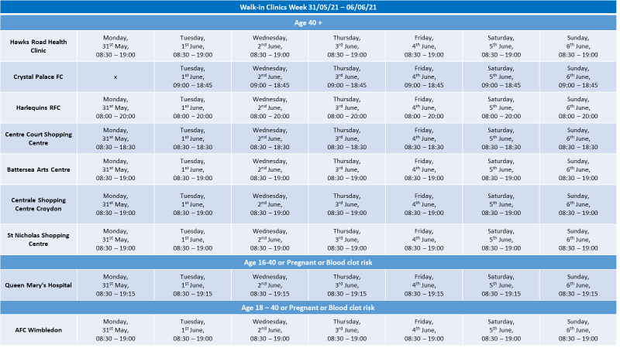
- Valley Pharmacy: St Aiden’s Church Hall, Chipstead Valley Road, Croydon CR5 3BB
Please note this information is applicable to Care Home staff only and should not be shared more widely.

Opening times and Vaccine Centers for walk in
Please note that for all sites you will need to take proof of employment:
- staff id card with photo
- or letter from manager/payslip plus photo id (e.g. Passport, Drivers Licence)

We recognise that information on the COVID-19 virus and vaccine can sometimes be confusing.
In South West London, we are offering staff a chance to ask questions and receive advice about COVID-19 in general and/or the vaccine. The questions are reviewed and answered by qualified clinicians, including GP’s, nurses and other healthcare professionals.

We aim to respond to your questions quickly, but this may take up to 2 working days. Please feel free to submit more than one question.
Carehome.covidvaccine@swlondon.nhs.uk
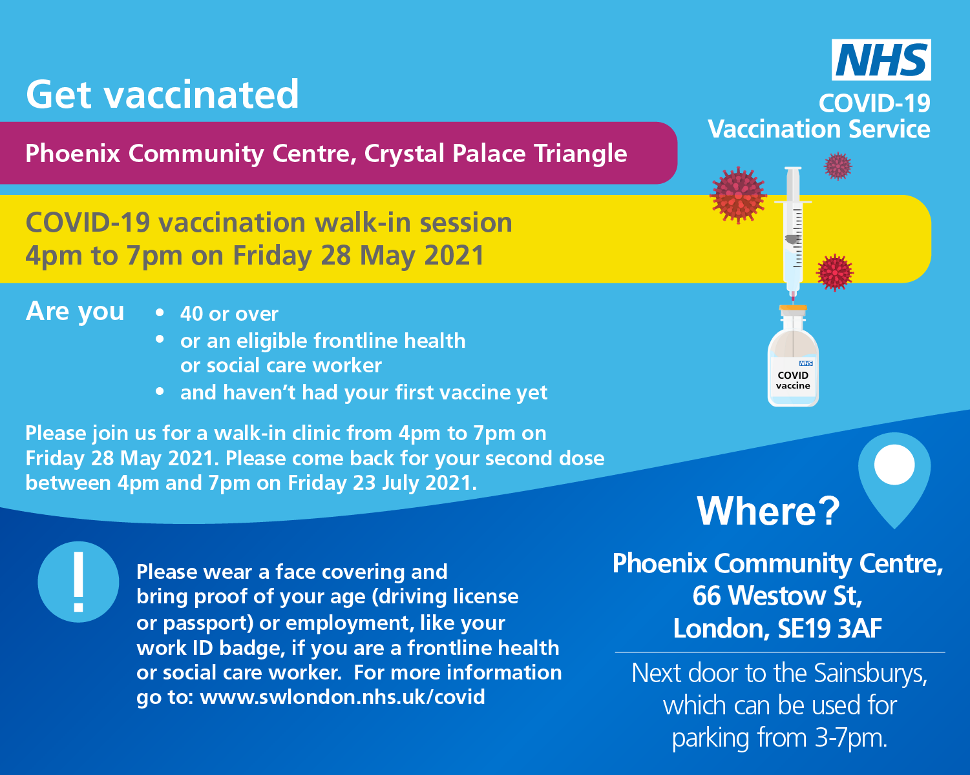

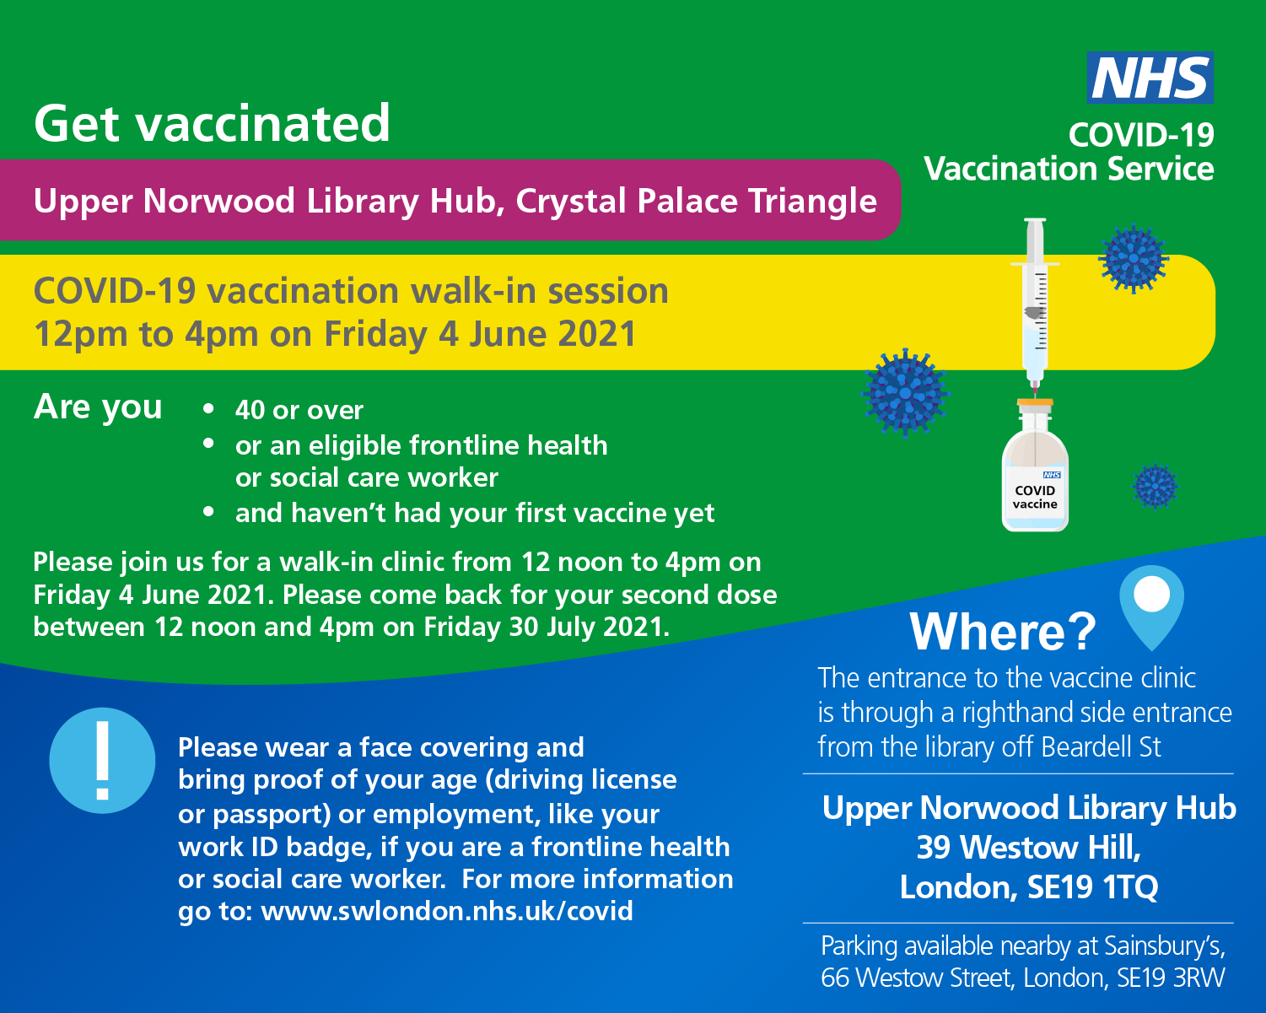

Second COVID-19 Vaccine Doses
From this week, Health and Social Care Workers and people over the age of 50 will have their second dose vaccines brought forward to 8 weeks. If you have booked on the national booking system this will be done automatically. People under the age of 50 who do not work in Health and Social Care will still receive their second dose vaccine between 77 days – 84 days after the first vaccine. If you do not have a second dose appointment booked within these time frames, then please contact Carehome.covidvaccine@swlondon.nhs.uk who will support you to book your second dose and can answer any questions.

New Guidance for first dose Astra Zeneca (Oxford) Covid-19 Vaccine

The JCVI has posted their press release on the new guidance for under 40s.

Of note, they emphasize this is a precautionary approach and influenced by the lower infection rates in the UK.
The advice provided indicates a ‘preference for adults aged 30-39 without underlying health conditions to receive an alternative to Oxford/Astra-Zeneca vaccine-where available and only if this does not cause substantial delays in being vaccinated.’

It remains safe for people under the age of 40 years to have a first dose Pfizer or Moderna Covid-19 vaccination.

If you experienced any of the following symptoms after your first Astra Zeneca (Oxford) Covid-19 Vaccines:
- As a precautionary measure, anyone who has symptoms four days or more after vaccination is advised to seek prompt medical advice, such as:
  - a new onset of severe or persistent headache, blurred vision, confusion or seizures
  - develop shortness of breath, chest pain, leg swelling or persistent abdominal pain
  - unusual skin bruising or pinpoint round spots beyond the injection site
Then a clinical consultation should be undertaken before the second dose appointment. If these side-effects were not experienced if is safe to receive the second dose.
For people over 40 years of age it is safe to use any of the vaccines unless you have a specific clinical allergy or contraindication.
To book a Pfizer first dose, for any queries or to enquire about 2nd doses, please email: CareHome.CovidVaccine@swlondon.nhs.uk for more information

Supporting Staff with Vaccine Hesitancy
A one to one interview vaccine hesitancy pack for managers has been developed to support managers to undertake interviews with staff who are vaccine hesitant. This pack will be regularly updated with support material. Please contact your CCG Care Home lead if you do not have a copy of the pack; contact details available on first page.

The following recordings of the live webinars on the COVID-19 Vaccination can be accessed below.

- COVID-19 Vaccine Q&As with Dr Patrick Gibson and Dr Marek Jarzembowski with Polish translation
- COVID-19 Q&A with Dr Agnelo Fernandes and COVID-19 experience shared by Erik Cortez
- COVID-19 Vaccine Q&A with Dr Agnelo Fernandes, Dr Aditi Shah and COVID-19 experience shared by Vanessa Vyapooree
- COVID-19 Vaccine Q&As with a Focus on Allergies and Health Conditions with Dr Paul Riley and Dr Vasa Gnanapragasam
- Young Fit and Healthy, why do I need the COVID-19 Vaccine? With Dr Paul Riley, Gassan Yacob and COVID-19 experience shared by Erik Cortez
- COVID-19 Vaccine Q&A with BSL, focusing on Race Religion Background or Beliefs with Dr Vasa Gnanapragasam and Chief Pharmacist Sedina Agama
- BSL interpreted FAQs on COVID-19 Vaccine with Dr Paul Riley and COVID-19 experience shared by Lisa Royle
- COVID-19 Vaccine Q&A with a Focus on Women's Health with Dr Aditi Shah and Fiona White

Below is a video of social worker Marcia Wilson explaining her journey and decision to have the COVID-19 Vaccine https://twitter.com/yourcroydon/status/1357041318313263112

SECTION 1: Updated Guidance 28/05/21

Current Coronavirus restrictions: what-you-can-and-cannot-do

There has been a joint statement from UK Chief medical officers recommending that the UK COVID-19 Alert will move from level 4 to level 3 Covid -19 alert level on the 10th May 2021

Further guidance on what this means for your area and visiting for care homes can be found at: Care Home Visiting &
Visits out of care homes

Demonstrating Covid-19 vaccination status when travelling abroad
From 17 May, people in England who have had a full course of the Covid-19 vaccine will be able to demonstrate their Covid-19 vaccination status for international travel. A full course is currently two doses of any approved vaccine. Find out more.

Polyethylene glycol (PEG)
laxatives and starch-based thickeners: potential interactive effect when mixed, leading to an increased risk of aspiration
Addition of a polyethylene glycol (PEG)-based laxative to a liquid that has been thickened with a starch-based thickener may counteract the thickening action, placing patients with dysphagia at a greater risk of aspiration.
- there have been reports of a possible potential harmful interaction between polyethylene glycol (PEG) laxatives and starch-based thickeners when they are mixed together
- combining the two compounds can counteract the thickening action and result in a thin watery liquid — patients with swallowing difficulties (dysphagia) are potentially at greater risk of aspiration of the thinner liquid
- avoid directly mixing together PEG laxatives and starch-based thickeners, especially in patients with dysphagia who are considered at risk of aspiration such as elderly people and people with disabilities that affect swallowing More information at: .Gov Drug safety update

111*6
If you are concerned about a resident, please contact a member of your Care Home Support Team (CHST)
If out-of-hours, please contact 111*6. This service is available to all Care Homes across South West London.

The 111*6 telephone line will enable staff in care homes to speak to a service advisor who will take the patient’s details and ask a few clinical questions. They will not have to wait in the same call queue as patients who are calling themselves; this will enable them to have a quicker response.

111*6 is for all care homes who need fast access to a clinical team who can give advice and medical input needed for residents. If admission is required, hospitals are finding patients are arriving without key information (the Reg Bag should contain key paperwork, medication, and essential personal items).

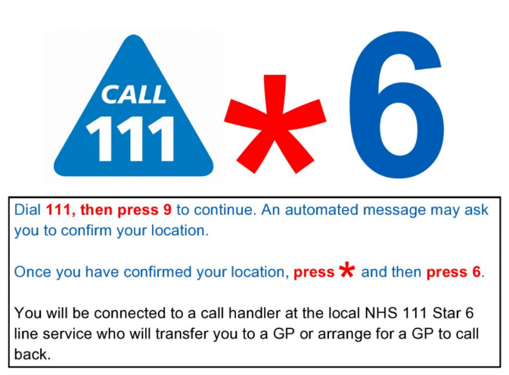

What’s New?

Vaccination Guides
Version 4 of COVID-19 vaccination guide for childbearing, pregnant or breastfeeding women has been published.

We have also revised the
COVID-19 vaccination guide for adults leaflet– new version 4 for Phase 2 paper copies available to order now
What to expect after your COVID-19 vaccination leaflet – new version for Phase 2 as above

COVID-19 vaccination and blood clotting collection has been revised
https://www.gov.uk/government/collections/covid-19-vaccination-and-blood-clotting

VITT investigation / management HTML is live
https://www.gov.uk/government/publications/clinical-investigation-and-management-of-covid-19-vaccine-induced-thrombosis-and-thrombocytopenia

COVID-19 vaccination and blood clotting – patient guide (must be given to anyone offered the AstraZeneca vaccination)

Care Home Champion Meeting
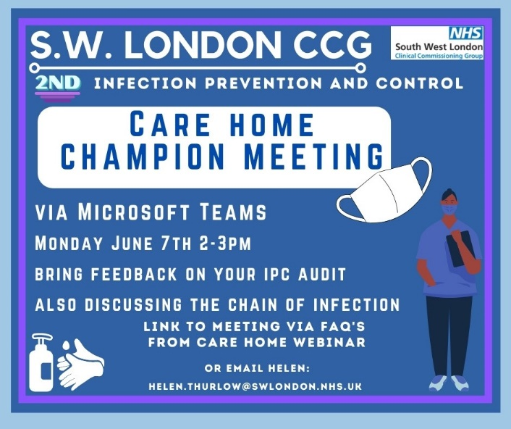
The 2nd Infection Prevention and Control Care Home Champion Meeting takes place on the 7th June 2021 2-3pm
Please use the link below to access the meeting or contact Helen.Thurlow@swlondon.nhs.uk with any questions
Microsoft Teams meeting
Join on your computer or mobile app
Click here to join the meeting
Or call in (audio only)
+44 20 3880 0300,,59019580# United Kingdom, London
0800 026 6146,,59019580# United Kingdom (Toll-free)
Phone Conference ID: 590 195 80#
Find a local number | Reset PIN

IPC guidance direct to your mobile

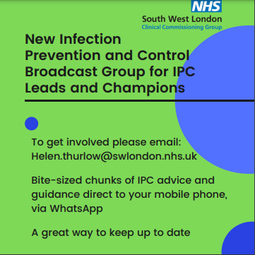
Direct information and Infection Prevention Guidance straight to your mobile.

If you would like to receive this and are an infection prevention and control lead or champion, you can access this service by emailing

Helen.Thurlow@swlondon.nhs.uk

IPC Training offers
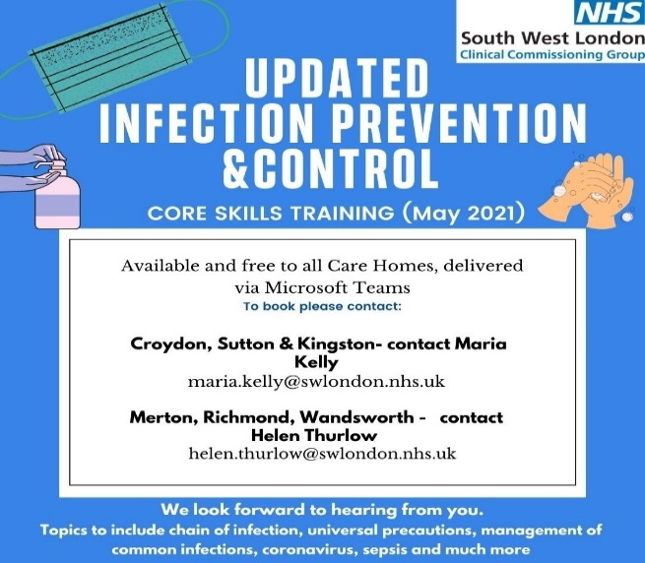
The South West London infection prevention and control team are offering two types of training to all care homes to choose from:

- Covid-19 specific training

- Core Skills Training

They are now booking sessions for the week commencing 1st June please contact Maria Kelly for Croydon Sutton and Kingston or Helen Thurlow for Merton Richmond and Wandsworth.

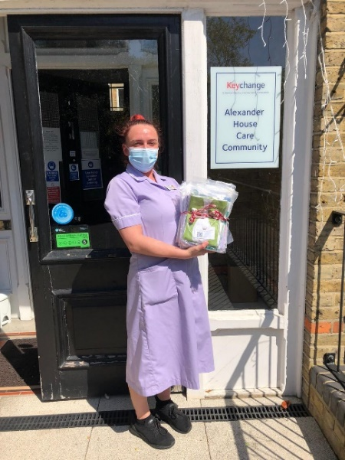
Uniform Bags
A uniform bag is a fabric bag that carries a staff member’s uniform. When staff travel to and from work, they should wear everyday clothes to prevent work clothes coming into contact with coronavirus.
The staff member then changes into the uniform for their shift. At the end of the shift, staff should change into everyday clothes and the used uniform is placed inside the uniform bag securely. When the staff member gets home, the uniform bag and uniform should be put directly into the washing machine and washed on a hot wash. The bag and uniform should then be tumble dried and/or ironed to ensure all virus particles are eliminated.
If a staff member does not have a uniform bag, pillow slips can be used instead.
If you are interested in receiving a uniform bag please contact Jiggy Trivedi-Gardner on jiggy.trivedi-gardner@swlondon.nhs.uk with Care Home name, location, number of bags required and a contact.

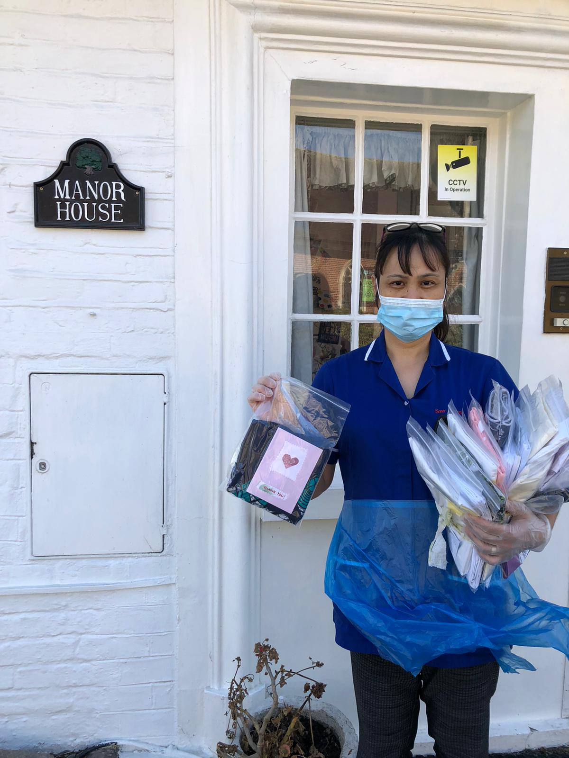

Local charity, Merton A.R.K. (Acts of Random Kindness) have kindly donated Uniform Bags to South West London Care Homes. Pictured here are staff from Care Homes who have gratefully received bags for staff.
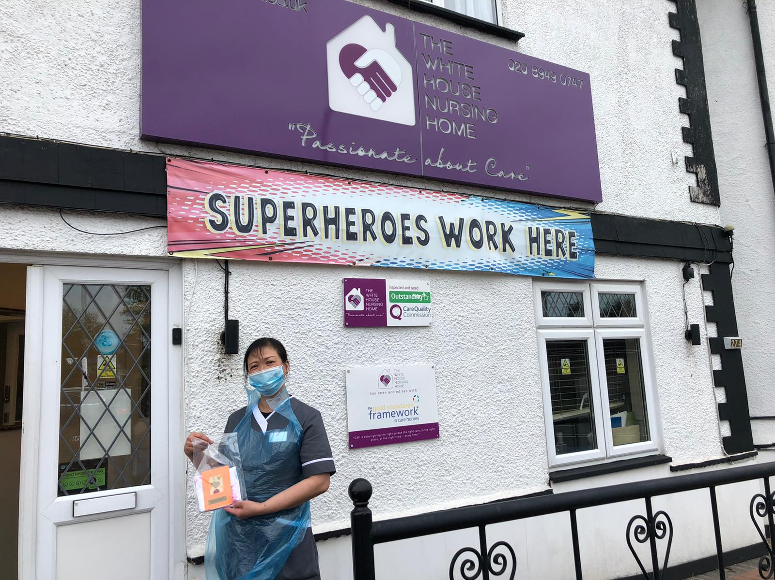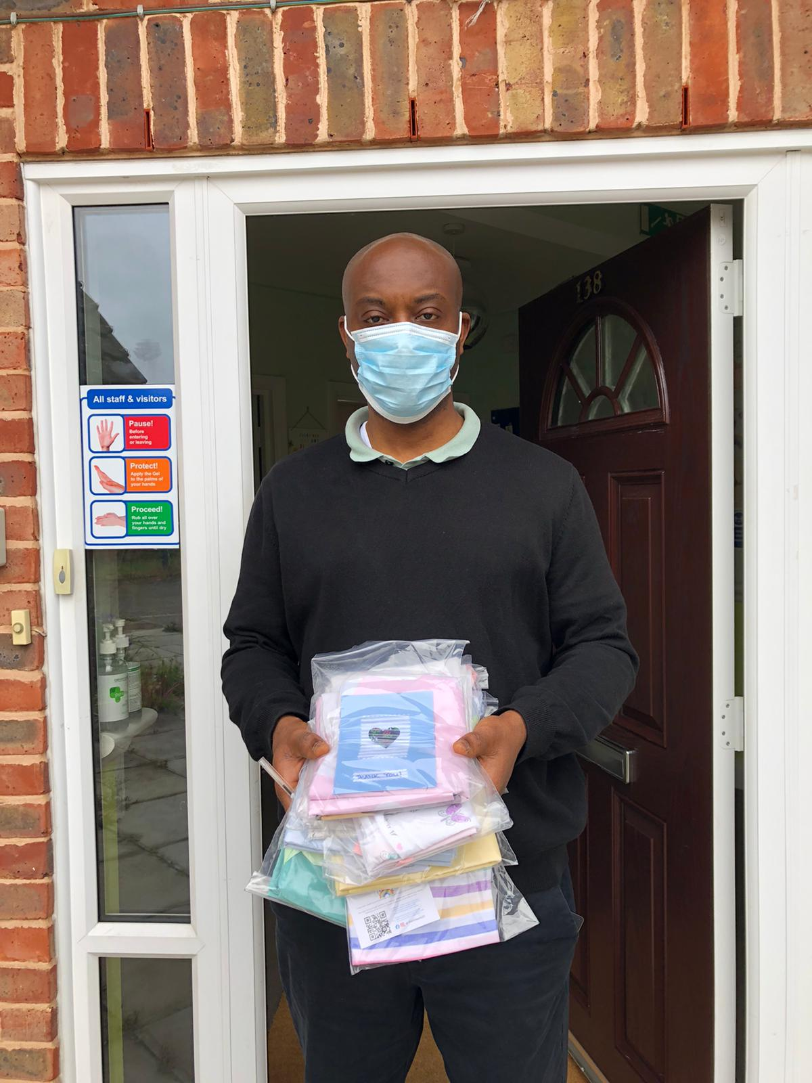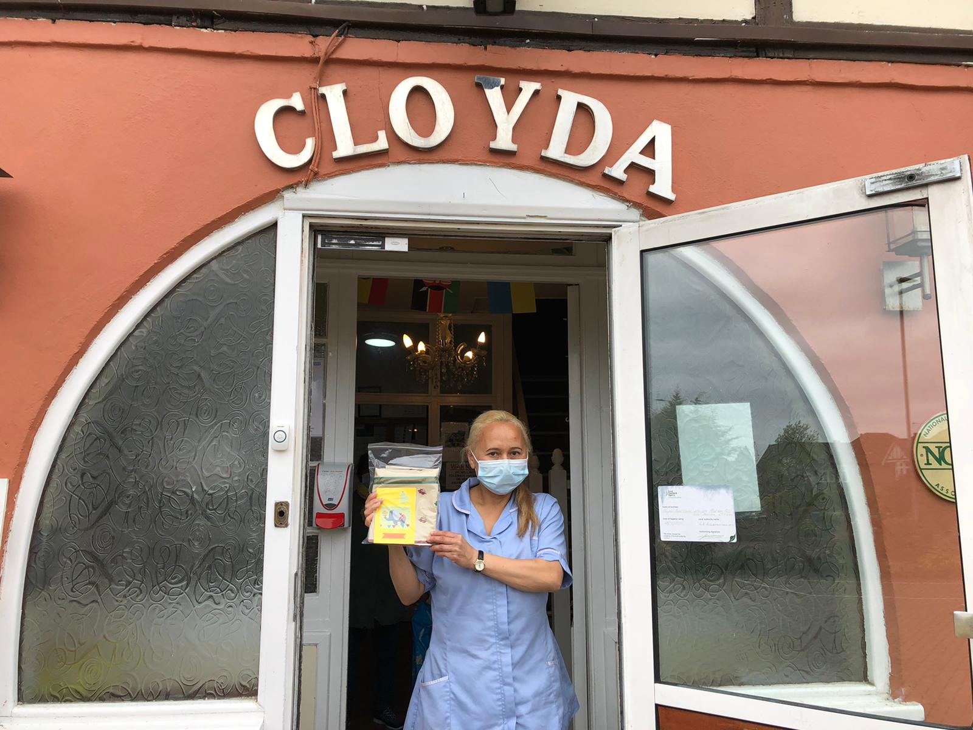

Upcoming COVID-19 Vaccine Q&A Webinars

We are pleased to invite you to an Educational Webinar session on Thursday 3rd June 2021 1230 – 1330 focusing on: Maternal Health & Covid Vaccine

Background
Pregnant and lactating women were excluded from initial COVID-19 vaccine trials; thus, data to guide vaccine decision-making are lacking. But information & guidance is helpful in guiding women to make the right choices.
Objectives
To understand the immune response of COVID-19 vaccination in pregnant and lactating women and the risks and benefits compared to risks of non-vaccinated women who are exposed to COVID-19 infection in pregnancy. Importance for high risk pregnancies - impact of covid on pregnant women
Joint Chair: Dr Anu Jacob | GP SWL maternity lead & Fiona White | Nurse Consultant Merton Maternity Lead
Speakers:
Miss Antoinette Johnson | Consultant Obstetrician and Gynaecologist
Professor Aris Papageorghiou | Consultant Fetal Medicine and Obstetrics
Chelone Lee-Wo | Consultant Midwife/Public Health | Maternity Transformation Co-chair | Maternity Covid Lead

To Register to attend please click here - Book Here
(By registering to attend, you will receive a calendar invite for your diaries)
OR
Join Teams Meeting

Pre-Recorded COVID-19 Vaccine Q&A webinars

Please see below the link to the staff Q&A session on the Covid-19 vaccine, fertility and pregnancy:
Recording: Staff Q&A on the Covid-19 vaccine, fertility and pregnancy
A recording of the health and social care staff Q&A session on the Covid-19 vaccine, fertility and pregnancy is now available to view via this YouTube link. Questions were answered by three clinical experts:
- Helene Brown, Medical Director (System Improvement and Professional Standards) for NHS London
- Memuna Sowe, Specialist Midwife for vulnerable and marginalised women at NHS Croydon Health Services
- Garima Srivastava, Consultant Gynaecologist and fertility lead at Homerton University Hospital

COVID 19 Vaccine Questions and Answers in English and Polish

COVID-19 Vaccine Q&As with Dr Patrick Gibson and Dr Marek Jarzembowski with Polish translation

Care home staff try out laughter yoga

Staff at Royal Star and Garter care home in Surbiton have been reducing their stress and cortisol levels by trying out laughter yoga.
As well as laughter yoga, staff took part in Tai Chi, reiki, Indian head massage and mindfulness as part of a wellbeing week.

To read more about this story click link below
https://www.carehome.co.uk/news/article.cfm/id/1649318/care-home-staff-laughter-yoga-lady-haha

Ways to Reach out to Friends and Neighbours

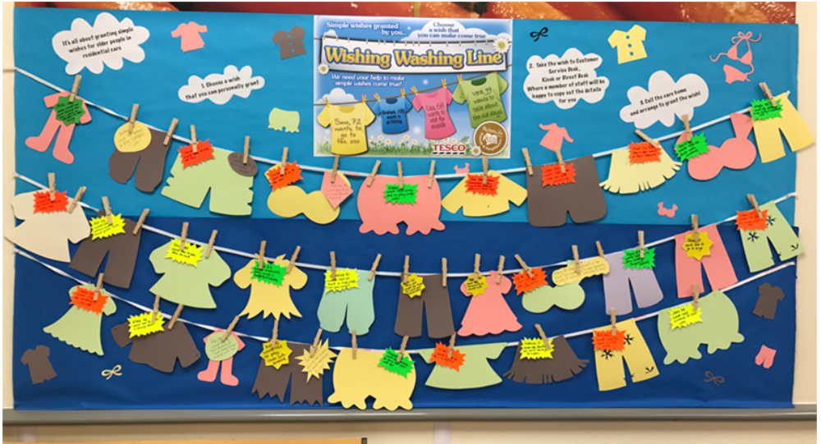
http://carehomefans.org/fans_in_action/wishing-washing-line/

Are you a care home wanting to start a Wishing Washing Line? Or are you a community member who could host a Wishing Washing Line in your local area? Either way, please get in touch! mhl@city.ac.uk

Good thinking website for Wellbeing
There are lots of NHS-approved wellbeing apps available on Good Thinking (many of which are free if you live or work in London) and workbooks written by the Centre for Clinical Interventions. The Good Thinking team has also produced specific advice for health and care professionals related to mental health and COVID-19, including a free employers toolkit to help support employees' mental health.
You can scan the QR code to access the site or click on this link: https://www.good-thinking.uk/health-and-care-professionals/

Support available from The Prince’s Trust

The Prince’s Trust has committed to supporting 10,000 young people aged 18-30 into Health & Social Care careers over the next four years. To take part in this programme all The Princes Trust needs is entry level roles for young people to interview for and someone to interview them on the recruitment day.
Student Placements
Are you interested in hosting a placement student (Nurses and AHPs in training)? Individual placements run for a minimum of 3 weeks, we can establish a regular rotation, supervision is required (training and is provided).

Recruiting staff
The Work and Health Programme is an employment support programme, seeking to find long term sustainable employment opportunities for people in South London.

Please let us know about your recruitment needs, we may be able to help - please complete our survey:

Upcoming Webinars

https://www.eventbrite.co.uk/e/becoming-an-advocate-for-allyship-and-inclusive-leadership-tickets-156978662405
https://www.eventbrite.co.uk/e/plenary-session-on-unconscious-bias-tickets-156852485005

SECTION 2: Frequently Asked Questions

I want to ask about Service user's families wanting to take their loved ones on holiday abroad. Is there currently any restrictions or further guidance on residential clients taking holidays with their families?
Please access visits-out-of-care-homes-summary-of-guidance for further information. Any resident planning a trip abroad will need to self-isolate for 14 days on their return. This guidance remains under active review and it is hoped that self-isolation following overnight stays will be amended as soon as the data and evidence show it is safe. Please note however trips abroad should follow the red-amber-and-green-list-rules-for-entering-england.

I have not been receiving the weekly information sharing FAQs?
The weekly information sharing FAQs are sent out to Care Home managers every week. At present these should be to your NHS Mail inbox and your work email inbox. From the 5th July 2021 we aim to only be sending these to your NHS Mail. If you are not receiving to either mailbox at present, please contact your CCG Care Home Lead (contact details available on page 2 of this document). If you are having difficulty with your NHS mail please contact: SWLcarehomes.admin@swlondon.nhs.uk

How can I support my staff with the EU Settlement Scheme?
There is a template letter for EU citizen staff that central government is encouraging employers to use in advance of the June deadline. The template can be found here.

I am a manager of a Care Home and I have really tried to encourage my staff to have the vaccine, with several supervision sessions but I don’t know what else I can do for those staff who won’t have it?
People have many reasons for declining a vaccine; if you can talk to your member of staff and find out the reasons they are declining. You can ask the member of staff to speak to a clinician they trust to enable them to make an informed decision. We are aware that it has been developed to protect us from the Covid-19 virus and it is important for Care Home staff to have the vaccine.

As a manager, it is good practice to have a 1 to 1 meeting with each staff member who has declined the vaccine to discuss their concerns, ensure they are making the decision based on facts, undertaking a risk assessment and documenting these discussions and actions.

To support you as a manager, we have developed a 1 to 1 interview pack for managers to use with staff who are vaccine hesitant. The Pack has been sent out with previous FAQs if you have not yet received it please email carehome.covidvaccine@swlondon.nhs.uk and it can be sent to you.

We strongly encourage you to use this pack with any staff who are refusing the vaccine so that you are protecting the staff and that you are providing evidence as a manager of the support that you have given.

Staff should be encouraged to speak to someone about the vaccine – they can phone Nurse Fiona White on 07770684842 and she will be happy to answer any of their concerns and questions. There is a consultation about vaccinations and care homes currently in progress. The covid-19 vaccine helps prevent the risk of hospitalisation and decreases the complications to the person, family members and clients, staff you work with. No vaccine is 100% effective so it may not prevent you getting the virus, but evidence is currently showing it can reduce transmission and complications. Fiona has offered to speak to anyone who needs help making a decision.

What is the updated care home visiting guidance?
A press statement from The Department of Health and Social Care https://www.gov.uk/government/news/more-restrictions-eased-for-care-homes published on .gov states from Monday the 17th May Care homes can allow every resident to name up to 5 people who can come for regular indoor visits. But importantly this will only include a maximum of 2 per resident at any given time and in one day As far as possible these should remain the same 5 people. Care homes can only welcome a certain number of visitors a day to ensure social distancing can be adhered to. The visits will need to be arranged by appointment in advance and ad hoc visits cannot be enabled. Care Home mangers are best placed to decide how this will be managed.

These 5 visitors must include the essential giver if one has been identified.

Please find more information at Summary of Care Home visiting guidance This has yet to be updated.
The named visitors will need to follow some important steps to reduce the risk of infection to the person they are visiting and to others in the care home.
Take a rapid lateral flow test
The named visitors will need to take a rapid (lateral flow) test every time they visit. If the result is negative, the visit can go ahead.
Wear PPE
Visitors will need to wear personal protective equipment (PPE) for the duration of the visit.

Visits should take place in a well-ventilated room, for example with windows and doors open where it is safe to do so. Providers should consider the use of designated visiting rooms, which are only used by one resident and their visitors at a time and are subject to regular enhanced cleaning and ventilation between visits. Any areas used by visitors should be decontaminated several times throughout the day and providers should avoid clutter to aid cleaning.

BEREAVEMENT AND WELLBEING SUPPORT FOR STAFF

Borough | Name of Service | Contact Details
All SWL | Marie Curie | Call 020 7091 3656 for emotional and bereavement support.  Monday – Friday, 08:00 – 18:00  Saturday – Sunday, 11:00 – 17:00
Sutton | Sutton Uplift | Telephone hotline (8 am – 5 pm): 020 3513 4044  Self-referral: https://www.suttonuplift.co.uk/psychological-therapies  Email: ssg-tr.suttonuplift@nhs.net
Merton | Merton Uplift | Telephone hotline (9 am – 5 pm): 020 3513 5888  Self-referral: https://www.mertonuplift.nhs.uk/  Email: ssg-tr.mertonuplift@nhs.net
Wandsworth | Talk Wandsworth | Telephone hotline (8 am – 5 pm): 020 3513 6264  Self-referral: https://www.talkwandsworth.nhs.uk/  Email: ssg-tr.WANIAPT@nhs.net
Kingston and Richmond | Bereavement Support  iCope (Kingston only)  Richmond Wellbeing Service | https://www.kingstonbereavementservice.org.uk/contact-us/  https://www.icope.nhs.uk/kingston/  https://www.richmondwellbeingservice.nhs.uk/
Richmond | Cruse | Tel: 0749 5776 401

EOLC CLINICAL SUPPORT FOR STAFF

Provider Service | Borough | What is on Offer | Operating Hours | Contact Details
St Raphael’s Hospice | Sutton and Merton | Clinical Advice from Clinical Nurse Specialist on triage team.  Access to Medical team advice.  Clinical Advice from Palliative Care Nurses covering inpatient wards. | Monday - Sunday  09:00-17:00  Monday-Sunday  17:00-09:00 | Central Hospice Switch:  020 8099 7777  Ask for CNS triage team.  Ask for inpatient unit.
Royal Trinity Hospice | Wandsworth | A Clinical Nurse Specialist to provide expert advice and support for GPs, HCPs, patients and carers.  Medical on call cover (Registrar and Consultant) | 24 hours a day, 7 days a week | Central Hospice Switch:  020 8099 7777  Ask for CNS triage team.  Ask for inpatient unit.
Marie Curie | All SWL Boroughs | Professional Information and Support | Monday – Friday  08:00 – 18:00  Saturday – Sunday  11:00–17:00 | Tel: 020 7091 3656  www.mariecurie.org.uk/southwestlondon
Princess Alice Hospice | Richmond and Kingston | Careline which has a triage process with access to senior staff and Community Nurse’s | 24 hours a day, 7 days a week | Tel: 020 8744 9414
St Christopher’s Hospice | Croydon | Professionals’ helpline for clinical support  Patient support line | 24 hours a day, 7 days a week | Professionals: 020 8767 4582  Patients: 020 8767 4500

Section 3: Additional information

Infection Control Champions for Care Homes
Please contact Helen Thurlow (infectioncontrol@swlondon.nhs.uk) with the details of any individual who would like to become an IPC Champion.

Contact details for advice and support for mental health and wellbeing.
The Health and Wellbeing of staff in the care sector is available online at: https://www.good-thinking.uk/
This website has links to useful apps quizzes workbooks and advice. There are 4 free apps at present. If you register on the app now you can have lifetime access to meditation sessions, mindfulness, cognition exercises and other podcasts that help with improving wellbeing.

Support for Managing Residents with Dementia
NHS England have just published a guide for Dementia wellbeing in the COVID-19 pandemic. This provides single page support pages for supporting people with Dementia. The document is attached and is available via the following links: https://www.england.nhs.uk/mental-health/resources/dementia/
https://www.england.nhs.uk/coronavirus/community-social-care-ambulance/mental-health/

SECTION 4: ONGOING ADVICE AND SUPPORT

Support for EOLC from Hospice UK
Hospice UK have released a support pack. You can access the guidance at: https://www.hospiceuk.org/what-we-offer/clinical-and-care-support/clinical-resources

What to do if a resident has coronavirus symptoms
Isolate the resident in their own room and away from other residents for 14 days. Close the door if possible or consider moving the resident's bed 2m away from the door. The resident should preferably have a room with an en-suite. If this is not possible then the resident will need to use a commode. Contact the resident’s GP, or access 111 services online. For a medical emergency dial 999. If ONE resident displays COVID symptoms you need to contact the South London Health Protection Team/London COVID Response Cell (LCRC) to advise them of a suspected outbreak.

SWL Health Protection Team | 0344 326 2052
London COVID-19 Response Cell | 0300 303 0450 / phe.lcrc@nhs.net

If PPE is running low in your Care Home

From the 6th November 2020 it had been agreed that CQC registered organisations in primary and social care should access the national PPE portal for their stock requirements.

The PPE portal can be found at https://www.gov.uk/guidance/ppe-portal-how-to-order-emergency-personal-protective-equipment and we have attached an FAQs document which has been shared with us for your information. You will need to register on this portal first.
From this week social care organisations, including Care Homes, should utilise the national PPE portal as its primary supply of PPE. If organisations have difficulty in securing PPE stocks the steps they should take are:
(1) PPE Portal
(2) Local Resilience Forum
(3) BAU Suppliers
(4) South West London Mutual Aid via http://swlpp.uk online access.
South West London Mutual Aid will be updating their agreement with you and will contact you directly.

NICE guidelines on Safeguarding adults in care homes

This final guideline has now been published on the NICE website.
The guideline is for care home providers, commissioners of care homes, safeguarding practitioners, local authorities and safeguarding boards. It may also be useful to anyone who lives, works or visits care homes.

- induction and training
- care home culture and management
- indicators of individual abuse and neglect
- immediate actions to take if you consider or suspect abuse or neglect
- how care home safeguarding leads and local authorities should respond to reports of abuse or neglect
- indicators of organisational abuse and neglect

It includes summary versions of indicators to help practitioners identify abuse and neglect relating to individuals and indicators of organisational abuse and neglect.

APPENDIX 1: Useful Links and Contacts

NHS MAIL
NHS Mail is available free to all Care Homes allowing personal identifiable information to be sent securely to NHS services. NHS Mail also allows access to Microsoft Teams which has video conferencing facilities, to connect with GPs, Health Care staff and the resident’s family.
If you need help to access, please contact: SWLcarehomes.admin@swlondon.nhs.uk

Most of you will have your NHS mail account now and we really want you to use your NHS shared mailbox now as this is the way the NHS will now contact you using the shared mailbox. We will be setting some deadlines for that with your local leads. The shared mailbox does keep your data secure and accessible and everything is in one place. We are sending out certificates so you can email your care home email lead or SWLcarehomes.admin@swlondon.nhs.uk from your shared mailbox, we will send you a certificate.

CAPACITY TRACKER
All Care Homes are being asked to submit daily information on staffing, bed vacancies, number of COVID cases and PPE or when the situation changes so that the NHS can support your homes more effectively. If you are not yet set up, or have more questions, please contact your local lead listed on the front of the FAQ. Please complete the ASC fund questions weekly. Contact 03005550340 or 01916913729 8am to 8pm if you have any questions or need support with this.

WORKFORCE AND STAFFING
COVID is a challenging time for maintaining staffing levels in Care Homes. We have a project running with Princes Trust to provide Care Support Workers, Domestic and administrative staff into Care Homes. If you would like some support, please contact Paul Harper at: paul.harper@swlondon.nhs.uk

Topic | Click Links below
The phone number for the IT Helpdesk is 020 3880 0268. Open during 09:00 – 17:00. | Information for free digital tools from Digital Social Care
PPE Portal help line number: 0800 876 6802 | How to order COVID-19 PPE  PPE resource for care workers  How to correctly don and doff of PPE in Care Homes
Swabbing Residents Staff and Visitors | Coronavirus Testing process and how to register LFD Test  Online Swabbing competency assessment
Admissions and Care | COVID-19 Admission and Care of Residents in Care Homes
Infection Prevention and Control Guidance | Infection Prevention and Control Recommendations
Advice for pregnant health care workers | Pregnant employees COVID-19 advice
Travel and self-isolation | Travel Corridors

