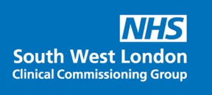
This Photo by Unknown Author is licensed under CC BY-NC

Calling all Care Home Staff

Do you have COVID-19 Vaccine Questions?

The COVID-19 Vaccination Single Point Access Team will be holding daily webinars for any care staff member to call in and ask those burning questions or queries

The Calls will be facilitated by a clinician

Phone Number – 08000266146 or 02038800300
Pin - 354457979#

This will be held daily (inc. Weekends & Evenings)

1st February – 15th February 2021

3pm – 4pm
&
7pm – 8pm

